Learning Objectives.

Understand the importance of acceptable use policies, passwords, and constant vigilance while online.

Learn why your computer is not secure on the Internet unless you make it secure.

Discover what you can do to protect your computer and personal data while you are online.

Know when your online activities violate copyright or software piracy laws.

Become aware of privacy issues and learn what you can do to protect your personal privacy.

Find out how to separate fact from fiction when you see warnings and advice on the Net.
Taking Charge

While you may feel secure in the privacy of your own home, each time you connect to the Internet you enter a public place

Your conduct is visible to many different people

You have both rights and responsibilities

The Internet has its own code of conduct

You need to minimize your personal risk as you work and play online

Actions that you take have consequences
Acceptable Use Policies

All computer accounts and some public servers are subject to an Acceptable Use Policy (AUP)

An AUP is a policy that outlines appropriate use of the Internet and is enforced by system administrators

Violating the AUP can result of the withdrawal of your Internet access privileges

The restrictions that pertain to an ISP account are called the terms of service

When you sign up for an account, you also agree to the terms of service or AUP

You should locate and periodically check your account’s AUP, as you are expected to know the AUP

CCSF Disclaimer link at the bottom of my Web page samsclass.info

See link Ch 2a on my Web page

Common university AUPs include the prohibition of the use of university resources for:

Commercial activity

Academic dishonesty

Harassment

Some universities also prohibit the use of specific Internet services, such as some music sharing sites
Password Security

Your password is the first line of defense

While you may think that your account has nothing to offer, someone can use it as a starting point to access other accounts

System administrators have resources to maintain accounts and the system

No system administrator will need to ask you for your password

Do not be tricked by an email, no matter how official looking, asking you for your password

Hackers try tactics like this

Do not share your password with anyone, as this is a security hole

You protect others by not telling them your password, and you protect yourself by refusing to learn their password

Choose a good password

Here are some tips to help you choose a good password:

Do not use a word from the dictionary

Do not use a proper name

Do not use the same password on more than one site

A good password has at least one number, has at least 6 characters, and has uppercase and lowercase letters
Viruses (not in textbook)

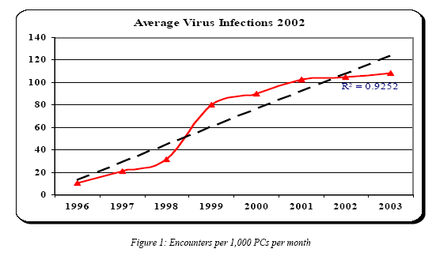
Viruses are a big and rapidly-increasing problem

Now over 100 infections per 1000 machines per month

From techtips101.com/

Link Ch 2b on my Web page

Chart from brief.weburb.dk

Link Ch 2c

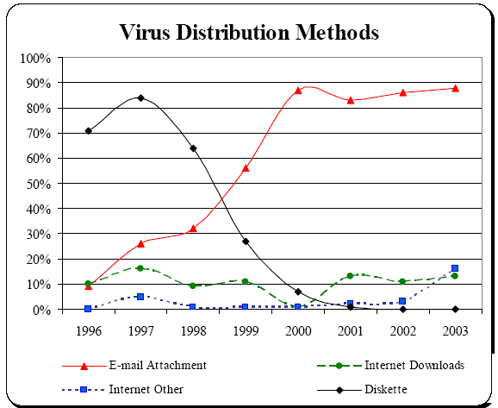

Where do they come from?

From link Ch 2c

Rate of Spread is Increasing

File viruses took months to years to spread widely

Code Red took about 12 hours

http://www.newsfactor.com/perl/story/12668.html Link Ch 2d

Klez went around the world in 2.5 hours

Slammer affected the world in about 10 minutes!

From link Ch 2c
Viruses, Trojan Horses, and Worms

Some software is a security risk

The mainstream news calls all such software “viruses”, but there are three different classes of such software

A virus is a computer program that can replicate itself through files to move from computer to computer

Some viruses are benign, others are destructive

You have to copy or run a file to catch a virus (such as a download

A Trojan horse is a program that slips into a computer under the guise of another program

Someone could e-mail a game to you that contains a Trojan horse. If you run the game you also run the Trojan horse

The Trojan horse could record your keystrokes or allow someone to access your computer

A worm is a program that is similar to a virus, but spreads through a network

Software can be exploited by worms

Some worms run over several computers

Others communicate among themselves over the network

A worm may be malicious or may take up system resources, causing a slowdown in performance

You can take control and secure your computer

Use antivirus software and keep it updated

Antivirus software can scan files moving from the computer onto disks and CDs

Your email and downloaded files can also be scanned

Since new viruses are created every day, the data files needed to detect these viruses needs to be kept up-to-date

Keep floppy disks out of your floppy drive unless you are actively working with the files on the floppy disk

Some viruses can hide on the boot sector on a floppy

These are triggered when the computer starts up and accesses the floppy disk

If you need to work without a virus scanner running in the background, you should manually scan each file before opening or executing it

Install a firewall on your home computer (especially if you use a broadband connection)

Windows XP Service Pack 2 puts a firewall on your PC for you

You can get a free PC firewall at www.zonelabs.com (link Ch 2j)

Mac OS X has a firewall built in (link Ch 2k)

Mac OS 9 firewalls are available (link Ch 2l)

Do not download files offered to you in chat rooms or personal Web pages

For maximum safety, encrypt all files that contain sensitive information or store them offline on removable media

Do not leave your computer connected to the Internet any longer than necessary
E-Mail Viruses

E-mail is the number one source of computer viruses

Attachments are the most common culprit

Some attachments contain scripts

A script is a small program written in a scripting language (e.g. Visual Basic)

You can take precautions

Configure your mailer to not open attachments automatically

Save attachments and scan them first

Microsoft Word documents are a popular source of viruses

Someone can spread a virus unknowingly

Precautions include:

Keeping your antivirus software up-to-date

Saving an attachment and scanning it for viruses before you open it

Not opening a document that contains a macro

Microsoft Word (and Excel) documents are a popular source of viruses

Because Word documents contain both data (text and formatting) and programming instructions (macros)

Combining data and programming in the same file is a departure from computing tradition, and Microsoft has been criticized for doing it

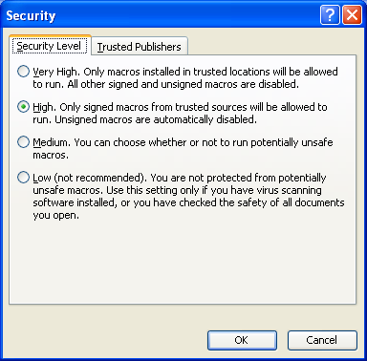
RTF files don’t contain Macros, but graphics are very large

Melissa and Love Letter were famous

See link Ch 2f

www.cert.org has reliable virus information (link Ch 2e)

Microsoft Word has had a macro security feature since Word 97

This helps protect you from macro viruses

Click Tools, Macro, Security to set your security level

Mailers that render messages into Web-like displays are susceptible to script attacks

Some messages contain scripts

If the script is automatically executed, it can cause harm

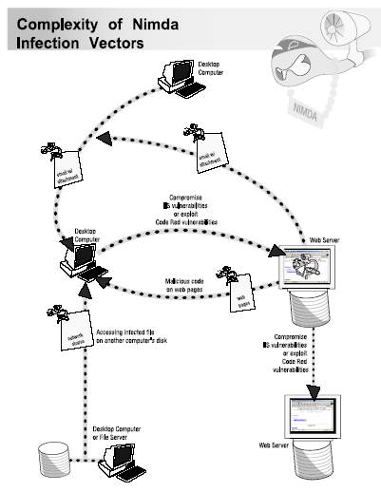
Some threats can contain a blend of different types of attacks

Code Red, Sircam, and Nimda

Nimda

Link Ch 2g
Hacker Attacks and Intrusions

Hacker intrusions are less likely than viruses, but are more devastating

Many companies monitor their computers, so home computers are easier targets

It doesn’t take much effort to break into a computer that is not protected

Tools exist to make breaking into a computer as easy as point-and-click

The existence of such tools doesn’t mean that it is okay

The results can range from:

A hacker changing your wallpaper to

Adding, changing, or deleting files

You can take precautions to protect your computer

The precautions are similar to those discussed earlier in regard to viruses

Install a firewall, a software program that acts as a boundary between your computer and the outside world
Shopping Online

Purchasing items online does have some risk

There are some precautions you can take

Using a credit card is better than a check, because you can dispute the charges

Bank/debit cards are not equipped with the same consumer protections as credit cards

Use the secure page, which uses the Secure Sockets Layer (SSL) when ordering

Look for https:// in the URL and the padlock symbol in the status bar

When using one-click shopping, choose a good id and password

Though convenient, reusing the same ones is risky
Protecting Your Privacy

The Internet has provided opportunities for data collection that go far beyond a marketer’s wildest dreams

Your browser contains information about you, including the types of sites you visit

Web pages can also be programmed to collect information about you, such as when you visited the site

The Online Personal Privacy Act (2002) limits the kinds of information that is collected

For information about the current status of this bill, visit www.netcoalition.com/keyissues

To protect your privacy:

Do not provide personal information unless it is needed for a credit card transaction

Do not provide your Social Security Number or other sensitive information

When you do provide personal information, read the site’s Privacy Policy

Some companies sell your information, but you can opt-out of this

If you plan to use a portal, and have a personalized page, then you may need to supply personal information

Be aware that this same information can be used by advertisers

Two federal laws exist to protect privacy

Children’s Online Privacy Protection Act of 1998 - children under 13 years old

Online Personal Privacy Act of 2002 - everyone
Internet Scams

Scams are nothing new, but the Internet makes it easier for them to reach you

Examples include:

Get rich quick offers (e.g. Nigerian money offers)

Miracle health cures

Guaranteed loans or credit

Your credit report repaired for a fee

If it sounds to good to be true, then it probably is (link Ch 2m)
Online Auctions

Online auctions allow buyer to purchase items from sellers who they otherwise would not encounter

Millions of transactions take place on such forums as eBay everyday

Locally, try craigslist.com

While online auctions do contain some risk, you can take precautions

Learn how the auction site operates

Look for sites that have safeguards to protect you

Learn all that you can about the seller

See if the company has any complaints listed at the Better Business Bureau

If the site has feedback, read the feedback that other customers have left about the seller

Consumer protection laws apply only to commercial businesses

Be wary of people who only give you a PO Box

Never pay for an item in cash, unless you can examine the item first

Paying with a credit card offers the most protection

Alternative payment services, like PayPal or the use of escrow are useful

Start with inexpensive items on well-known auction sites
Libel and Lawsuits

Libel is any written or pictorial statement that damages a person or an organization

Posting libelous statements can result in legal action against the poster

Some companies even monitor Web pages and online forums to protect themselves and their products

While libel is not criminal, it can result in civil litigation

Statements against a company or their product is libelous if it results in lost revenues for the company

Statements against a person may or may not be considered libelous

If the person is a public figure, he/she is open to ridicule

A public figure has fewer rights than someone who is not a public figure

Threats and Harassment

Our society takes threats very seriously nowadays

Online stalking and hate mail incidents also need to be taken seriously

As people communicate in chat rooms and email over long distances, some people lose their temper

A flame is a message where the writer makes a personal attack against another individual

A flame war is an exchange of flames

Flame wars can make people nervous, as you may not know much about the person behind the communication

Laws exist that make issuing threats illegal

This includes kidnapping or bodily harm

Threats against the President are investigated by the Secret Service

Employees are also protected against harassment in the workplace

Students and staff are also protected at schools

Title VII of the 1964 Civil Rights Act protects employees against workplace harassment

E-mail is not private, and you never know who it may be forwarded to

Most e-mail at companies is monitored

Save the questionable jokes for after work
Software Piracy and Copyright Infringements

Software piracy is the willful reproduction or distribution of programs that prohibit such activity

Piracy is against the law

You do not have to profit to be guilty

Purchasing commercial software, grants you the right to use the software under certain restrictions (the license rights)

Intellectual property, in the form of text, images, and audio, is protected under copyright

Downloading MP3s has become popular

Unless they have been explicitly made public by an artist, they are protected

Universities are starting to protect themselves by cracking down on students who violate copyright

Some have also been prosecuted (link Ch 2n)
Pornography and Other Lapses in Good Taste

The Internet contains all sorts of material, including pornography

The First Amendment protects against censorship, as well as obscene language

Some material, such as child pornography is illegal to own and distribute

Increasingly, employers monitor employees’ email and web activity

Your employer determines your rights and freedoms in the workplace (Link Ch 2o)
Hoaxes and Legends

The Internet contains both valuable information and misinformation

Many hoaxes and urban legends persist

A popular hoax is an email message that says not to read an email with a subject such as “Good times”, then pass it on

You cannot get a virus through a plain text message

Chain letters and scams are also common

Don’t forward these messages (Link Ch 2p)

