Learning Objectives.

Become familiar with the basic operations of your e-mail client.

Understand the basic differences among the SMTP, HTTP, POP, and IMAP mail protocols.

Learn how the MIME protocol and HTML-enabled e-mail clients have changed e-mail.

Find out how to augment your primary e-mail service with a Web-based e-mail account.

Learn to use e-mail filters to save time and combat information overload.

Taking Charge.

E-Mail has become an indispensable tool for business communication and a speedy, and inexpensive alternative to physical mail.

It is also time consuming.

If you do not control your email it can take time away from other important tasks or activities.
Basic E-Mail Client Operations.

An e-mail message has the following characteristics

E-mail messages are usually fairly short

Each message usually addresses a single topic

Most messages rely on plain text (though this is changing)

Messages are usually written in an informal style

Some messages are replies to previous messages

Messages can be sent to one or more people

Messages can be forwarded to other people

E-mail is often timely

A reckless e-mail message might come back to haunt you

An email message has 2 parts, the header and the body.

The header contains addressing information, such as

Who sent the message

Who the message is sent to

When the message was sent

The body contains the content of the message

A valid email address consists of a userid and a host address.

For example: ajones@apple.orchard.com

Userid: ajones

Host address: apple.orchard.com

Be careful as a typo may still send your message to a legitimate address.

Online directories can help you find people’s email addresses.

An email client allows you send, read, reply or forward email messages.

A good email client allows you to

Sort, tag and filter email

Keep an address book

Save email

Use a filter to route incoming email

New mail is stored in your inbox.

The inbox lists your messages, allowing you to select which one(s) you wish to read

If your e-mail account has a quota and you exceed it, new e-mails may be lost.

If you send an email to someone whose account has exceeded its quota, the mail is lost and the mail server will NOT inform you.

Some mailers can display text in different colors, fonts or styles. Some let you insert graphics or hyperlinks.

A signature file can be used to personalize your email messages.

Text files can be imported into e-mail messages.

Respond to e-mail using the reply command.

Reply only replies to the sender of the message.

Reply-To-All replies to the sender and all of the other recipients.

The original message can be included in a reply.

Tips for good e-mail etiquette include:

Avoid inserting carriage returns into your message body.

Keep your sig file short, use no more than 4 lines

Always include a signature in the message body that contains your full name and return e-mail address

Reread the complete message body before sending the mail

Tips for e-mail replies include:

Knowing the difference between sender-only reply and group-reply

If you get into a lengthy dialog with someone, replace the Subject when it is no longer accurate

If you find yourself responding emotionally to e-mail, take a time out first

Be selective when you include text from the original message in your reply
MIME Attachments and HTML-Enabled Mailers.

MIME: Multi-Purpose Internet Mail Extension.

MIME is a protocol that allows you to send files as attachments to e-mail easily.

HTML enabled mailers allow you to send and receive e-mail written in HTML.

Allows e-mail with all the elements found in web pages: pictures, hyperlinks, etc.

These messages look like Web pages.

They may be vulnerable to the same viruses that web browsers are.
E-Mail Netiquette and Netspeak.

Netiquette: Standard rules or courtesy for online communication.

Keep your messages short and concise

Watch your grammar and spelling

Be careful with humor and sarcasm

Use uppercase words sparingly, IT MEANS THAT YOU ARE YELLING

Never leave the subject line blank

Include your name and email in the message body, such as in your sig file

Netspeak: A telegraphic style of writing designed to minimize keystrokes through the liberal use of acronyms and emoticons.

For example LOL means Laugh Out Loud

Emoticons: combinations of keyboard characters that represent emotions.

For example :-) means a smile or friendly laugh

A “flame” is an angry email message that often attacks someone personally.

Two people trading “flames” are engaged in a “flame war.”

Cool down before sending an emotional email to prevent “flaming” another user.
SMTP and Mail Servers.

Simple Mail Transport Protocol or SMTP is the universal standard for moving mail over the Net.

When setting up your email client you will need to know your incoming and outgoing e-mail servers.

To send mail you need access to an SMTP server.

HTTP, POP, and IMAP.

There are 3 types of incoming mail servers:

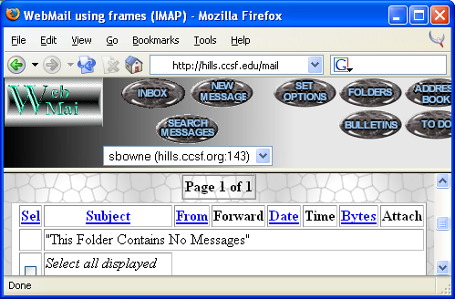
HTTP or Hypertext Transfer Protocol servers allow web-based e-mail.

POP or Post Office Protocol was designed to allow offline e-mail management.

IMAP or Internet Message Access Protocol

With POP you download email from the mail server to your PC then disconnect from the mail server.

Not all mailers (E-mail clients) are compatible with all mail servers.

HTTP or Hypertext Transfer Protocol

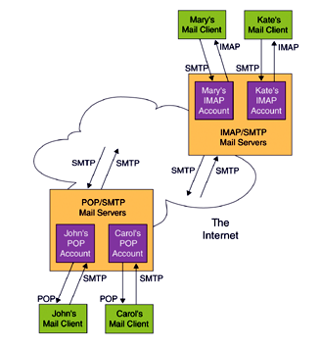
Web-based e-mail

Your browser is your mailer

Examples: Yahoo Web mail, Hotmail

POP or Post Office Protocol

Designed to allow offline e-mail management.

Email is downloaded from the mail server to your PC, then you disconnect from the mail server.

Email is sent by connecting to server

IMAP or Internet Message Access Protocol

Allows the user to manage their email on the server.

Allows the user to access their email from multiple computers.

The mail always stays on the server

hills.ccsf.edu/mail is CCSF’s IMAP page

Not all mailers are compatible with all mail servers.

Some mailers can handle both POP and IMAP.

Filtering and Routing.

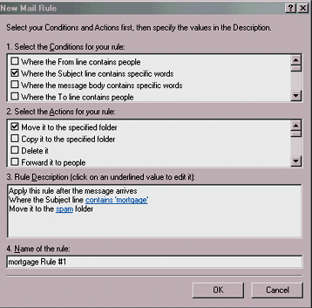
A mail folder is like a file folder for correspondence.

Use mail folders to organize your e-mail.

For example, you can organize your e-mail into Personal, School, and Work folders.

E-mail filtering and routing allows your email client to automatically sort your mail into folders.

With filtering the mailer recognizes specific messages by keywords.

Some people use filtering to try and minimize the spam that they see in their inbox.

Not all mailers support filtering though.

With routing, the mailer directs mail to a specific folder or subdirectory.

Filtering and routing are often combined to help people manages large amounts of e-mail.

Users create filtering rules in their e-mail client to route their mail to specific folders.

Automatic e-mail filtering can help you deal with a barrage of e-mail.
Web-Based E-Mail Accounts

Every major portal on the web offers free web-based email.

Yahoo

Hotmail

The free service is subsidized by banner ads.

Some allow you to combine e-mail from other accounts.

You read web-based e-mail with a web browser.

