Learning Objectives

Learn how to combine basic HTML elements to create Web pages.

Understand how to use HTML tags and tag attributes to control a Web page’s appearance.

Learn how to add absolute URLs, relative URLs, and named anchors to your Web pages.

Find out how to use tables and frames as navigational aids on a Web site.

Get the answers to all you questions about copyright law and the Web.
Taking Charge

Anyone with access to the Internet can post a Web page.

You can create a Web page with just a text editor.

There are Web page construction tools available that allow you to create pages without understanding the underlying machinery.
Web Pages and HTML

Web browsers are designed to display any ASCII text file with the file name extension .htm or .html .

You can view your Web pages locally on your computer as you develop them.

Web browsers rework each Web page in an effort to display it in the best way possible.

Web page authors can control how much the browser can dynamically adjust the pages.

Hypertext Markup Language or HTML is a markup language that gives Web page authors control over what a Web browser can and can’t do when it displays a Web page.

A markup language is not a programming language.

A markup language is a way to insert enhancements into a text file so a browser can render it as specially formatted text, text with special effects or with graphics

Web page authors communicate formatting commands to Web browsers by inserting HTML elements in the Web page.

HTML elements give authors control over text formatting and graphical elements.

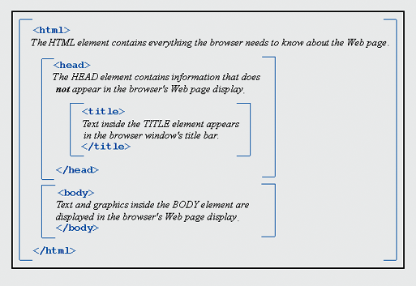
Tables and frames are devices for controlling the layout of a Web page.

Web authors must balance what they want with what their visitors’ web browsers can handle.

All Web pages should contain four basic elements:

HTML

HEAD

TITLE

BODY

You can add HTML elements to a Web page with any text editor. Examples:

Notepad (Windows)

Simpletext (Macintosh)

Using a text editor instead of a Web page construction tool gives you maximum control over your web pages.

Web page construction tools include:

Microsoft FrontPage (Windows)

Macromedia Dreamweaver (Macintosh & Windows)

Use of MS Word is not recommended

Knowledge of HTML is still useful even when using construction tools

HTML tags tell a Web browser how to render a Web page.

HTML tags are used to divide a Web page into segments with different kinds of information.

You can nest HTML tag pairs inside other tag pairs to produce a hierarchical structure for each Web page.

Most HTML tags come in pairs, such as <TITLE> </TITLE>

Basic Web Page Formatting

The HTML tag pair is used to mark the beginning and the end of the page

While your page will still display without this tag pair, you may need to use it to differentiate your HTML page from another type someday

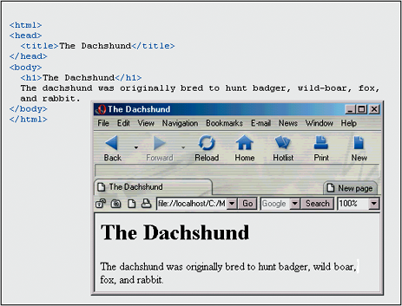
The HEAD tag pair contains information that is used behind the scenes but is not displayed in your Web page

The TITLE tag pair is needed to associate a title with your Web page

The title is displayed in the title bar of the browser window

The title bar is not part of the page

The TITLE tag pair is inside of the HEAD tag pair

The BODY tag pair is where the content of the Web page is presented

In many pages, the first visible element is the heading

The heading element allows you to add a title to the Web page body.

Do not confuse the heading element with the HEAD element

The heading element comes in six sizes.

<H1> </H1> : very large through

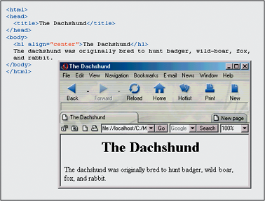
<H6> </H6> : very small

An HTML attribute is a property of an HTML element that allows for fine tuning.

The paragraph tag <p></p> pair breaks text up into blocks separated by blank lines.

The line break tag <br> is an example of a tag that does not come in a pair.

There are two kind of lists found in Web pages.

An ordered <ol></ol> list is an enumerated list.

An unordered list <ul></ul> is bulleted list.

Each list item must be in <li></li> tags

Font assignment is difficult because different computers have different fonts available on them.

You can specify a list of font choices in the face attribute of the font element.

Safest choices:

<font face=“Arial, Geneva, Helvetica”>

<font face=“Times New Roman, Times”>

<font face=“Courier New, Courier”>

Avoid designing a page that depends on specific type properties since the user may override them in their browser preferences.

Other useful tags:

<b>Bold</b>

<i>Italic</i>

<font size=“+2” color=“red”>

<!-- This is a comment -->

Nesting tags

This is correct nesting:

<b><i>Bold and Italic</i></b>

This is wrong:

<b><i>Bold and Italic</b></i>

Usually such errors are forgiven by some browsers but not by others, so the more mistakes you make the more viewers see your page distorted

Basic Web Page Graphics

JPEG and GIF are the most common graphics formats on the Web.

JPEG is better suited for high-resolution photographs and complex graphics.

GIF is better suited for line drawings and simple graphics.

The IMG HTML element creates an inline image: <img src=“button.jpg”>

An inline image is an image that is treated like a single alphanumeric character.

