Basic Web Page Graphics

JPEG and GIF are the most common graphics formats on the Web.

JPEG is better suited for high-resolution photographs and complex graphics.

JPEG stands for Joint Photographic Experts Group

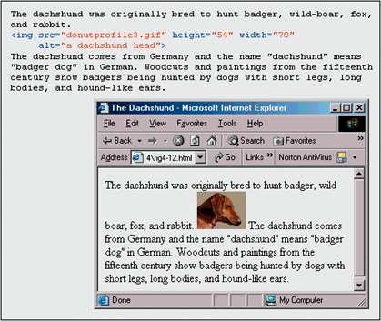
Allows you to use all 16.7 million colors

Amount of compression can be varied, but it is lossy compression – image details are lost

GIF is better suited for line drawings and simple graphics.

GIF stands for Graphics Interchange Format

No loss of quality, and there is no way to control the degree of compression

Limited to 256 colors

The IMG HTML element creates an inline image: <img src=“button.jpg”>

An inline image is an image that is treated like a single alphanumeric character.


Use the ALT attribute in the IMG tag to describe graphic elements for users who cannot see graphics.

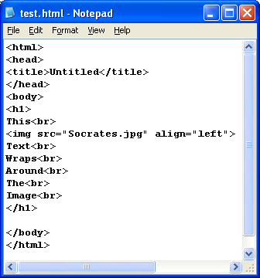
The align attribute controls the vertical alignment of the graphic: <img src=“x.jpg” align=“left”>

Text will wrap around a left- or right-aligned image

<br clear=“all”> will go to the next line below the image

There is an error on page 182 in the book: there is no </img> tag in HTML

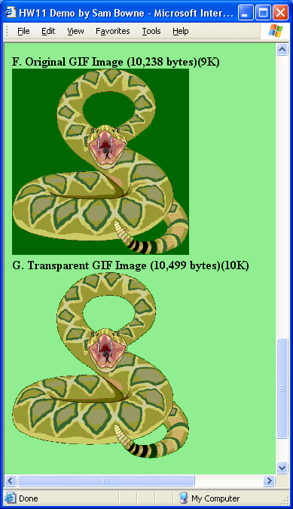
Adding the Height and Width attributes to the IMG tag will make graphics display faster on your Web page.

The Height and Width tags can also be used to scale an image.

A transparent GIF looks as if it were drawn on the background of the Web page.

Colors

There are 16,777,216 =2563 possible colors that can be used on Web pages.

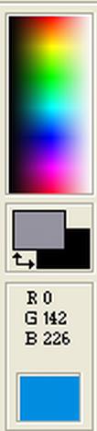
Red brightness from 0 to 255

Green brightness from 0 to 255

Blue brightness from 0 to 255

Web-safe colors are 216=63 colors that can be faithfully reproduced on any computer monitor regardless of the operating system used.

Red = 0, 51, 102, 153, 204, or 255

Green = 0, 51, 102, 153, 204, or 255

Blue = 0, 51, 102, 153, 204, or 255
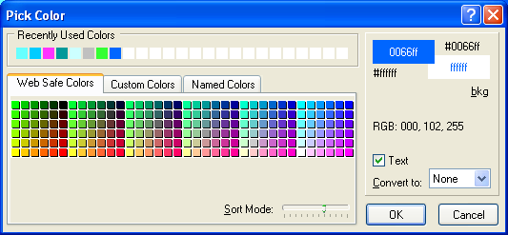

Web pages use hexadecimal (base 16) codes to describe colors.

Black = #000000

White = #FFFFFF

Red = #FF0000

Green = #00FF00

Blue = #0000FF

The bgcolor attribute of the Body tag sets the background color of the Web page.

A color palette is a collection of colors.

8-bit and 24-bit color describe the size of the affiliated color palette.

An 8 bit palette contains 256 colors

A 24 bit palette contains 16,777,216 colors

JPEG images use 24-bit color (True Color)

GIF images use 8-bit color

Background Images

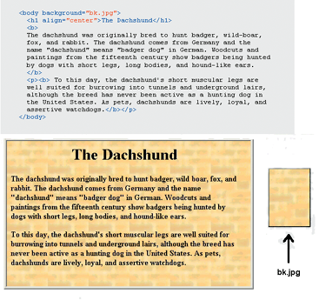
You can use any JPEG or GIF file as a background for a Web page.

The browser will place the image in the upper-left corner and will tile it left to right.

For example,

<BODY background=“texture.jpg”>

The background attribute is used only in the tag

Different utilities exist for processing images for different purposes.

An image viewer displays graphics files quickly and easily (like Irfanview)

Graphics editors are used to manipulate graphics files such as photos or drawings (like Paint, Photoshop, or Paint Shop Pro)

Color samplers can find the hexadecimal code of a color in a picture.

Screen shot utilities allow you to take a picture of a window on your computer.
Three Types of Hyperlinks

Absolute URL:

links to a Web page on a different Web server.

<a href=“http://www.treehouse.com”> The Treehouse </a>

Relative URL:

links to a Web page on the same Web server

<a href=“photoalbum.html”> My Photo Album </a>

These URLs make your page portable

Named Anchor: links to a different location on the same Web page.

In the Web page, you need to mark the destination location in the page

The link that takes you to another location uses the # in the anchor tag for the link

For example: <a href=“#tree”> some tall trees </a>

Mark the destination location with the NAME attribute in the Anchor tag

For example: <a name=“tree”> Trees </a>

