Page Layouts with Tables

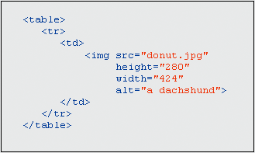
Tables can be used to control the layout of the graphical elements of a Web page.

Tables contain rows and columns.

The intersection of a row and a column is sometimes called a cell.

HTML tags are used to designate:

the table

its rows

each cell within a row

You can put anything inside of a table’s data elements, even another table.

The border attribute of a table can be used to create borders on your Web page.

Tables can be used to give Web pages a margin.

Each cell can have it’s own background color or pattern.

The colspan attribute is used to extend a cell across multiple columns.

The rowspan attribute is used to extend a cell across multiple rows.

Table Examples
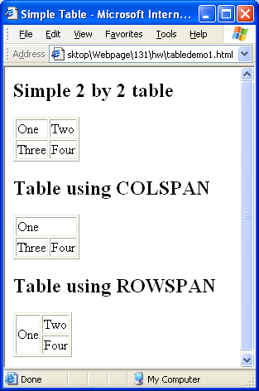
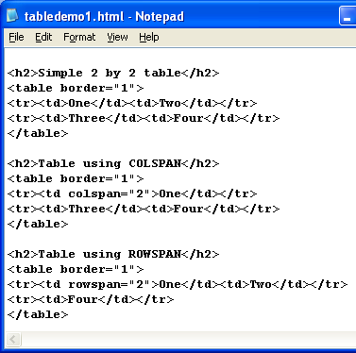

Navigation Maps with Frames

A frame allows you to partition a Web page into multiple segments so that you can display a different HTML file within each segment.

A FRAMESET document refers to the Web pages that will appear in the frames

FRAMESET instead of BODY

FRAMESET tag has attributes ROWS and COLS
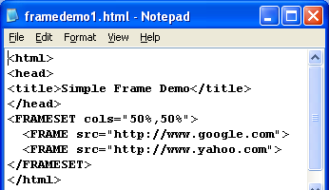
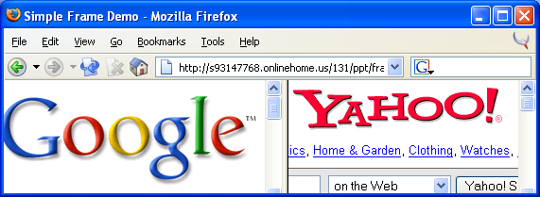

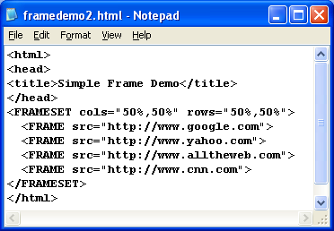
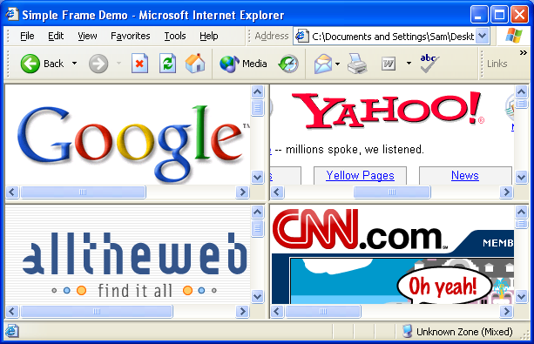

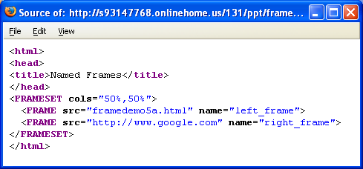
Targeted Links

You can specify what frame a target should open up in, if you name your frames

These frames are named left_frame and right_frame

You can use the same navigational aids on all pages using frames.

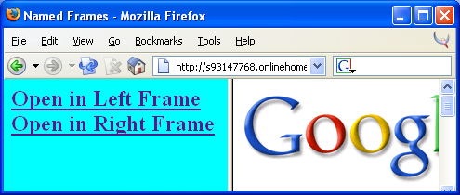
These links will now open in specified frames

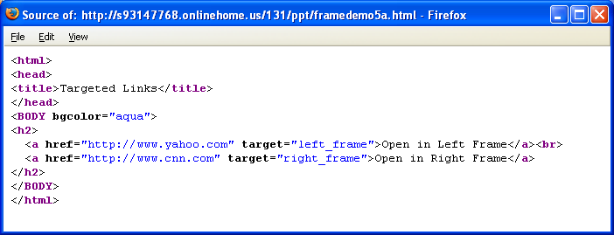

You can use the same navigational aids on all pages using frames.

Think twice about using frames, some browsers don’t support links and some people don’t like frames even if their browsers support them.

Consider having a non-frames version of your site for your visitors who don’t like or can’t view frames.

A Web Site Construction Checklist

Remember the three C’s of Web page design:

quality Content

reader Convenience

artistic Composition.

Write, view and test all Web pages before installing them on a Web server.

Keep Web page titles short but accurate.

Keep download times short.

Make your pages portable.

If you make your Web pages too sophisticated, people with older browsers will not be able to view them.

Installing Web Pages on a Web Server

Installing a Web page on a server is sometimes called publishing a Web page.

Acquire access to a Web server.

Determine the DNS address of your Web server.

Determine the pathname needed when you upload files to the server.

Upload your Web files to the Web server.

Determine the URL to use to view your home page.

Fix any file protection codes that need fixing.

You can upload files with an FTP client or an HTML construction kit that has an upload function.

You can also use Web sites with FTP functions like Yahoo Geocities

Copyright Law and the Web

Copyright laws protect the creative and economic interests or writers, musicians, and artists.

A copyright confers certain rights and privileges to its owner.

Copyrights are normally granted to the author of a written work or to an artist, musician, or other person who creates some intellectual product.

Do not violate copyright laws when you add materials to your website.

What is protected?

Personal use of online materials.

Fair use guidelines.

