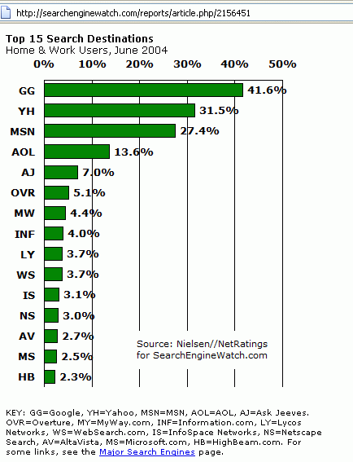
Learning Objectives

Find out how to analyze your information needs in order to select appropriate tools for the job

Learn how to search subject trees and clearinghouses for useful information and resources

Discover how to use successive query refinement when you visit general search engine

Explain how and when to select a new query mode

Find out about advanced search features and specialized search engines

Find out how to assess the credibility of information of the Web

Search Engine Watch

Link Ch 6a
Taking Charge

Search engines and meta search engines have become powerful

People can use search engines without knowing much about using them or how they work

Search engines are designed to be easy to use, but you still need a strategy when looking for information

Finding information quickly is important

Analyzing your information will allow you to select the right resources

Selecting appropriate search queries will allow you to begin the process of find exactly the information that you are looking for

When you begin the search process, you should decide which type of question you need answered:

Voyager question: an open-ended exploratory question

What was life like in Medieval Europe?

Deep thought question: a more focused open-ended question with a specific goal that may have multiple answers

What caused the Great Depression?

Joe Friday question: a very specific question that has a simple answer

What is the population of Canada?

Voyager and Deep Thought questions require input from multiple documents

Browsing is part of the exploratory process

Joe Friday require facts, which will likely come from one document

The next step is to select the type(s) of Web resources needed to help you find your answers

Subject tree

Clearinghouse

General search engine

Specialized search engine

You may need to ask more questions

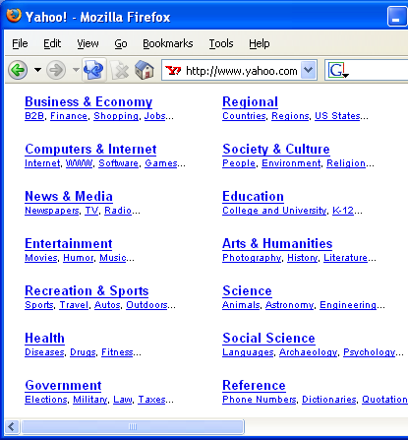
Subject Trees

A Subject tree is

A hierarchy that is organized by topics

Each topic has an associated list of Web sites and online documents

You navigate through the hierarchy to find information

Also called directories

Since subject trees have a specific organization to maintain, each new document is added by people

The content is checked

The appropriateness of the document insertion is checked

This does not guarantee the quality of information

Organizational problems can still occur

The structure is not always intuitive

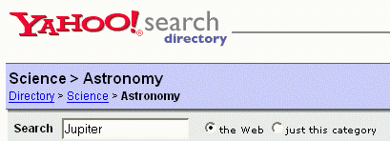
Some subject trees also have a search engine to help you search the site

Can sometimes search within categories

The URLs that you see listed in a subject tree are not for pages located on that site; they will be on another site

When trying to answer an Deep Thought question using a subject tree:

Look for relevant topics that relate to the question

Think of keywords to help you during browsing or using the search engine

Keyword creation may require associative thinking

Also, try considering the larger context in which the original question was posed

Example Subject Tree Search

Yahoo, Astronomy – note Categories (@ are cross-listings) and Sites

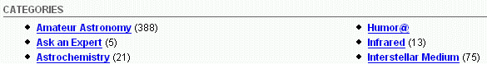
Famous Subject Trees

Yahoo.com

About.com – expert guides

Dmoz.com
Clearinghouses

A Clearinghouse is a collection of Web pages and online documents about a topic; may contain a hierarchy too

Example: infosyssec.com

LOTS of interesting security info

Internet Public Library has an index of clearinghouses

Ipl.org

Try Computers, Internet for interesting sites

General Search Engines

A general search engine is a search engine that indexes a large collection of Web pages via keywords

Before using a general search engine, you will want to keep some points in mind

Know your search engine, as the structure of the query can vary

Never look beyond the first 20 to 30 hits for any given query

Experiment with different keywords in different queries

Don’t expect the first query you try to be your last

For a Joe Friday question, the search engine Ask.com is a good place to start

Type in your question in the form of a question (Who invented the television?)

Ask.com returns a list of Web results and related searches

I don’t see the list of questions your book discusses any more

Now Ask.com has a picture search

If you can’t find what you are looking for using one search engine,

You may need to try another one

You can also try a different query
Meta Search Engines

A Meta Search Engine allows you to access multiple search engines

Saves you time

You use it to send a query to multiple search engines; best with simple queries

Ixquick.com worked well

Infonetware.com did not work when I tried it
Tools of the Trade

Don’t expect to find the best hits on your first try

Each new search problem will give you an opportunity to refine your queries until you find what you are looking for

Query refinement may consist of

Narrowing if you get too many hits

Broadening if you get only a few good enough hits

Redirecting if nothing useful comes up

Several search tools can assist you with query refinement

Exact phrase matching allows you to enter a phrase that is treated as a single keyword

Documents that contain this phrase are ranked higher than if the words were in separated

For example: “chocolate cream pie”

Used for narrowing or redirecting a search; and for proper names

Title Search searches for a keyword in the Title

Intitle:zebra in Google

Wildcard Matching is useful for retrieving variations of a word

For example, art* will search for art, artwork, artist, artistry, and so forth

An excellent way to broaden a search

Different wildcard characters are used by different search engines

The most common characters are: *, #, and ?

If you are looking for something specific, then a Boolean query is useful

A Boolean query consists of keywords combined with the Boolean operators AND, OR, NOT

X AND Y returns pages with both X and Y

X OR Y returns pages with X, Y or both

X AND NOT Y returns pages with X that do not contain Y

Boolean queries are flexible enough to handle all three types of query refinement

Boolean queries correspond to formal logic

Some search engines have a special Boolean search mode, such as AltaVista

Search engines are not forgiving if you make a mistake in your query

AND is used for narrowing a query

If you know that your target documents will contain a group of keywords, list them using the AND operator

You can combine exact phrases with the operators too

OR is used for broadening a query

If you can think of related words for a topic, list them using the OR operator

NOT is used to redirect a query

If you find that a keyword or phrase is leading irrelevant hits, then represent it in your query as AND NOT keyword

For example, cookies AND NOT JavaScript

You can combine keywords and operators to create complex queries

Use parenthesis () for grouping

For example, X AND (Y OR Z)

Example of Boolean Queries

Using Altavista.com

France OR Exports gives 132,000,000 hits

France AND Exports gives 952,000 hits

France AND Export*: 2,650,000 hits

France AND NOT Exports: 129,000,000 hits

Exports AND NOT France: 5,130,000 hits

Tools of the Trade

You can use required and prohibited keywords to filter documents with certain words

+ means that the word is required

For example, +apples

- means that the word is prohibited

For example, -apples

Useful during query refinement

You can combine this with phrases too
Specialized Search Engines

Many exist for a variety of topics

A search engine even exists to search for these search engines

profusion.com

Start with a keyword that describes the topic that you are looking for

Specialized search engines are great for Deep Thought questions

Assessing Credibility on the Web

You need to be have a critical eye when examining the Web for legitimate research

The Web contains both good and bad information

Focus on the information rather than the page’s appearance

Many factors should influence your decision to use information found online

Author credibility

Information is useless if the author is not identified

The author’s contact information should also be available

Try to verify that the author is who he/she claims to be

Find out if the author is qualified to write on that topic

Accurate writing and documentation

Sloppy writing can mean that the content is of poor quality

Check out any references to other work

No references may be a red flag

Objectivity

If the author is associated with a company, separate the content from advertising

Take sources of funding into consideration

Stability of Web pages

Information comes and goes

Does the page have a date?

When was the page last revised?

The life of the average page is 75 days

Fraudulent Web pages

It is easy to create a Web page in someone else’s name

Some of these pages are parodies, but others may be malicious

