Learning Objectives

Learn how to find and participate in mailing lists.

See how message boards can be valuable as well as recreational.

Discover how easy it is to start your own Web-based discussion group.

Discover Usenet and Usenet gateways on the Web.

Learn how to search Usenet archives.

Find out how to use a news reader to monitor your favorite newsgroups.

Learn about chat rooms and instant messaging.

Explore the psychology of chat rooms.
Taking Charge

Human beings are highly social and are drawn to communicating media.

E-mail is the most widely used application.

However e-mail is only one of several venues for communication online.

Other applications include:

Real-time chat

Instant messaging

Video cams

Some universities use web casts

UC Berkeley Web Casts at http://webcast.berkeley.edu/courses/ Link Ch 7a

I had to open my firewall to see them

Corporations use video conferencing

This chapter focuses on the virtual community

Like real communities, virtual ones:

Establish social norms

Maintain social records

Organize important resources

Contain people with mutual goals

A virtual community is a group of people who maintain ongoing group communications online

Privacy is an issue in online communities

Some groups’ logs are archived to Web pages

Law enforcement can gather group correspondence from the hosting ISP

Carnivore is an FBI software package that collects data from ISPs about “suspected criminals”

See links Ch 7b, 7c

Some groups are private, but none can guarantee complete privacy

If you are concerned about privacy, you can use an anonymous remailer

An anonymous remailer is an e-mail account that safeguards your real identity

Some are operated outside the US

It is like a Swiss bank account for online communications

Some anonymous remailers are free; other are not

See links Ch 7d, Ch 7e, Ch 7f

E-mail Headers

Here is the header from Yahoo mail – it shows the source of the mail
Message-ID: <20041020214835.51283.qmail@web53606.mail.yahoo.com>
Received: from [64.121.0.246] by web53606.mail.yahoo.com via HTTP;

In pine, press H to see this header

The header from Flashmail conceals the sender’s address (see link Ch 7f)

Taking Charge

Having a general understanding of the visibility of your communications is important

You never know who may use your communications

Corporate data collection operations

You boss (or prospective boss)

Your significant other

You have control over your level of risk
Mailing Lists

A mailing list is a forum where people use e-mail messages to share information with each other

A mailing list generally has a particular subject area that is discussed

Mailing lists vary in size in terms of the number of subscribers

Some mailing lists are private while others are open for anyone to join

Communication is generally in plain text

Mailing lists are moderated or unmoderated

Moderated lists:

The list owner posts messages

Subscribers can send the list owner a message

The list owner reserves the right not to post a message

Many lists don’t accept subscriber posts at all, like Internet Tourbus

Unmoderated lists (interactive list):

Anyone can post a message at any time

Subscribers can interact with each other over the list

A good forum for meeting people with similar interests

Most mailing list subscribers lurk, where they read posts but do not submit their own

List owners tend to be sensitive to the privacy of the list subscribers

Many lists explain the privacy policy on the list welcome message

Assuming the list owner takes precautions, mailing lists are low risk

Joining a mailing list = subscription

Subscribing to a list requires you to send an email to automated list server software

Mailing lists have two delivery options

Regular list subscription: each list posting is sent to you as a separate e-mail

Digest subscription: a number of postings are collected and e-mailed to you as one e-mail message

Having a digest subscription for an active list means that your inbox will not be flooded with dozens of list messages

When working with a mailing list, you need to be aware of 2 e-mail addresses

List command address: used to interact with the list server software (e.g. subscribe and unsubscribe)

List distribution address: used to post a message to everyone on the list

To subscribe to a list, send this e-mail to the list command address

subscribe name_of_list your_first_name your_last_name

You will get an email that acknowledges your membership in the list

You will also get instructions for the list

To unsubscribe from a list

unsubscribe name_of_list

Send this command to the list command address

Many lists now use a Web page to handle subscriptions instead of e-mail, like Internet Tourbus

When participating in a mailing list, observe proper netiquette

Each list has a culture, that you will need to observe the norms of

Lurk for a while so that you can get a feel for the list’s social norms

The discussion is a collection of threads

Each thread is an ongoing discussion between 2 or more people on a topic

Netiquette guidelines regarding the posting of a message include:

Keep the message short

Be sure that your topic is relevant to the list

Send personal messages to individuals, not to the list

Clearly separate facts from opinions

Try to avoid insulting anyone

Netiquette guidelines regarding the posting of a message include:

Include your full name in your signature

Include your full e-mail address in your signature

disguise it, like sbowneNOSPAM@ccsf.edu

Do not include e-mail attachments

Do not use an autoreply if you’re active on any mailing lists

Netspeak is often used in messages to convey common aspects of communication

LOL: Laugh Out Loud

ROFL: Rolling on the Floor Laughing

Some of these abbreviations are used to soften potentially offending content

Examples include:

FWIW: For What it’s Worth

IMHO: In My Humble Opinion
Web-based Discussion Groups

A Web-based Discussion Group is a message board or a Web-based mailing list

A message board (or forum) is a Web site where people can read, post, or reply to messages and track discussion threads

Some message boards allow anyone to post messages

Examples include: product review forums and topical discussion boards

The owner starts the topic & ground rules

Some Web portal sites have such groups

Many message boards are related to the content of the Web site that it is on

For example, a company promotes a new product

A message board may exist for the owners to talk to one another

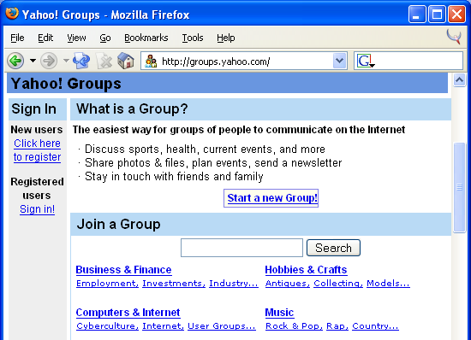
A message board can allow owners to discuss problems with the product

Here are some good discussion groups

Epinions.com for product reviews

Macfixit.com for Macintosh problems

Windows XP users can find help with Start, Help and Support, Windows XP Newsgroups

A Web-based Mailing list is a mailing list that has a Web-based interface

groups.yahoo.com

When you subscribe to a Web-based mailing list, you can set delivery options

Messages can be e-mailed to you

Messages can be viewed over the Web

You can set privacy controls too

Most groups are open to the public

You can start your own groups

Yahoo Groups

Topica.com

PAML.net

Before you start your own list, subscribe to some lists on different services to see which you like best

Be careful when you are looking for information in a message board

People may misrepresent themselves or their institution online

People may post misinformation

Always verify information

Be especially careful when getting technical, medical and legal advice
Usenet Newsgroups

Usenet newsgroups are the oldest collection of message boards on the Internet

The groups are public, and are separated into a variety of topics

The newsgroups are organized in a large hierarchy, utilizing the Network News Transport Protocol

A message posted to a newsgroup is called an article

Similar to an e-mail message, each article contains a header

To read and post articles, you could use a news reader

Many browsers contain a news reader

However, Google Groups is easier for most people to use than a newsreader

The newsgroups are organized in a hierarchy

Names are read from left to right

From the broadcast name to the successive subcategories

The top-level categories include;

Biz: business

Comp: computers

Soc: social issues

Rec: hobbies and recreational

Newsgroup names can be self-explanatory

Alt.adoption.searching

Misc.forsale.computers.mac

Others provide answers about the Internet

Alt.newbie

News.groups.questions

Usenet newsgroups are constantly being added (and some are removed)

Creating a newsgroup can be difficult

Most new groups require submission of a public Request for Discussion (RFD) and a Call for Votes (CFV)

Following a process, votes are collected via email

If it passes, then a waiting period ensues before the group is actually created

The process can take months

Alt newsgroups do not follow these rules

Netiquette rules apply to newsgroups too

Newsgroups tend to have their own norms as well

Posting on newsgroups are highly visible and public

You want to take special care to post your message to the newsgroup that pertains to that topic

Some groups have FAQs that can answer Frequently Asked Questions

Usenet articles are continuously cycled through each news server

The old articles are deleted to make room for new articles

Some newsgroups are omitted from the server due to space constraints or policies

Reading Usenet with a News Reader

You can use Google Groups for occasional newsgroup interaction

News readers allow you to read and post articles

They also organize your news groups and the threads within them

You use your news reader to subscribe to the news groups that you want to use

News readers have different interfaces

News readers show different Usenet levels

The Group Selection level shows the list of available newsgroups

The Article Selection level shows the list of available article headers

The Article level shows the contents of a specific article that you selected

A threaded news reader displays the replies to an article in a list

You can post a message to the newsgroup or email the article’s author solely

You can subscribe and unsubscribe to newsgroups at any time

Your article posting can include your signature file

Cross-posting allows you to post an article to more than one newsgroup at a time

You can automatically remove articles posted by a specific person by using a kill file

Like mailing lists, you can lurk for a while before you contribute in order to get a feel for the culture and norms
Locating Mailing Lists and Newsgroups

To locate mailing lists, visit searchable directories and clearinghouses

Locating Usenet groups are easier since they are all in one place - you just need to find the address for a news server

You can search for Mailing Lists at Yahoo Groups

Notice the number of members

If there are only a few members, it may be a boring list

You can search for Newsgroups at Google Groups
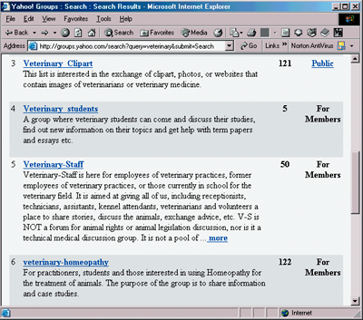
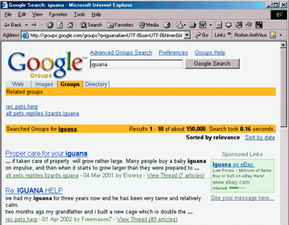

Internet Relay Chat, Web-based Chat and Instant Messaging

Communication in real-time is also possible on the Internet

Internet Relay Chat (IRC)

Predates the web

Relies on IRC servers

Users connect to the server with an IRC client and tune into available channels

Different IRC channels cover different topics

Web-based Chat

Requires a JavaScript-enabled browser

The chat rooms may discuss a particular topic

Some chats are even scheduled

Some people have chat rooms on their web pages

Some companies offer customer support through chat rooms

Instant Messaging

Is a hybrid between IRC and Web-based chat

Requires a client to participate

You can find chats that are ongoing or start your own chat (even a private one)

Can even share files

If you want to chat with someone, then you both must be on the same network (ICQ or AOL’s Instant Messenger)

Be careful about revealing personal information

You can also get a virus by receiving an infected file
The Psychology of Chat Rooms

People can behave differently online than in real life

It is easy for someone to pretend to be someone else as well

Anonymity contributes to the change in people’s behavior online

In some aspects the Internet keeps people from being themselves

In some aspects the Internet can bring people together

