Learning Objectives

Know what to expect when you download software from the Internet.

Understand how your antivirus software is configured and how to ensure that it scans all new files.

Become familiar with five different software installation scenarios.

Know which file utility to use when you need to open a file archive.

Find out how to locate reputable software on the Internet through clearinghouses.

Learn how to navigate FTP servers and download files from them.

Find out how to keep your computer in good working order as you add software to your system.

Learn the proper procedure for removing unwanted software from your system.

Discover where to find many software reviews.
Taking Charge

On the Net, you can find software recommendations, tutorials, discussion groups and software.

Some retail software can be purchased in stores and also purchased and downloaded over the Internet.

Some manufacturers offer demos of their software on their Web sites.

Shareware: Software that can be be installed and evaluated for some fixed trial period at no charge but that requires a registration fee when the trial period ends.

Nagware: Shareware that continues to launch after the free trial period is over, but with reminders that it’s time to register.

Freeware: Software that is distributed free of charge.

Open Source Software: Software whose code is willingly shared publicly so that other programmers can offer their own improvements.

Open Source software includes application software and even operating systems

Such as Open Office and Linux
Trouble-Free Downloads

Most software available on the Internet can be found on the Web.

Web browsers can download software.

FTP programs and download managers can help you download software too.

Only download software from trusted sources.

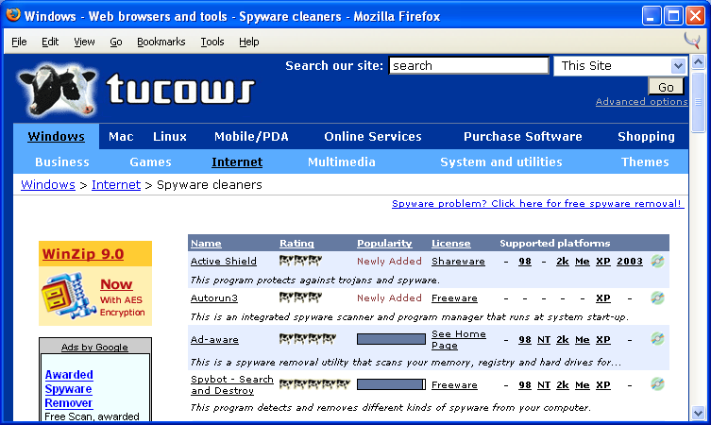
Never download software from someone’s personal Web site, an email, chat channel, chat room, or instant messaging session.

Tucows.com, Windows, Internet, Spyware cleaners

Make sure that you download the correct version for your OS.

While some software is available for both Windows and the Macintosh, you still need to download the right files for your computer’s operating system.

Most downloads are labeled to help you find the right version.

The file extensions are also a clue

Windows uses .exe and .zip

Mac uses .bin and /sit

When downloading with a browser, always choose to save the program to disk rather than run it from its current location.

Put all your downloads into a downloads folder so you can easily find them.

After downloading a file, and before double clicking it, scan it for viruses.

Some antivirus software will scan files automatically when you download them.

AntiVirus Protection

Virus: Potentially destructive code hidden inside a host program and distributed to a large number of computers.

Viruses are spread via executable files, documents that contain macros, and scripts read by script-enabled e-mail clients.

If you don’t have antivirus software, don’t download software from the Internet.

Check to see if your antivirus software must be run manually or if it runs automatically in the background.

Make sure that your antivirus software is set to scan all incoming files not just executables

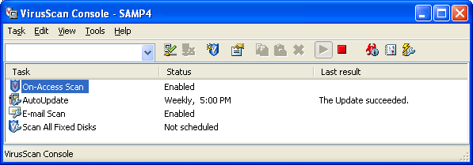
Some antivirus software can scan file archives so you don’t have to expand them to scan them.

Check to see how your antivirus software can be customized.

McAffee VirusScan

Right-click shield in the lower-right corner of the desktop, select VirusScan console
Installation Tips

An installer is a setup utility used whenever a computer program requires multiple files in order to operate.

An installer might include a file containing

executable code

data files and graphics

These are all files that the program may need.

The installer automatically places all the program’s files where they need to go.

Some installers require you to shut down all other running programs.

A few installers will ask you to turn off your antivirus software temporarily. Only do so if you trust the software.

Always read the software’s license agreement before accepting it.

Always read the program’s ReadMe file before installing to learn about bugs or incompatibilities.

The following installation scenarios are not platform-specific.

Ready-to-go executable: An entire computer program that:

can be stored in a single file

will not require a complicated installation process.

Ready-to-go executables do not require an installation program.

Check the program’s Web site for ReadMe files and documentation.

Zipped File Archive: A single file that can be unpacked (unzipped) to produce the multiple files it contains.

It is like a package that contains several files (and maybe even folders) that is compressed to save storage space.

Software files are often packed in a file archive for easy downloading.

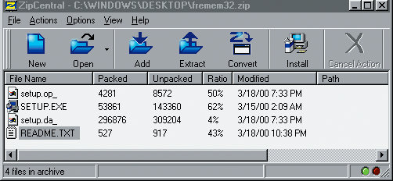
These archives require a utility to unpack them.

StuffIt Expander is popular on the Macintosh platform

WinZip is popular on the Windows platform

Windows XP contains a built-in utility to open Zip archives

A Zip Archive

Self-Extracting Archive: A file archive that unpacks itself when you double-click it.

They are similar to zipped archives.

You don’t need a special file utility to open a self-extracting archive.

They have a .exe extension under Windows and a .sea extension on the Macintosh.

A self-extracting archive unpacks its files:

into the current directory or

Creates a new subdirectory for the expanded archive

Documentation files may also be included in the expanded archive to help you work with the software further.

ActiveX installers only work with Internet Explorer on Windows.

ActiveX installations are fully automated.

Unlike JavaScript and Java, ActiveX controls have no restrictions on what they can do to your computer.

Be aware of the security risk.

Authenticode enables a developer to place a digital signature on ActiveX utilities.

ActiveX and Digital Signatures

Unfortunately, all a digital signature proves is that you know who the software came from

It does not mean they really told you exactly what it’s doing to your machine

See Link Ch 8a about a Microsoft Frontpage 98 backdoor

Link Ch 8b about “Comet Cursor” which a lot of sites try to put on your computer
Spyware and Adware

Spyware: Any software application that surreptitiously collects data about your computing activities and send it back to a data broker.

The information may be collected by a third party who will sell the information.

Adware: Any software application that displays advertisements.

There are utilities available to scan for and remove spyware from your computer.

Spyware Links

Spychecker.com (link Ch 8e)

Tells you if a common download is known to use spyware

Demo: Search for CoolWeb

Link Ch 8c: Spyware Removal Tools Compared

Link Ch 8d: Anti-Spyware Guide
File Download Utilities

If you expect to download a lot of software from the Internet there are utilities that will help you.

File archive utilities like WinZip (Windows) and StuffIt (Mac) will easily expand file archives.

Web browsers can handle file downloads in a basic way.

A download manager is a utility that specializes in managing file downloads and offers many features.
Software Clearinghouses

Many software clearinghouses index large collections of downloadable software in searchable subject trees.

Most include a brief description, software ratings, download counts and e-mail newsletters.

Software clearinghouses exist for many platforms (Windows, Mac, Linux, Palm, …)

Visit different clearinghouses to find the one you like.

Examples of some of the more popular sites include:

Tucows: www.tucows.com

Download: www.download.com

Shareware: www.shareware.com

Some sites have several platforms, while others specialize in just one

Some sites specialize in a particular type of software, such as games
FTP Software Archives

File Transfer Protocol (FTP): An Internet protocol that makes it possible to transfer files between two host machines.

FTP has been used since before the Web to share files on the Internet.

To reach an FTP server you can use your browser or an FTP client.

A mirror site is an alternate FTP site that contains the same files as the main FTP site.

If you aren’t sure sure where to go on an FTP server, look for files named index, welcome or readme.

Read everything available that could help you navigate the site.

If you get an error when trying to download a file, try again later.

Try to visit FTP servers at off hours.

If mirror sites are available, use the one closest to you.

Web browsers can be used to download files from Web and FTP servers.

Browsers can also upload files to FTP servers.

If you use FTP servers a lot, a graphical FTP utility will save a lot of time.

SSH uses Secure FTP, which protects your password

ftp://sol.ccsf.edu is CCSF’s public FTP site

Managing Your Software
Now that you are ready to download lots of software, you need to learn to manage it all

If your computer becomes unusually sluggish or unable to open new applications, try restarting it.

Restarting your computer can recover RAM and speed up processing.

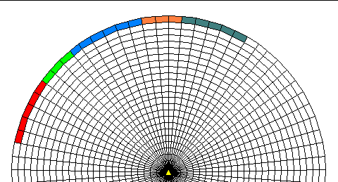
When programs start, they set aside RAM.

When they quit, they are supposed to release the RAM (they don’t always)

Defragmenting Disks for Better Performance

On a freshly formatted hard disk, files are stored in contiguous clusters (in order)


Reading and writing go faster with contiguous clusters

As you delete files and save new ones, the files get fragmented

Scattered over the hard disk into many noncontiguous pieces

Running a disk optimizer on your hard drive may improve performance by reducing file fragments.

Fragmented File: A file that does not occupy contiguous space on a hard drive.

Some books recommend defragmenting your hard drive once a month. (at least once a year is good)

A device driver creates a communication link between your computer and its peripheral devices so data can flow smoothly between the two.

You can solve or prevent driver conflicts by keeping your drivers up-to-date.

Drivers can be downloaded from the manufacturer’s Web site

Windows Update does it on PCs most of the time

Running too many programs with too little memory may cause your computer to be sluggish or crash.

An uninstaller is a utility designed to remove, safely and completely, all files associated with a program.

You can use maintenance programs to perform preventative maintenance on your computer.
Finding Good Software Reviews

You can use software reviews to help you choose a software package to buy.

Software reviews can be found on the Internet.

Some sites are general, while other specialize in specific operating systems.

There is always some element of risk.

Software obtained over the Internet is no riskier than shrink-wrapped software purchased at a retail store.

