Learning Objectives

Learn the difference between a plug-in, an add-on, and a helper application.

Find out how to locate and install browser accessories.

Learn how Web accelerators work and when they work best.

Discover how download managers can save you time.

Find out how password managers can help you stay secure online.

Decide whether you should try out a new browser (maybe one you’ve never heard of).

Learn how to configure a firewall to protect your computer from hackers.

Decide whether any of the productivity tools described in this chapter are right for you.
Taking Charge

Your computer probably came preinstalled with an OS and various software packages.

It is up to you to customize your computer for your needs.

As you become more familiar with your own computing needs, you’ll want to customize your computing environment.

As you install more software on your computer the more likely you are to encounter a software conflict.

Software conflicts occur when

Two programs both rely on a single shared resource

One program modifies the resource in some way that adversely affects the other program

To prevent problems, perform a system backup before installing software and assess the stability of your system afterwards.

A system backup copies only those resource files that are most likely to be modified during a software installation.

Consider getting a suite of system utilities that includes several useful tools.

These tools can help identify and fix many common problems that can occur.

Recommended Utility Suites

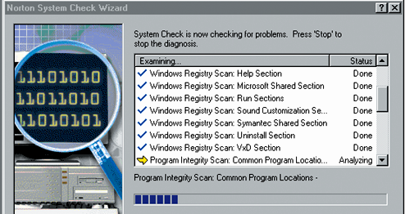
Windows

Norton SystemWorks

Ontrack SystemSuite

Mac

Norton Utilities

TechTool Pro

Get a free system checkup for PCs at pcpitstop.com

See link Ch 9a

For Macintosh tune-up

See link Ch 9b

Applications: Helpers, Plug-Ins, and Add-Ons

An application is a program you run on your computer to accomplish specific tasks.

You can obtain applications from retail software stores or the Internet.

A browser often uses other applications to view the Web.

You can customize what applications your browser uses.

A helper application is an application a browser can launch. It can be any application on your computer.

When your browser encounters a file that requires special handling, it looks for an appropriate helper application and opens the file in that application.

When browsers first were introduced, helper applications were the only option.

A browser plug-in is an application that expands the capabilities of a web browser.

When you install a plug-in, you extend the capabilities of your browser to handle a file type that it wasn’t originally designed to handle.

Any file requiring that plug-in will be displayed inside the browser window, with the plug-in working as if it were a part of your browser.

Plug-ins support everything from audio to animation to documents

Plug-ins increase you browser’s memory requirements and launch time.

You can find Web pages to help you locate plug-ins for your browser.

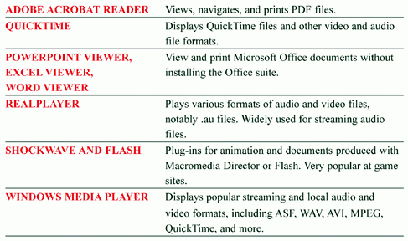
Common plug-ins and helper applications:

A browser add-on is

An application that works in conjunction with your Web browser

Used to enhance or complement your browser in some specific way.

Not clearly distinct from a plug-in

You download and install an add-on like any other program.

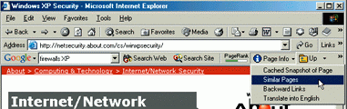
For example, Google has an add-on to aid Web searches

Browser add-ons and plug-ins can be browser specific. Make sure you download the one for your browser.

Download and install only the items that you need as

Each one requires some amount of RAM

Each one will add to the time it takes to launch your browser

Web Accelerators

A Web browser downloads Web pages from the Web on demand.

When you click a link or type in a URL, the browser retrieves the Web page.

If you revisit a Web page that you visited earlier, and it hasn’t changed since your last visit, then it is a waste of bandwidth to download the page again.

To avoid downloading the same files over and over, all browser have a memory cache for recent file downloads.

For users with a dial-up connect, speeding up the process of viewing pages is important.

A Web accelerator can’t do anything about the speed of your Internet connection, but it can speed up your browser’s page displays.

Web accelerator: Software that leverages the available bandwidth so you spend less time waiting for Web pages to download.

Some people see a dramatic speed-up when they use a Web accelerator.

Others see no real difference.

Results can vary depending on

The computer

The settings that you choose
Download Managers

If you download files, you may want to look into options other than your Web browser.

While Web browsers can download files, they can only do so successfully if there are:

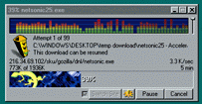
no interruptions

no lost Internet connections

no difficulties on the server side

A large download, and with several files, can take a while.

A download manager is software that facilitates file downloads from Web pages and FTP servers.

Download managers allow users to restart failed downloads

Download managers allow users to pause and restart downloads.

Some download mangers will also help you choose a faster site to download a file from.

Password Managers

If you visit many Web sites that require a password, you may find a password manager useful.

Passwords are important and you should do everything you can to keep them secure.

A password manager is a program that helps you keep track of unique userids and secure passwords for multiple Web sites.

A good password manager will encrypt your entries and require its own password on start-up.

The password that gives you access to all your other passwords is called a master password.

A nice feature in a password manager is a random password generator. This will create passwords for you.

The following screens show one example.

A more sophisticated version of a password manager is a form assistant.

A form assistant is a browser add-on that matches passwords to Web pages.

It can record frequently required information and fills in the information in forms for you.

Your book mentions Gator, which contains spyware (see link Ch 9c)

Internet Explorer can remember passwords and fill them in for you

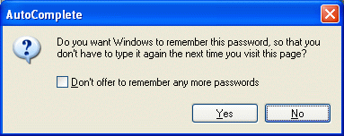
But it does not require a password, so anyone who gains access to your computer can get your passwords

To adjust Internet Explorer’s AutoComplete settings, click Tools, Internet Options, Content, AutoComplete
Alternative Web Browsers

Netscape Navigator and MSIE are not the only Web browsers available

But the others are not popular

93% of people use IE

6% use Firefox, Mozilla, or Netscape

1% use Safari and all others

See Link Ch 9d; these numbers as of 11-1-04

See Link Ch 9g for current browsers, including Avant

You can have more than one browser installed on your computer.

Only one browser can be your default browser.

Your OS will give you a way to select your default browser

See link Ch 9e

Opera, Lynx, and Avant are other Web browsers
Firewalls

A firewall is software that

Monitors all attempts to move packets over the Internet in either direction and

Blocks the or notifies you when it finds something suspicious

Note: Windows XP’s Service Pack 2 firewall does not scan outgoing traffic

Firewalls previously were only used by large organizations but now home users can install them on their computers.

They can prevent a Trojan horse from stealing your files or spyware from “phoning home.”

Both the Macintosh and PC have firewalls

Examples include:

Zone alarm

Symantec Internet Security

The software can be configured or used with default settings.

Read software reviews to help you choose what firewall to buy.

