Learning Objectives

Understand what you can do to protect yourself when you make purchases online.

Find out how to ensure that sensitive data is encrypted before you send it over the Net.

Learn how to check a digital certificate for an e-commerce business

Find out how to check a secure Web server to see how strong the encryption is.

Understand what it means for commercial sites to be self-regulating.

Learn about different kinds of online auctions.
Taking Charge

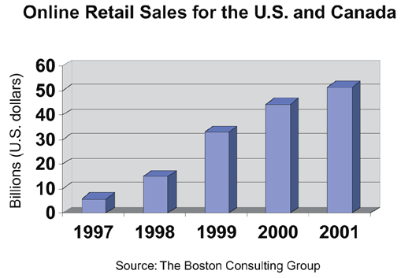
During the late 1990’s major e-commerce sites competed aggressively by trying to undercut each other’s prices.

Profit margins for online stores are low.

Brick-and-mortar stores that go online see their traditional profits eaten up by their new online storefronts.

Brick-and-Mortar Stores: Traditional retail stores. The name refers to the store as having a building as opposed to online stores.

Amazon.com did not turn a profit until 2001.

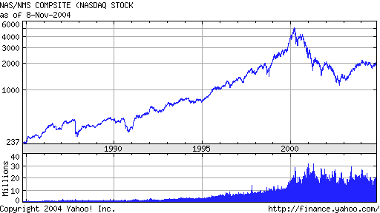
Few retailers are willing to sit on the sidelines without some sort of Web presence.

Online sales have soared since 1999 in spite of the dot-com crash.

During the dot-com crash many high-tech startups went under for lack of profits.

Link Ch10a

The web allows buyers to be more knowledgeable about products and pricing.

This knowledge gives them a new edge when dealing with retailers.

Online stores have lower prices but retail stores allow customers to see and touch the item and get it today.

Online stores have the advantage of larger inventories than retail stores.

Browsing online is not the same as browsing in a retail store.

The web allows consumers to find out about leading manufacturers, their product lines, and their relative merits.

Using an online supplier allows you to comparison shop, create lists of frequently ordered supplies, and keep your information online for quick checkout.

Brick-and-mortar stores will still be an option.

The Web offers additional options and information for consumers.
Online Shopping Risks and Safeguards

Shop with merchants whom you know and trust.

Look for and read each site’s delivery, return, and privacy policies.

Never enter and relay sensitive information on a page that does not have both a URL that begins with https:// and either a locked padlock or an unbroken key icon.

Make all online purchases with a credit card and not a debit card.

Be careful not to hit the ORDER NOW button more than once.

Never send credit card account information via e-mail.

Keep a record of your transactions, and save all online receipts until your shipment arrives with all the items you ordered in good condition.

Use a shopping bot to comparison shop for big-ticket items.

If you’re considering buying from an e-store you don’t know, there are sites that rate online stores based on feedback from customers.

There are also sites where consumers can leave their reviews of products.

Some sites give you onsite updates regarding your order.

Some shippers allow you to track your shipments online.

A Web server that is set up to protect sensitive data being sent over the Internet is assigned a digital certificate.

Digital Certificate: A document on a Web server that can be checked to verify the identity of the server.

A digital certificate makes it possible to keep sensitive information sent over the Internet safe from prying eyes.

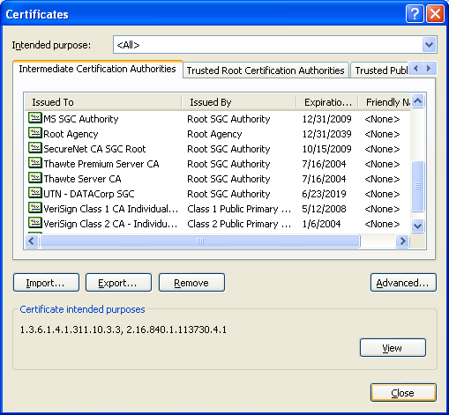
Your browser watches for a digital certificate whenever a Web server asks for a secure connection.

The browser needs the digital certificate in order to encrypt your personal data.

Unencrypted data sent over the Internet is in the clear.

Sensitive data should always be encrypted before it goes out over the Internet.

Your Web browser is prepared to accept a digital certificate issued by a recognized certificate authority.

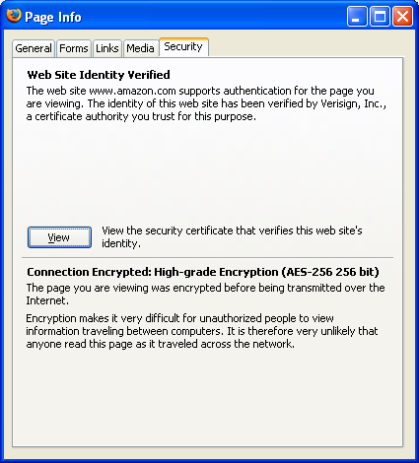
A certificate authority (CA) is an organization that can certify the identity of a certificate holder.

If the CA database in your browser is not up-to-date, it might not recognize an otherwise legitimate CA and reject certificates signed by them.

Tools, Internet Options, Content, Certificates shows the CA database in IE (see figure to the upper-right)

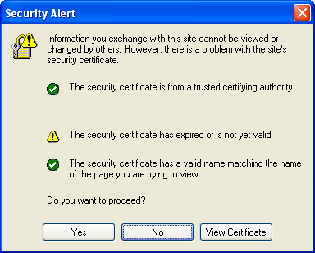
Your browser should be able to show you information about an e-store’s digital certificate (see middle right figure)

Before making a purchase, look at the e-store’s digital certificate information.

See if the domain for the current Web page’s URL matches the domain listed on the certificate.

Check that the CA listed on the certificate is one of the CAs in your browser’s CA database.

Verify that the certificate’s expiration date has not passed.

The browser does these checks automatically but it gives you added protection to check it manually.

Some sites are their own CA’s and won’t be in your browser’s database.

As a rule, avoid any site that doesn’t have its site certificate in order

If your computer’s calendar is set incorrectly, or the certificate has really expired, you’ll see this message (see lower right figure)

Secure Servers and Secure Web Pages

Secure Sockets Layer (SSL): A protocol used to establish secure (encrypted) communications between a Web browser and a Web server.

SSL has been instrumental in the growth of e-commerce on the Web and is an industry standard.

The installation of SSL on an e-commerce site eliminates a number of potential security problems.

Site spoofing is the deceptive art of setting up a counterfeit Web site that looks identical to some other legitimate Web site.

The counterfeit site may have a URL closely resembling the real site’s URL

If unwary consumers can be routed to the counterfeit site they could be tricked into giving their credit card information.

A common browser vulnerability can make the wrong URL appear in the address bar

See Links Ch 10b & Ch 10c to test your browser

Firefox is immune; so is a patched IE

McAffee stops it

Phishing uses an e-mail to trick people into visiting a spoofed site to get their passwords and other confidential data.

Take the Phishing IQ test at link Ch 10d

Unauthorized disclosure is the practice of sending data from a browser to a Web server in the clear (unencrypted).

This enables hackers to intercept the transmission and obtain sensitive information.

Unauthorized action is an intrusion associated with unauthorized access to and modification of the pages on a Web server in subtle and destructive or obvious and embarrassing ways.

Data alteration is the interception of data sent from a browser to a Web server in the clear (unencrypted) and the alteration of that data en route, either maliciously or accidentally.

All modern Web browsers support SSL.

A Web page URL that begins with the prefix https:// indicates that the Web server is prepared to offer a secure connection to your browser.

A closed padlock on your browser indicates that you have a secure connection.

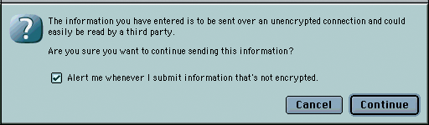
An open padlock means that the connection is not secure.

Your browser may also warn you if the connection is not secure.

A secure SSL connection guarantees:

Authentication

Message privacy, and

Message integrity

Authentication

Users can verify the actual owner of the Web site by checking the digital certificate

So you know who you are communicating with

Message Privacy

SSL encrypts all information moving between a Web server and a browser by using public key encryption and unique keys.

So you know no one else can read the messages you are sending and receiving

Message Integrity:

When a message is sent, the sending computer generates a signature code based on the message content

The signature code is sent with the message

The receiving computer generates its own signature code for the file just received.

If the message was not altered en route, these two codes agree.

If even a single character in the message was altered, an alert is issued about the legitimacy of the message.

The SSL protocol for secure Web-based communications can be used in combination with different encryption algorithms.

Algorithm

A set of instructions spelled out in sufficient detail so that a programmer can write a working computer program based on those instructions.

Some encryption algorithms are harder to break than others.

Encryption is measured in bit counts.

128-bit (strong encryption): This is the strongest level of encryption

(not really – see Link Ch 10e).

64-bit (medium level encryption): Not the best, but still quite secure.

56-bit (medium level encryption): Somewhat safe - but probably not for long.

40-bit (weak-encryption): No longer adequate for commercial purposes.

Firefox is More Secure

Internet Explorer uses 128-bit encryption

Firefox uses 256-bit encryption
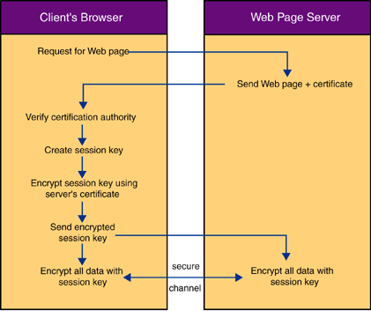

Commercial Sites and Self-Regulation

The world of e-commerce is advancing at a breakneck pace.

Security, privacy, and taxation raise many difficult questions.

The U.S. government has been very reluctant to intervene in the evolution of e-commerce.

Politicians believe that the public wants less interference from government and that businesses can regulate themselves.

The Federal Trade Commission (FTC) acknowledged in 1997 the concerns about the adequacy of self-regulation on the Internet.

Some companies are sensitive to public opinion and want to comply to emerging industry standards on a voluntary basis.

Privacy policies are an interesting case study of the effectiveness of self-regulation

Toysmart collected confidential data about children, then went bankrupt and tried to sell the list as an asset. The list was eventually destroyed – see link Ch 10f

AOL tried to sell its customer’s phone numbers to other companies, but stopped after public outcry – see link Ch 10g

More stories at links Ch 10h & Ch 10i
Online Auctions

Online auctions are an increasingly popular feature on the Internet.

eBay is a C2C auction

UBid maintains its own inventory – B2C

Craigslist is not an auction, but is C2C

Auction sites are a virtual flea market for used goods, found treasures and the occasionally bizarre item.

They also top the list or reported incidents of Internet fraud.
E-Commerce Categories

There are 3 types of e-commerce:

customer to customer (C2C)

business to customer (B2C)

business to business (B2B)

