Learning Objectives

Understand how private-key and public key encryption work.

Learn how digital signatures protect document integrity.

Understand why key authentication is needed to protect people from counterfeit keys.

See how the web-of-trust approach to key authentication works.

Find out how digital certificates and certificate authorities solve the problem of key authentication.

Understand the difference between strong and weak encryption.
Taking Charge

Cryptography is the study of secret codes associated with classified information and intelligence gathering.

The National Security Agency (NSA) is responsible for developing and applying secure communication technologies in the service of national security.

Cryptography used to be only of interest to the military.

As digital communication is more widespread, it is of interest to more of us.

Cryptography is of interest to:

Client/server software developers

Anyone interested in digital commerce

All Internet users who want to keep their communications private

Without safeguards, our sensitive information is at risk.

Cryptography offers protection.

When the Internet was started, secure communications were not a high priority.

The technologies that enabled the access to the Internet was never designed to protect data.

The military has always understood the need to secure data.

Large corporations followed suit by opting for intranet connectivity, rather than Internet access.

An intranet is an internal computer network that is carefully segregated from all external networks such as the Internet.

Internet access from an intranet is possible.

Such access is only available through a firewall.

The firewall keeps the sensitive data within the organization’s network.

Usually a proxy server is also used – see link Ch 11a)

We don’t all work for the military or a large organization, but we want privacy safeguards too.

This chapter will introduce the basic concepts for encryption.
Private-Key Encryption

Encoding and decoding information is key to encryption.

A key for a simple substitution code is just a map that tells you how to substitute one character for another.

When you receive a coded message, you trade each character for a new one according to the instructions on the key.

The Caesar cipher is a simple substitution cipher

A →B

B →C

C →D

D →E

etc.

Encoding is the process of creating the coded message.

Decoding is the process of unscrambling the coded message.

To encode a message, you must use the same key when decoding (though you have to reverse the key).

Private-key encryption is the use of the same key for encoding and decoding messages.

If you have the key for the code, it is easy to decode messages.

If you don’t have the key, then

You can try and break the code

Or try and figure out the key if you have several messages

To figure out such a key,

Try and find commonly used letters

The letter “e” is the most common

Try and decipher common words (e.g.“the”)

An effective code is one that only reaches the intended recipients.

Every effort should be made to confound code breakers.

A substitution code is the easiest to break (like the Caesar cipher)

Private-key encryption is risky since many people share the same key.

Each time the key is passed from person to person, it may be intercepted.

If the information that you are sharing is not critical, then you can evaluate the risk.
Public-Key Encryption

If your information is more important, then you may choose to use public-key encryption.

Public-key encryption uses 2 keys, which is more secure than private-key encryption.

If one of the keys is lost, the other key is useless by itself.

These 2 keys are generated as a special key pair that works together.

The 2 keys consist of:

A public key that can be freely distributed to anyone and everyone

A private key is held by only the owner of the key pair

Although both keys are needed, having the public key available does not make it possible to deduce the private key.

If you want to receive encrypted messages

You create a pair of keys

You can give copies of the public key to anyone (but you keep your private key)

The public keys are used to encode messages

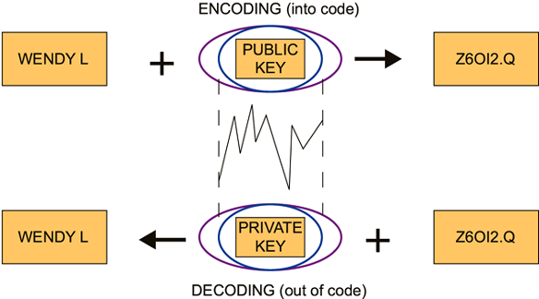
Your private key is used to decode messages

Only your private key can decode messages encoded by your public key.

If you want to send an encrypted message to someone else, another pair of keys is needed.

You can share encrypted messages with others, you all just need to share your public keys with one another.

A growing community of users uses PGP (Pretty Good Privacy) for secure e-mail communication.

Many mail clients can be configured to use a PGP plug-in for sending, receiving and PGP key management.

Public-key infrastructure (PKI) is the establishment and maintenance of a system of public-key servers.

All of the overhead involved in locating public keys and encoding outgoing e-mail can be handled by the PKI software running quietly behind the scenes.

Digital Signatures

Like signatures on paper, when a document is signed you know who wrote it or approved its contents.

Written signatures can be forged

Digital signatures need to be resistant to forgery.

Public-key encryption is used to make digital signatures forgery-resistant.

Digital signatures are important for e-commerce and other sensitive communication.

If you encrypt a signature with your private key, anyone can decrypt it with the public key and read it

Although anyone can read that signature, only you can create it because it requires your private key

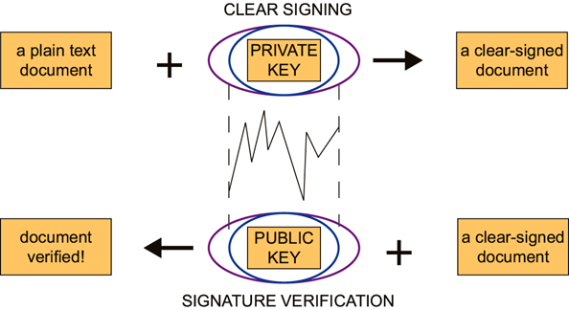
That is called a digital signature

A clear signature is a digital signature that is attached to a plain-text file.

A clear-signed document is a document signed with a clear signature.

The process of generating and verifying a digital signature is similar to the process of encrypting and decrypting a file.

Digital signatures change from document to document.

A digital signature contains information

about the person behind the signature

about the document being signed

So one digital signature cannot be copied from one document to another

PGP not only verifies the signature, but also that the contents of the message has not been altered.
Key Management

Public-key encryption makes it easier to keep a private key private.

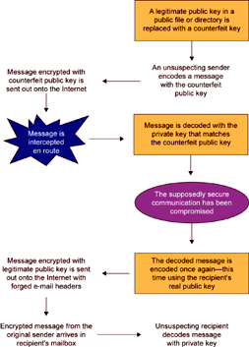
If you store a private key, you must be able to protect that key.

Protecting your private-key with a passphrase helps secure your key.

Whenever you create a key pair, you enter a passphrase.

Whenever you need to use your private-key to decode a message, you must enter your passphrase.

You need to choose a good passphrase in order for your signature to be well protected.

Although your passphrase is stored on your computer, it is protected by a hash code.

A hash code is an encoding algorithm that converts an input string into a numerical signature for that string.

Counterfeit Keys

A security hole remains where a hacker can generate a key pair under your name and intercept messages.

This is called the Man-in-the-Middle attack.

The interception of encrypted e-mail takes work.

Besides the technical skill involved, the willingness to break several laws is needed.
It can happen though.

Some organizations require reliable communication channels in order to minimize misinformation and disinformation.

Public-keys are subject to scrutiny.

You need to know who owns the keys that you use to encrypt information.

You need to trust that the information you receive is from the sender of the message.

A public-key is said to be a trusted key when you are certain that the key is not counterfeit.

The process of identifying a person as the legitimate owner of a public key is called key authentication.
Key Certification

A system of key certification is needed to help people decide how much risk is associated with any given pubic-key.

Key certification is the process through which someone can vouch for the legitimacy of a pubic key.

When a key is certified by a trusted friend, that person can add his or her digital signature to the public key being certified.

Then if the key is sent to you, you can verify the digital signature with confidence

The model for key certification based on friends (and their friends) is called the “Web of Trust”

Public keys are passed among friends, accumulating certification as they go.

This model works well in small worlds.

When communities become large, this model is not viable.

A digital fingerprint for a key pair is a unique sequence of integers associated with that key pair.

Digital fingerprints are generated when a key pair is created, based on random conditions

The fingerprint cannot be tampered with.

Fingerprint verification is an alternative to the Web of Trust, but it’s still not good for large communities (e.g. for e-commerce)

Digital Certificates

The problem of key authentication had to be solved before public-key encryption could be used for e-commerce.

Without a system for certifying valid public keys, counterfeit pages could masquerade as legitimate e-stores.

A digital certificate is a digital signature attached to a public key.

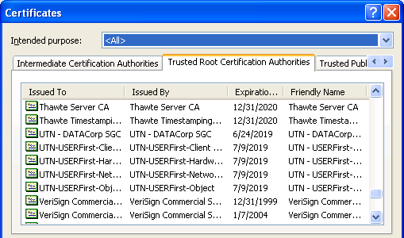
The purpose of the certificate is to reassure users that the public-key is the authentic key.

In the Certificate Authority (CA) model of key authentication, there are only a few trusted institutions that can generate digital certificates.

Any key generated by a trusted CA can be immediately trusted without question.

All the user has to do is decide which CAs can be trusted.

If you placed a credit card order online, your browser probably checked server certificates for you and you didn’t know it.

Your browser has a list of trusted CAs built into it.

Your browser will then accept any public-key certified by a recognized CA.

You can check the settings in your browser.

Digital Certificates
Strong and Weak Encryption

When people worry about whether they can trust encryption, they generally are concerned about how hard it is to crack.

The amount of time needed to crack a code is important.

40-bit keys can be broken by run-of-the-mill personal computers in minutes.

Any key that can stand up to thousands of years of computing time on the fastest computers is safe enough.

Strong encryption refers to encryption methods that are safe in this sense.

A code that can be broken in a practical time frame is called weak encryption.

Strong encryption steadily becomes weaker over time.

Taking Moore’s law into consideration

64-bit encryption will be weak by 2011

128-bit encryption will be weak by 2107

Last modified 11-30-04

