For each example below, write HTML code in the box on the left that will create the Web page shown on the right. To check your answers, type them into a text editor and see if they work. You don't have to turn this is and it's not worth any points, but the practice will help to prepare you for the quizzes and Final exam.

3

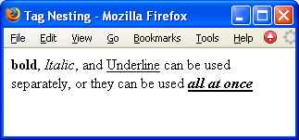

4

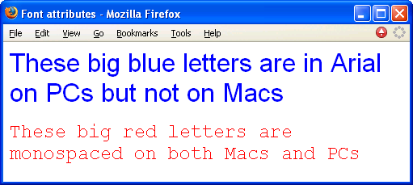

5

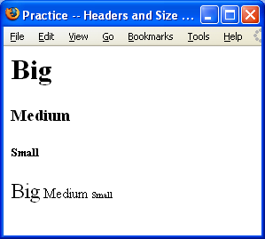

6

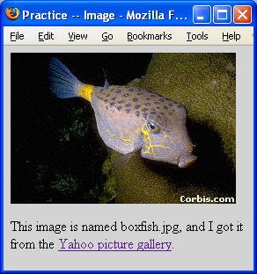

7

8

