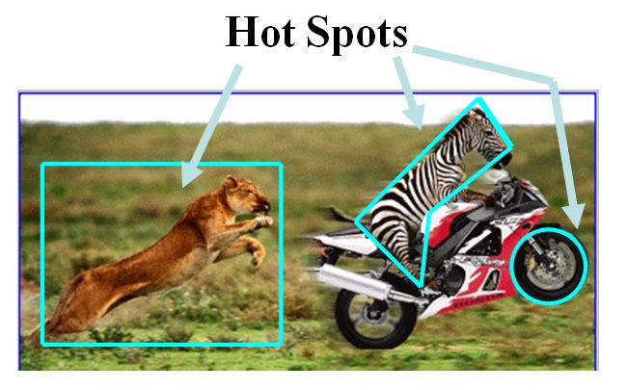
Image Maps

An image map is a single image that can be used to link to several different URLS
Server-Side Image Maps

Image used as image map

Map file defines areas of image and corresponding URLs

Image map program runs on server as part of its server software

Map file and image map program reside on server

Web server performs calculations
Client-Side Image Maps

HTML document contains map information

Browser performs calculations

Better performance that server-side image maps

Can test and implement locally

URL of hyperlink will display in browser status bar when mouse hovers over image
Four Steps to Create a Client-Side Image Map

1. Select image to use

2. Define areas of image map
Three shapes: circle, rectangle, polygon
X and Y coordinates in pixels
Get coordinates from a graphics program such as Paint Shop Pro or Photoshop

3. Include map information in HTML document:
<MAP></MAP> - NAME attribute names the map
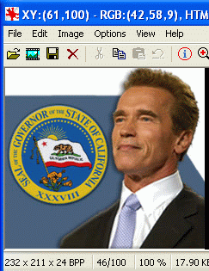
<AREA> tags identify shapes in map
SHAPE attribute – circle, rect, poly
HREF attribute – URL to load
COORDS – x and y coordinates of shape

4. Connect image with map information
USEMAP attribute in <IMG> tag
USEMAP value is map name with a # symbol before it
Finding Coordinates

Open image in Paint Shop Pro or some other graphics program

Point to the locations of interest and find the X, Y coordinates in the status bar

(The white pencil in the image to the right represents the cursor, which has a variable shape in the actual graphics program)

Circle
x,y
x+r,y

<AREA SHAPE=“circle”

COORDS=“x,y,r”

HREF=“url”>

Replace x,y,r with three numbers: horizontal and vertical position of the circle’s center, and the radius of the circle in pixels

Replace url with the Web address of the link target

Rectangle
x1,y1
x2,y2

<AREA SHAPE=“rect”

COORDS=“x1,y1,x2,y2”

HREF=“url”>

Replace x1,y1 with two numbers: horizontal and vertical position of one corner of the rectangle

Replace x2,y2 with the horizontal and vertical position of the opposite corner of the rectangle

Replace url with the Web address of the link target

Polygon
x1,y1
x2,y2
x3,y3
x4,y4
x5,y5
x6,y6

<AREA SHAPE=“poly”

COORDS=“x1,y1,x2,y2,x3,y3,x4,y4,…”

HREF=“url”>

Replace x1,y1 with two numbers: horizontal and vertical position of a point on the edge of the polygon

Add more x,y pairs until you have traced around the desired shape

Revised 5-18-05

