Download NVU from http://www.nvu.com – it works on Windows, Mac, or Linux.

NVU User’s Guide is at http://nvudev.com/guide/1.0PR/

Main Areas of the NVU Window

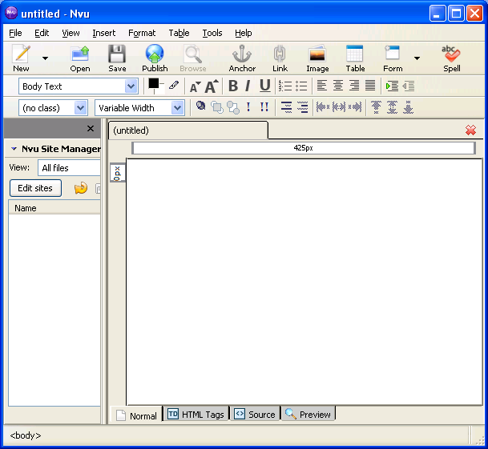
Composition
Toolbar
Format
Toolbars
Page
Area
Edit Mode Tabs

You add text, images, links, and such to the Page Area. This forms the body of your Web page.

Formatting Text: Type in the text first. Then drag through it with the left mouse button down to highlight it, and use the Format Toolbars to format it.

The Edit Mode Tabs let you see the page 4 ways:

Use Normal view to build your page with the toolbars

HTML Tags view is strange at first, showing tags in a cartoony way

Source view shows the HTML code. NVU uses a lot of advanced tags beyond CNIT 131.

Preview shows how the page looks in a browser.

Upper Format Toolbar

Paragraph Formats
Colors
Size
Bold, Italic, Underline
Lists
Indent

Alignment

Paragraph Formats: This list contains all the header styles <H1>, <H2>, etc. and other paragraph formats. The default value is Body Text.

Colors: These three tools control the Text Color, Background Color, and Highlight Color.

Size: Makes text bigger or smaller, with repeated <big> or <small> tags.

Bold, Italic, Underline: These work the same way they do in word processors.

Lists: Makes ordered or unordered lists

Alignment: Left, Center, Right or Justify, just like an word processor

Indent: Indents text from the left

Composition Toolbar

New: Makes a new blank page

Open: Opens a page previously saved on the local computer

Save: Saves the page to the local computer

Publish: Publishes the page to a server, such as the hills server

Browse: Previews the page in your default browser

Anchor: Makes a named location on the page for an intra-page link (not commonly used)

Link: Highlight text, then click this button to make a hyperlink

Image: Adds images to your page

Table: Puts a table on your page

Form: Puts a form on your page (beyond the scope of CNIT 131)

Spell: Checks spelling

Print: Prints the page

