Chapter Objectives

Things People Do Online

Connecting to the Internet

Acceptable Use Policies and Privacy Policies

Hand-Held and Other Devices

Web Browser Basics

Security Risks

Security Measures

Downloading Software

Internet Protocol (IP) Address

Domain Name System (DNS)

Online Activity

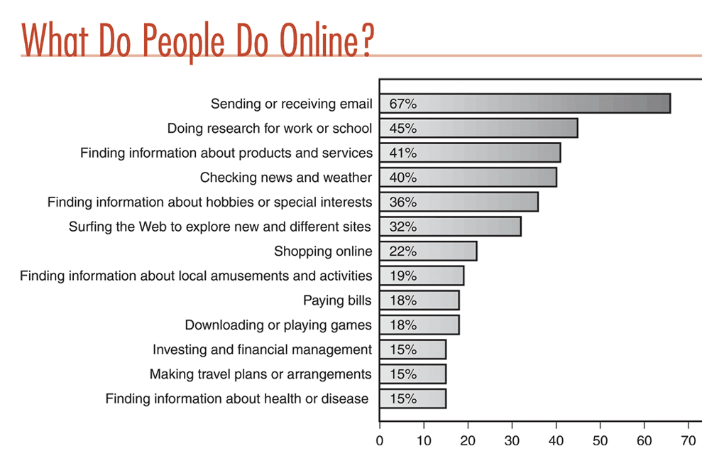
- Many activities involve “Seeking Information”

Connecting to the Internet

Internet Service Provider (ISP)

A company that provides a home or business access to the internet

Examples: AOL, Comcast, Verizon, and many more

Local Area Network (LAN)

A way for many computers to share an ISP connection

Computers, printers, and other resources, connected within a single building or a few neighboring buildings

Wide Area Network (WAN)

Computers, printers, and other resources, connected over a wide area (even worldwide)

The Internet is the Largest WAN

Connecting to the Internet

To connect to the Internet you need a connection device, like

Modem

Translates computer signals into a synthetic phone signal (or cable TV signal)

LAN connection

Wired, wireless, or fiber-optic

Older computers may need to be upgraded, by adding:

Random Access Memory

Fast computer memory that provides temporary storage required for programs to run.

Hard drive

More storage space for music, games, etc.

Modem (Modulator/ demodulator)

Image is a dial-up modem

For recommendations, try pcpitstop.com

What does Internet Service Include?

Email address

Ability to surf the web

Storage space

24/7 Technical Support

Spam filter

Spam is unsolicited commercial email

Data Travels

In two directions

Downloading

Data transmitted from another computer to your computer

Uploading

Data transmitted to another computer from your computer

Bandwidth

The data transmission rate over a network or the Internet

Kbps: A thousand (1000) bits per second

Mbps: A million (1,000,000) bits per second

Gbps : A billion (1,000,000,000) bits per second

Internet Connection Types

1. Traditional Dial-up Services

Slow (maximum of 56 Kbps)

Ties up your phone line

2. Broadband Services

Faster than dial-up

Telephone

DSL (Digital Subscriber Line)

A high-speed Internet connection over a normal telephone wire

Uses the frequencies not used for voice, transmits data over them

ADSL (Asymmetrical Digital Subscriber Line)

Download speed is faster than upload speed

Cable (Cable TV wire)

In practice, usually faster than DSL

Satellite (Communicates from a dish to a satellite via radio)

Expensive and slower than cable, but available in remote areas

3. Wi-Fi

(Wireless Fidelity) wireless LAN

Hotspots

Location where a wireless signal can be detected (see link Ch 1g on my Web page -- samsclass.info)

WARDRIVING

Driving around a city in a vehicle, with a notebook computer and antenna, detecting open Wireless LANs

To protect your wireless LAN, you can use:

WEP (Wired Equivalent Privacy) or

WPA (WiFi Protected Access) – much better than WEP

See Link Ch 1c on my Web page

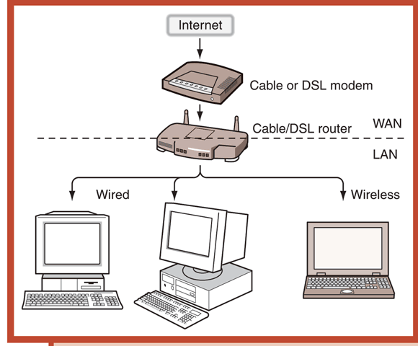
Wireless at Home (see figure at right)

ISPs for Travelers

ISP resource http://www.thelist.com

Look for national dial-up service

Hotels

Cyber cafes

Connecting to Work

Local Area Network (LAN)

Gateway

A computer that connects a LAN to the Internet, usually with a powerful leased Internet line, such as T3 or OC48

Ethernet

A method of networking computers, usually using copper cabling

Protocol

A way of packaging and addressing data to transmit it from one location to another on a network

Intranet

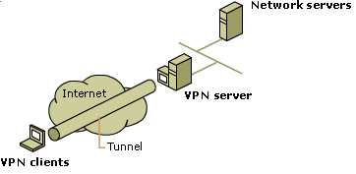
An internal Internet for employees to access information about a company; not meant for public consumption

VPN (Virtual Private Network)

A secure way to connect to a LAN over the Internet (see figure at right, based on a figure from microsoft.com)

VPN Dial-up Network (VPDN)

Way to connect to VPN at work

Desktop client software

Software to connect to NAS

Network Access Server (NAS)

Connects user and VPN

Tunneling

Employing an encrypted protocol to connect to a VPN

Acceptable Use Policies and Privacy Policies

Acceptable Use Policy (AUP)

Outlines prohibited and acceptable uses of the service, and possible consequences of misuse

Right to suspend service

Privacy Policy

See “CCSF Disclaimer” at the bottom of my Web page (samsclass.info)

Hand-Held and Other Devices

Internet without a computer?

Cell phones

PDAs ex: Blackberry

Brain-computer interfaces: See Link Ch 1d, 1e, 1f on my Web page

Internet Software

Surfing the Web

Figure of speech: describes browsing the Web

Web Browser

Software used to download and view Web pages

Examples: Internet Explorer, Firefox, Safari

URL (Universal Resource Locator)

Web page address

Examples: http://www.ccsf.edu, http://yahoo.com

protocol://name-of-computer/directory/file

If the file is not specified, the Web server will usually assume it is index.html

Protocol

System of communicating data from one location to another

If the protocol is not specified, the browser assumes it is http://

HTML (HyperText Markup Language)

language used to construct Web pages

http (HyperText Transfer Protocol)

protocol governing exchange of files on the Web

https (HyperText Transfer Protocol Secure)

specific protocol set employed when a page of a Web site must be encrypted for secure transfer

mailto:

protocol used to send email from Web pages

ftp: (File Transfer Protocol)

protocol for sending files

Web Browser Basics

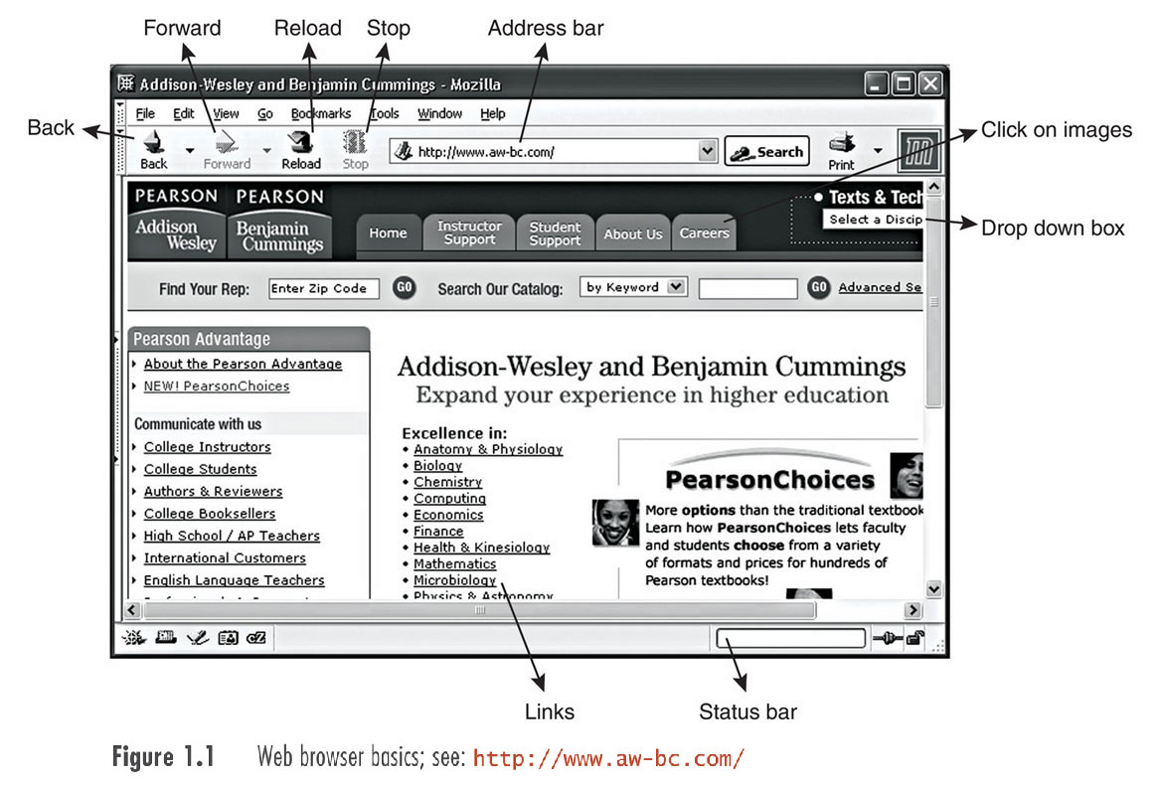
Temporary Files (Cache)

Temporary files stored on the hard drive

Clearing the Cache

Tools, Internet Options, Delete Files

Missing Page Errors (“404 Error”)

A common problem

Bookmarks and Favorites

History and Clearing the History

Tools, Internet Options, Clear History

Setting the Home Page

Drag the URL handle onto the Home button

Advertisements on the Web

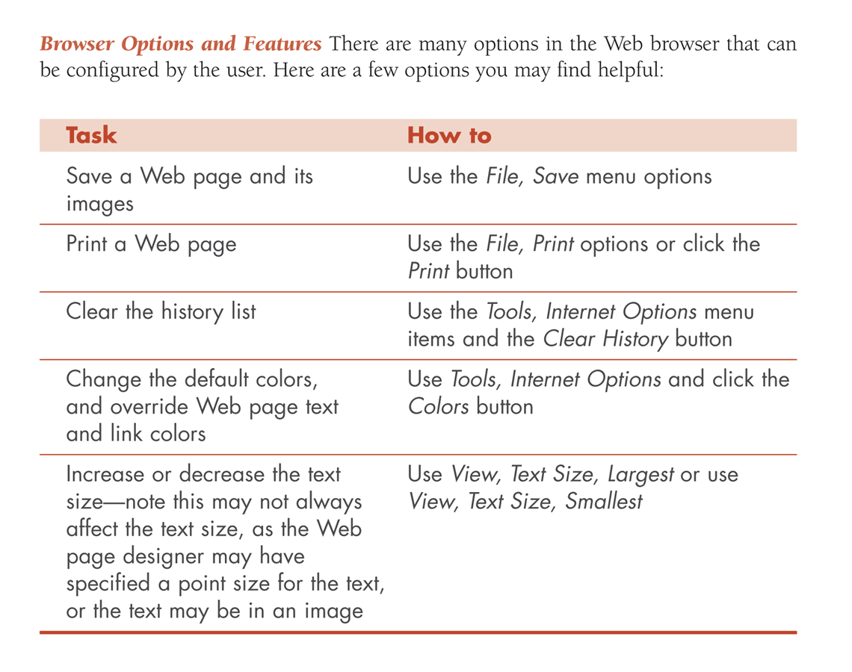
Click-through fee – advertisers pay for each click

Pop-ups and pop-unders are ads that open in new windows on your machine

Pop-up blockers protect you from pop-up ads

Internet Explorer: Tools, Pop-up Blocker

Email Clients

Software that helps you manage e-mail

Included with browsers

For example, Outlook Express is included with Internet Explorer

Security Risks

Virus

Small program that is self-replicating

Can cause destruction ranging from simple annoyances to rendering the computer inoperable

Trojan Horse

Small program usually designed to gather information such as passwords to send to the person who wrote it

Worm

Program designed to copy itself and send itself to other computers on the network (worms may contain viruses)

Adware

Advertising-supported software

Spyware

Any computer program that takes advantage of your Internet connection and tracks your internet use

Browser Hijacker

A program that is designed to change the settings on your Web browser: home page hijacker, browser helper objects

Web Bug

A small invisible image on a Web page that is designed to track the Web pages you view as you surf other pages that also contain Web bugs

DDos

Distributed Denial of Service Attacks

A group of computers all send requests to a Web server simultaneously, causing it to crash or become unavailable

mDDos

Mini Distributed Denial of Service Attacks

Individuals can be targeted in the gaming community

See links Ch 1g and 1h on my Web page

Security Measures

Choose a good ISP

Keep your computer up to date

Anti-virus software

Spyware removal software

Install firewall software or use a router that has one

Providing Credit Card and Other Sensitive Information

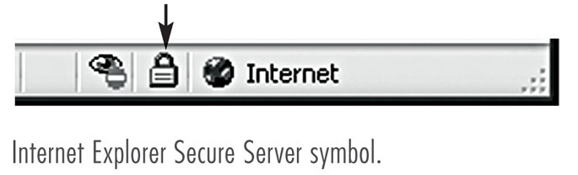
Before typing in confidential information:

Look for the padlock symbol in the status bar of your browser

Look for https: at the start of the URL

This means your data will be encrypted, and that the recipient is verified to be who they claim to be

Downloading Software

Good Download Sites

download.com tucows.com

Commercial Software

Software that is purchased, either online or from a retail outlet

Shareware

Freely distributed in a limited form – “try before you buy”

Freeware

Software that is completely free and may be freely distributed

Open Source Software

The source code, or original program, is available

Others are invited to help with the development and submit improvements, becoming part of the group who is developing it

Open source can also mean that the software use requires a paid license, and the source code is available

Example: Linux, an alternative to Windows

Internet Protocol (IP) Address

A numeric identifier for a computer or peripheral device connected to a network

Like a telephone number

Example: 147.144.1.212 is CCSF

The example of an IP address given in your book on page 25 (127.324.0.89) is invalid: each number must be between 0 and 255.

Hosts and Web Servers

Each computer connected to the Internet is called a host and needs its own IP Address, including your home computer.

Some hosts are Web servers – they provide Web pages to computers that request them

The definition of a host on page 26 in your textbook is wrong.

Static and Dynamic IP Addresses

Dial-up users usually get a Dynamic IP Address used only during the time they are online, and then assigned to a different user.

This is good enough for computers that are just viewing pages, but not for Web servers that provide Web pages to other computers.

A Web server normally has a Static IP Address so that other computers can find it

DNS

You can surf the Net by typing IP addresses into your browser

216.239.37.99 is Google

That’s inconvenient, so most Web sites use domain names like google.com

The domain names are converted to IP Addresses by Domain Name Servers (DNS).

Your ISP provides DNS Service – without it you could not surf the Web effectively

Troubleshooting
When you can't open a Web page

Check the URL – pay attention to each character

Click stop then reload

Try loading a different page to see if you have lost your Internet connection

