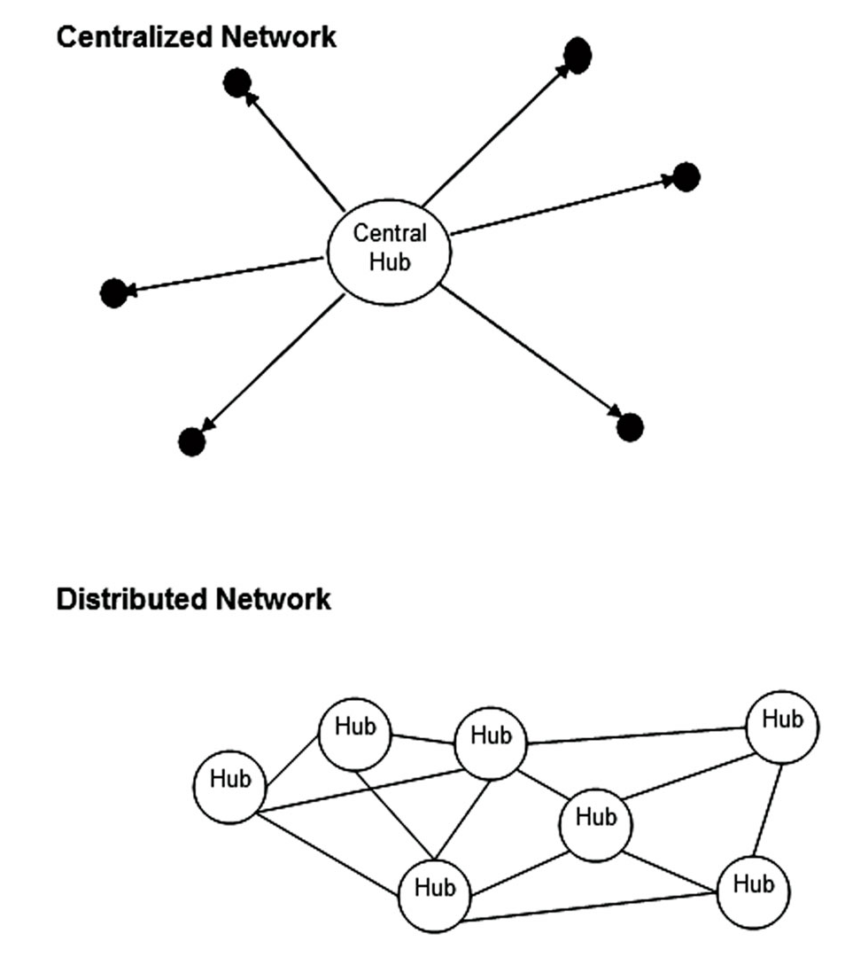
Chapter Objectives

Development of the Internet

Communication Tools

TCP/IP and Internetworking

Request For Comment (RFC) Documents

APRANET Goes Public

U.S. National Science Foundation

Internet2

Domain Names

The World Wide Web

Welcome to the Internet

The Internet

Hardware: cables and computers

A worldwide network of computer networks

The World Wide Web

Software that lives on the Internet

A collection of files viewable in a browser, including

Web Pages

Pictures

Audio

Video

Other files

Welcome to the Internet

The term “Cyberspace” was coined by William Gibson

A fictionalized exaggeration of the World Wide Web

People use brain implants instead of computers

Not realistic yet, but it probably will be soon

Development of the Internet

RAND Engineers Envision a “Galactic Network” in the 1950’s

Research and Development Corporation

Distributed network can withstand nuclear attack

No Single computer or communication line was critical

Centralized network has a critical hub in the center, if that hub breaks the network stops

Development of the Internet

Nuclear Threat and the Space Age

Hiroshima and Nagasaki prove the threat of atomic exchange (1945)

U.S.S.R. Sputnik I

First satellite -- Cold War heightened (1957)

U.S. Advanced Research Projects Agency (ARPA)

Formed to consider strategic issues of “satellite attack” and countermeasures

APRANET (1968)

Internetwork

Collection of computer networks, joined so that a computer on one network can send a message to a computer on another network

Host

Any computer on a TCP/IP Network (note incorrect definition on page 33)

ARPANET had four hosts in 1969

Protocol

A set of rules governing information transfer from one computer to another

Packet

A smaller package of information that makes traffic more manageable across the internet

APRANET (1968)

NCP (National Control Protocol or Network Control Program)

Protocol developed in 1970 that stabilized most data exchanges from APRANET members

Communication Tools

1972 - Tomlinson invented first email program for ARPANET

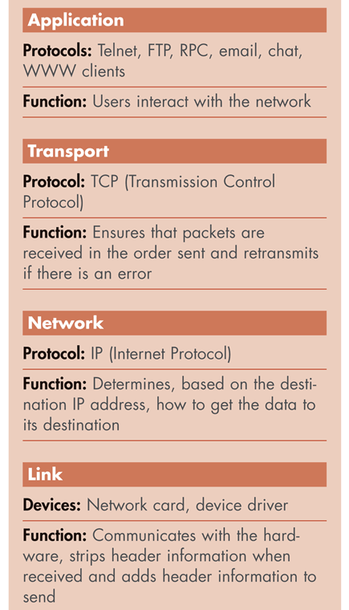
Email rapidly becomes the most popular activity on ARPANET (and later, on the Internet)

1975 - Transmission Control Protocol (TCP)

Provides connection-oriented, transport-level communications, email and file transfer

TCP/IP and Internetworking

TCP/IP (Transmission Control Protocol/ Internet Protocol)

Replaced NCP in 1983

1970s, suite of computer-to-computer communications protocols that deals with packet transportation, session communications, email and file transfer

A universal language that lets any computer network communicate with any other network

The Internet

The worldwide network of computer networks, and all its supporting structure

Request For Comment (RFC) Documents

Documents, detailing how Internet works, standards

Collectively developed by researchers

See link Ch 2a on my Web page

The TCP/IP Stack

A Family of protocols in 4 layers:

Application

Transport

Network

Link

See movie at link Ch 2b on my Web page

APRANET Goes Public

APRANET grew very quickly

MILNET was created to keep “online noise” from APRA staff

Separated from ARPANET in 1983

U.S. National Science Foundation to the Rescue

National Science Foundation (NSF)

Took over ARPANET in 1984

Created NSFNET

The National Science Foundation Network is a high-speed backbone network of all the major networks in the U.S.

NSF upgrades speed

1.5 Mbps (Million bits per second) in 1988 – T1 lines

44.7 Mbps in 1991 – T3 lines

Note error in book: T1 and T3 lines use wires, not fiber optics

http://www.ahk.com/t1_cable.html

Internet Backbone

Internet2

A.k.a. the Abilene Network

Making the internet ready for the future – much faster

http://www.internet2.edu

CCSF is connected to Internet 2

Internet History Timeline (see pages 41 & 42 in your book)

Internet Development Around the World

Skip this section (p. 40 – 43)

Convergence of Efforts in the U.S.

Because U.S. government agencies helped fund the Internet

Before 1991, the Internet was not available to everyone –just education and government institutions

In 1995 the Internet was handed over to Internet Service Providers (ISPs), who sell Internet access to anyone

http://www.zakon.org/robert/internet/timeline/

Domain Names

Domain names like yahoo.com exist so we don’t have to remember IP addresses

Top Level Domains (TLDs)

The last part of the URL that helps to categorize the type of organization

6 Original TLD’s

.com (commerce)

.edu (education)

.org (organization)

.net (network)

.gov (government)

.mil (military)

Domain Names

Domain name registrations are managed by Internet Corporation For Assigned Names and Numbers (ICANN)

http://www.icann.org/

A list of all Top-Level Domains is at:

http://en.wikipedia.org/wiki/List_of_Internet_top-level_domains

ICANN is a very controversial organization

http://en.wikipedia.org/wiki/ICANN

The World Wide Web

Developed in 1991 by Berners-Lee

Hypertext document

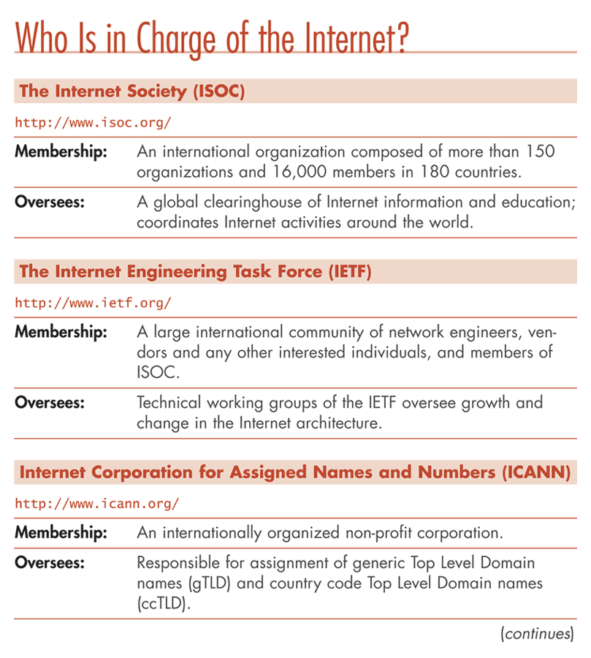
A document containing links and when a user clicks on a link, another document is displayed

Hypertext transfer protocol (http)

A protocol used for retrieving Web pages that works with TCP/IP

URL

The protocol, host, and domain name in the form of protocol://hostname.domain

May have a /directory/filename added to the end also

The World Wide Web

Gopher

The simple system of text menus that users had to “dig” through to get the information they wanted

Now obsolete, replaced by the WWW

Hypertext markup language (HTML)

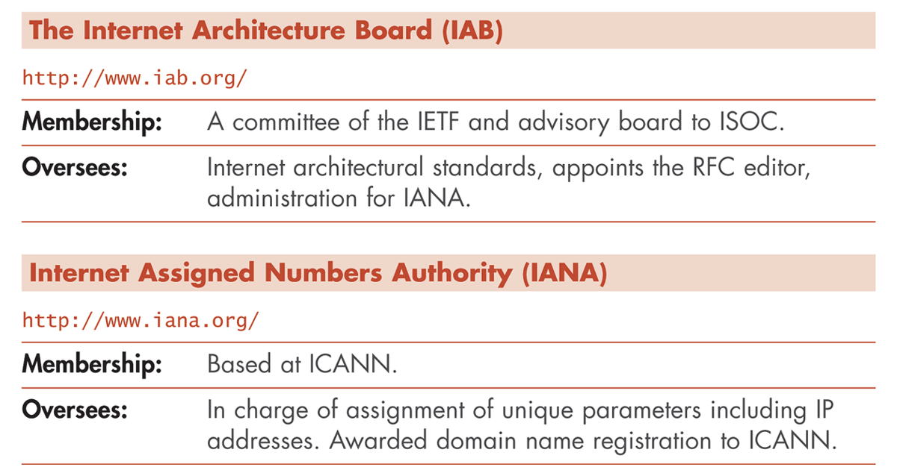
The markup language used to construct Web pages

1993 - first graphical Web browser: Mosaic

Four Major Events Make the Web Explode circa 1995

Microsoft Windows 95 – brings a Graphical User Interface to the masses

Netscape – popular Web browser

Private ISPs like AOL, CompuServe, etc.

Backbone ownership transferred to phone companies

