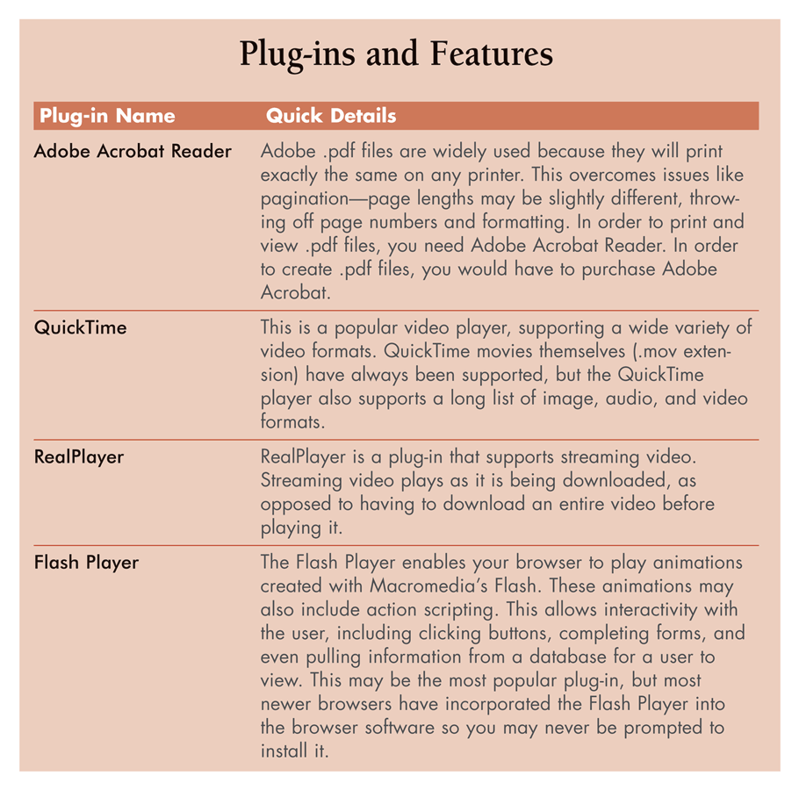
Summary

Browser Plug-ins

What’s available on the Web?

Online Research Tools

Searching Strategies

Understanding Evaluation Criteria

Citing Internet Resources

Finding Software

Open Source Licensing
Browser Plug-ins

Plug-in components

small programs that provide an environment in your browser for a specialized software program to run, or for viewing a specialized file
What’s available on the Web?

Hypertext documents

Web pages, documents constructed using HTML, most common type of document on the web, include combinations of text, links, graphics etc.

Data files

Spreadsheet or Word file, files you deal with on a daily basis

Media files

Specialized data file that contains audio or video data
Online Research Tools

Search Engines

Web-based program that allows users to submit key term requests to an online database

Ex: www.altavista.com, www.google.com www.yahoo.com

Click “search” or “submit” or hit “enter”

Results listed in decreasing relevance

Choosing Keywords

phrases need double quotes (“)

to refine search combine multiple keywords

Advanced Search Features

Help refine searches by file type, Boolean operations, file creation date, limiting the domains searched, etc.

Portals

Customizable Web pages consolidating features such as: email, news, calendar, etc., like Yahoo

Spiders

Computer programs used by search engines and designed to crawl from one Web page to another through links on each Web page, gathering keywords or whole pages as they go.

Error in textbook on page 59: these are not knowbots

Site notification

A method of submitting your Web site or Web page to a search engine so that it will be recorded in its database

Pros and Cons of Search Engines

Searches a large number of sites, sometimes too many

Each search engine chooses how to index and rank the pages

keywords meta-tag

An HTML tag used to identify the potential contents of a page for search engines

Paid search engine placement services will trick search engines into putting your page near the top

Directory Outlines or Web Directories

A search tool that contains a list of topics that can be browsed and searched ranging from general to specific)

Convergence of search engines and directory outlines – Yahoo and Google now contain both

Web pages are indexed by humans, not spiders

Smaller database of pages, but more accurately indexed

About.com hires expert guides to find pages

Bibliographic Databases

Reference collections to research materials such as journals and books

Often a fee involved, but college libraries pay for access

Pros – give quality academic resources, can be full text

Cons- rely on humans for indexing, may be out of date

Example: EBSCO.COM

Site-Specific Search Engines and Site-Maps

Outlines of a site’s layout

Search only the data on a Web site

Pros and Cons

Results are limited but specific

Tip: Use Google with site:microsoft.com to search the Microsoft Web site

Subject-Specific Search Engines & Directory Outlines

Search interface that emerged in 1996 that seek out the data stored on many different Web sites about a particular topic or theme

Pros good for specific data

Cons may not be as comprehensive as advertised

Example: imoutdoors.com

Metasearch Engines

Search engines that submit a key-term to several search engines, consolidating the results.

Examples: dogpile.com, profusion.com

Pros and Cons

Simple searches are effective, complicated ones may not be

Only produces the top 5% to 15% from each search engine

Can be untimely but are good for preliminary searches

Topic Rings

Webring. One in a series of Web sites with a common theme

Generally are not searchable but helpful for browsing

Frequently Asked Question Pages

FAQ pages. Compilations of the most frequently asked questions and their answers, pertaining to a given topic

Sometimes out of date or inaccurate

Expert Inquiries

Direct requests for data from a recognized expert, or body of experts

Can contact experts through Universities, list or newsgroups

Example: Google Groups

General References

Online versions of almanacs, dictionaries, encyclopedias or other resources that are searchable, hyperlinked and more easily retrievable via the web

Reference.com, Dictionary.com, Encyclopedias, Maps and Driving Instructions

Wikipedia

Easy to use, free resources in comparison to traditional versions

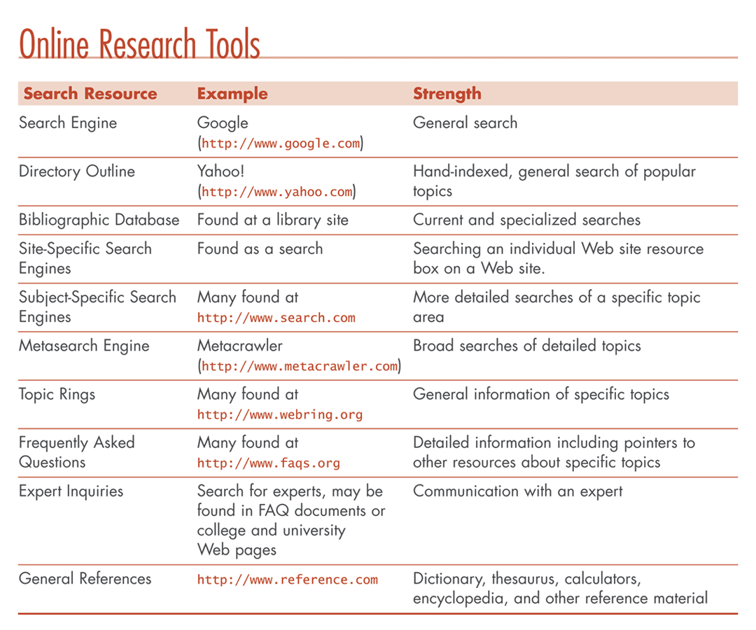
Searching for Jobs

Job boards and job search engines

Examples: monster.com, www.ajb.org, ww.jobs.com, www.dice.com

Searching for People

Email addresses

Mailing addresses / white pages

Personal Information pay services that give more personal information

Reverse telephone number lookup

Examples: 411.com, Yahoo People Search, zabasearch.com

Searching Strategies

Initiating a search

Pick the right tool for the job

Pick good keywords

Don’t be lazy

Phrase your questions to experts precisely

Refining a search

Use Boolean operators and wildcard characters

Boolean operators and Wildcard character

AND, OR, NOT, NEAR, *
Understanding Evaluation Criteria

Anyone can publish a Web page

To establish accuracy you need to ask yourself…

Is the information accurate?

Authority: Is the source credible?

Who is the intended audience?

What is the purpose of this publication?

How current is this information?

Is the depth of coverage sufficient?

Accuracy (Is the information Accurate?)

Three methods of verification

Editorial Checks – not required for Web pages

Multiple Sources – but you might just see the same thing on a different site

Personal Experience

Authority (Is the creator credible?)

Check credibility of sources

Check email address, “home” or backtrack to the URL

Audience and Objectivity (Who is the intended audience?)

Identify “we” statements

Look for Language level

Look for Jargon Level

Purpose (What was the purpose of publishing the info?)

Are they trying to inform, persuade, advocate or entertain?

Domain analysis (.com, .gov, .org)

Balance and Bias

Is that a fact?

Current Information (How recent is the information?)

Internet info. can be very recent

Understand the meaning of dates on the Web (sometimes they are deceptive)

Depth of Coverage (Is the information covered in sufficient depth?)

Citing Internet Resources

Cite sources to avoid plagiarism

Presenting someone else’s ideas as your own

Also so readers can find the information you used

Citing and Referencing Web Materials

Web Document

Author’s name

date of publication

Title of document

Date you accessed the source

Web site name and URL.

Ex:

Obie, D. (2004). Determine the goals for your small business Web site. Retrieved July 27, 2004 from SCORE Web site: http://www.score.org/eb_6.html
Finding Software

Software Review Sites

Sites detailing how specific software functions

Freeware

Free software programs

Shareware

Titles that allow you limited usage or usability until you purchase the full version

Downloads.com Tucows.com

Open Source Licensing

Programs are written in code such as C++ or Java

Open Source

Source code is available and can be modified and improved

Linux is the main example

http://www.openoffice.org/ is available for Mac and Windows too
File Compression

Reducing the size of a file or combining several files into one

.zip or .exe on a PC

.sit on a Mac

.tar on Linux

Win XP can open .zip files

Other OS may require a utility like Winzip or Winrar or Stuffit

