Chapter Objectives

How email was developed

The variety of email accounts available

Email Basics

Setting Up an Email Client

Header, Body, and Attachments

Smileys, Emoticons, and Netiquette

Sending and Receiving Email

Spam and Security
How Email was Developed

Brief History of Email

1960s Messages sent without email addresses to users of the same host

Late 1960s Tomlinson introduced the @ sign in e-mail address

1970s improvements to email

1980’s Compuserve and MCI Mail provide email access to the public

Early 1990s Steve Case founded AOL to bring Internet and email to everyone in the US
The Variety of Email Accounts Available

Getting an Email Account

Webmail interface

A Web page provided by an ISP that allows you to log in and see your email messages via the Web

(ex: hills.ccsf.edu/mail)

Email client

A computer program designed to send, receive and manage mail (ex: Microsoft Outlook Express)

POP (Post Office Protocol)

Protocol used by email client to download email from the server to your local computer

You can get an email account from an ISP or a free service, or your college
Email Basics

Email addresses are in the form

userid@host.domain

Examples:

sbowne@ccsf.edu

kittycat@aol.com

flast01@hills.ccsf.edu

User ID

The login name that you use for the Webmail or ISP service

Fully Qualified Domain Names

FQDN has three parts: host, domain, top-level domain, separated by periods

hills.ccsf.edu

Host name is not always needed

Domain and top-level domain are always needed

Using Webmail

Ex: Yahoo!, Hotmail, Gmail

Limited storage (2.5 GB for Gmail)

Features

Notification for new mail

Spam filters

Ads

Log out when you leave a public terminal to prevent the next user from accessing your account
Setting up an Email Client

You will need these things:

Userid

Password

Incoming Mail Server (POP, IMAP, or HTTP)

The name of the server you will be connecting to in order to receive incoming mail

Outgoing Mail Server (SMTP)

The name of the server you will be connecting to in order to send mail

Incoming Mail Server (POP, IMAP, or HTTP)

POP (Post Office Protocol)

Protocol used by email client to download email from the server to your local computer

IMAP (Internet Message Access Protocol )

Protocol used to access email messages stored on the server

Outgoing Mail Server (SMTP)

SMTP (Simple Mail Transfer Protocol)

Protocol used to send email messages

Microsoft Exchange Server

Used in corporate networks to handle email together with Microsoft Outlook or Outlook Express

Not available with CCSF mail, or mail from ISPs at home
Header, Body, and Attachments

Header of email includes addressing information and subject

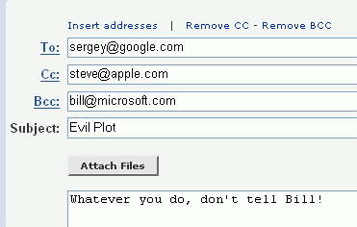
Body is the typed message at the bottom

Attachments are files sent with the message, like images

To:, CC:, and BCC:

To: Main recipient

CC: Carbon copy

BCC: Blind Carbon Copy

Every recipient sees the To: and CC: addresses, but not the BCC: addresses

Use BCC to send messages to a group of friends without giving them all one another’s addresses

Separate email addresses with commas

Subject

Always include a subject line

Avoid subjects that look like spam

Many people use their inbox as a to-do list, so make it easy to figure out what action is required from the subject

Examples of good Subjects:

Party next week

Estimates due today

Family news from Mom

ASCII v. Binary Files

ASCII (American Standard Code for Information Interchange)

Unformatted text (.TXT files)

7 bits per character (eighth bit is used for parity error-checking)

Binary Files

Images, Word documents, spreadsheets, etc.

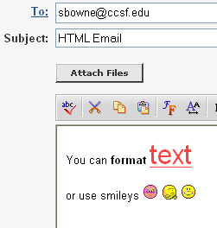
Uses all 8 bits in each byte to store data

Binary Files and MIME

Email was designed to send ASCII only

MIME Protocol (Multi-Purpose Internet Mail Extension)

Encodes binary files into ASCII to send them via email

Decodes files once they are received

Before MIME, people used UUENCODE and UUDECODE to send binary files

File Attachments

Any type of file can be sent as an attachment, except:

Very large files (2 MB is a common limit)

Executable files are often blocked (.EXE, .VBS, .MDB)

Attachments can contain viruses

Don’t open unexpected attachments from your friends or strangers

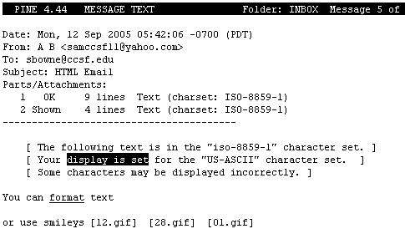
Explain any attachments you do send so the recipient doesn’t delete it

HTML Email

Web-based email and clients like Outlook usually send HTML email

This allows some formatting to be included in the message

It looks strange in non-HTML email programs like PINE

Smileys, Emoticons, and Netiquette

Smileys and Emoticons

Emoticons (emotional icon) – smiley

Ex: ☺

Ex: TTYL- talk to you later

:) >:-)

Etiquette

Proper social behavior as prescribed by some authority

Netiquette

Internet etiquette

Netiquette Rules

DON’T SHOUT – Use normal capitalization

Use a meaningful subject line

Be careful not to insult people

Messages sent from work will probably be read by your employer

Be concise -- address only topic per message

Don’t use chat acronyms like LOL, AFK at work

Consider file size: don’t send large files by e-mail, especially to dial-up users

Don’t flame – send angry messages

Remember that the recipient may be from another culture – avoid regional language and sarcasm

Use a spell-checker

With normal email, you are not anonymous, and your messages can easily be read by others
Sending and Receiving Email

Return Receipts and Importance Indicator

Return Receipts

Know when the recipient receives the message

Available in Outlook (View, Options), Outlook Express, and Eudora

Not offered by Yahoo or Gmail

Importance Indicator

Message of high importance (red exclamation)

Message of low importance (blue down arrow)

Address Book Feature

Gmail automatically adds all addresses from mail you receive to Contacts

Yahoo mail has a Quickbuilder feature to do the same thing

Third-party programs are available for sale to add this feature to Outlook

Receiving Email and Alerts

You can set how often your e-mail client checks for new mail

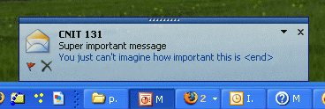
Alerts tell you when a message is received

Webmail alerts often use the associated instant messenger client

Outlook also shows alerts, but only if you leave it open

Bounced Mail

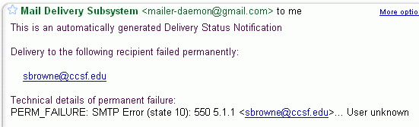
Typo in email address or other issue

Returns message to sender

Some email clients do not show bounce

Email Header Information

Information about the route taken

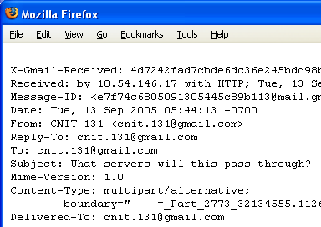
Where message comes from

When message was sent

Routes and Servers

In GMail, click More Options, Show Original

Anonymous Remailers

You can conceal your identity with these services, which is not often free anymore

Mailinator (Link Ch 4a) – Free but you can only receive mail

XmailY (Link Ch 4b) – Not Free but offers a free trial (didn’t work when I tried it)

These services tend to get flooded by spammers and shut down

Replying to an Email Message

Reply:

Goes to From: Address

Reply All:

All To and CC: recipients are included in the reply

Forward:

Send the complete message with attachments

.forward file on HP-UNIX will send all your CCSF email to another account you specify

Deleting Email Messages

Empty the Trash Bin to really erase messages

But nothing deleted on a computer is really gone if someone works to find it

Organize your mail by using folders

Depends on email client or Web Interface

Additional Email Features

Filters

Automatically file messages into folders

Signature

Add contact information or a message to each message you send

Sorting

Sort messages according to heading etc. etc.

Multiple Email Accounts

You can gather email from many POP accounts into one inbox with an email client, but not most Web mail

You must use your ISP’s SMTP server to send mail

SPAM and Security

Unsolicited email 8% (2001) to 83% (today)

Spam Blockers (Anti-spam software)

Software that automatically routes unwanted email into a folder

Can also block good mail

Reviews at links 4f, 4g, 4h

Blue Frog

Controversial new anti-spam tool

See links Ch 4d, Ch 4e

Email Trackers and Web Bugs

Email Tracker

Finds out when and where your email was read

See link Ch 4i

Web Bug

An invisible transparent image

When you view the image, the Web server hosting it knows you opened the email

Widely used in Spam and Web sites

Newer email clients don’t show images for this reason

To Email, or Not to Email?

Email is good:

To reach multiple people use email

For short messages

Large groups, short meetings

Three stages of a project:

Preparation

Decision-making

Execution

Email is good for stages 1 and 3, but not 2

Viruses and Worms

Be suspicious of e-mail attachments

RUN ANTIVIRUS SOFTWARE

Hoaxes and Chain Letters

Hoaxes are fake warnings of impending doom

Chain letters – pass along message

Phishing

Use of spoofed email and/or fraudulent Web site designed to trick the reader into divulging personal or financial information

Link Ch 4j

Encrypting Email

Clear Text

Unencrypted message that can be read by someone who intercepts it

Email is normally sent as clear text

DO NOT send your credit card information or social security number via email

You can encrypt email using PGP (Pretty Good Privacy), which you will do in a later homework

Last modified 9-13-05

