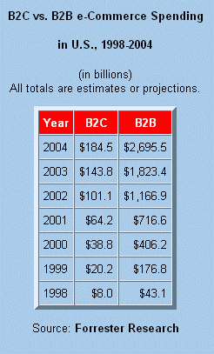
Chapter Objectives

The distinction between E-Business and E-Commerce

The classes of E-Commerce models

E-Commerce “business” models

Supply chain management

How to put a small business online

E-Commerce options available to consumers

E-Business and E-Commerce

E-Commerce or Electronic Commerce

Electronic transactions, the buying and selling of goods and services

E-Business or Electronic Business

Broader than E-Commerce

Includes electronic transactions, customer relations, communications, inventory control, purchasing, etc.

EDI or Electronic Data Interchange

Method of transmitting data in a standardized format from one computer system to another
Classifications of E-Commerce

Business-to-Business (B2B)

Transactions that include bulk purchases between businesses.

Most e-commerce transactions today (ex: www.staples.com)

See link Ch 5a

Business-to-Consumer (B2C) (E-tailing)

Retail transactions on the Internet, between the company and you, the customer

Business-to-Business-to-Consumer (B2B2C)

Business provides a product to another business which, in turn, provides a product to a consumer

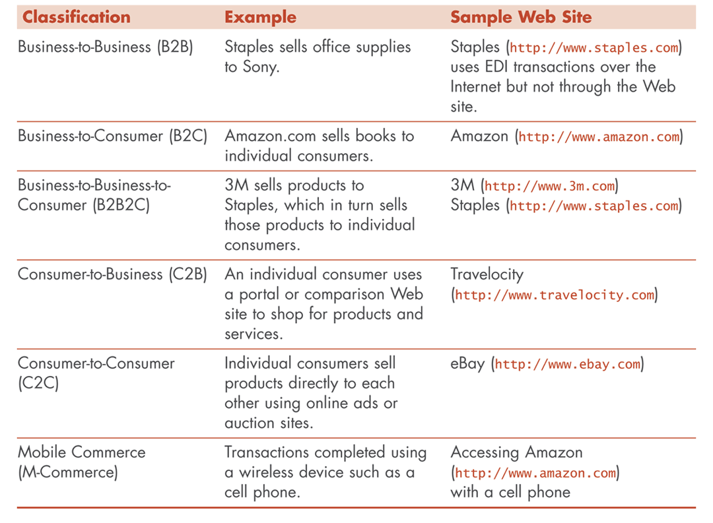
Manufacturer-to-Retailer-to-Customer

This is simple supply-chain management

Consumer-to-Business (C2B)

Individual customer selling to a business

Request for Quote (RFQ) www.travelocity.com

Consumer-to-Consumer (C2C)

Customers selling and buying directly between each other

www.ebay.com or craigslist.com

Mobile Commerce (M-Commerce)

Transactions completed in a wireless environment using a cell phone or other wireless device
E-Commerce Business Models

Online direct marketing

Retailer’s online presence

Product and Service Customization

Easy and fast customization

ex: Dell

Consumer Online Auctions

Allows consumers to bid on products and services

Highest bid wins

Financial transactions are submitted through PayPal

Electronic Tendering

Reverse Auctions

Items offered for a price

Lowest price wins

In B2B E-Commerce, suppliers bid on a job or project

Find the Best Price

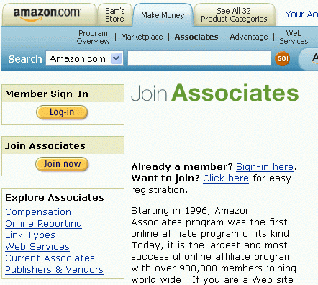
Intermediary company or association will display a listing to the consumer with a selection of items that fall within the consumer’s criteria

Affiliate Marketing

Arrangement between two businesses where each places a banner ad or logo of the other on their Web site, and pays a commission for sales completed as a result of the online referral

See Link Ch 5b

Viral Marketing A.k.a. Advocacy Marketing

Electronic word-of-mouth marketing in which consumers promote a product or service by telling other consumers about it

Blogs

Web logs (online diaries) used to promote products or services in a very causal manner

B2B Electronic Marketplaces (E-Marketplaces)

Vertical Marketplace

(vertical portal or vortal) -- services only one industry

Example: bakeryonline.com

B2B Exchanges

Horizontal – wider variety

B2B Auctions

Example: dovebid.com

Supply Chain Management

The collection and integration of business processes involved in the provision of products and services from the supplier or originator, to the customer or end user.

Keeping stock on hand requires frequent inventory reports

This is where RFID should help (Link Ch 5i on my Web page)

EDI and XML

EDI (Electronic Data exchange)

N1*SH*ACE MANUFACTURING*1*987654321*N2*RECEIVING*N3* 234 MARKET STREET *N4*SAN FRANCISCO*CA*94103*US

A method of transmitting data from one computer to another (example below)

XML

<shipper duns="987654321"> <organization unique-id="aceman">

<name>ACE MANUFACTURING</name> <division>RECEIVING</division>

<address> <street>234 MARKET STREET</street>

<city>SAN FRANCISCO</city> <state>CA</state>

<zip>94103</zip><country>US</country> </address>

</organization> </shipper>

Alternative to EDI, eXtensible Markup Language (example to the right)

Link Ch 5j

Putting a Small Business Online

Selecting and Buying a Domain Name

Domain Name

The name assigned to an IP address, which makes it easier to find a World Wide Web site online.

Whois

A site that gives information about domain names

Example: whois.net

Web hosting

The server where your Web site lives

Examples: Yahoo, 1and1.com, hostfor2bucks.com

Determining the Goals for Your Web Presence

Do you need a Simple Web page or something more complex?

What is the primary goal of your Web site?

Even if your business is off-line, the Web is a marketing Tool

Retail and Online Services

Selling or creating a storefront

Example: http://smallbusiness.yahoo.com/merchant/

Information Delivery

Selling Information on the Web

Example: peoplefinders.com

Customer Support on the Web

Frequently Asked Questions (FAQ)

Real-time online support

Developing and Promoting Your Web Site

Optimize for search engines

Accessible to disabled viewers

Dial-up users

Make it clear if you are global or local

Update often

Integrate Web site with your business

Other Considerations

Email Newsletters

Return email within 24 hours

Join Affiliate Program to trade promotion links with other Web sites

Analyze Web Traffic
E-Commerce Options for the Consumer

Business and Consumer Research

3rd most popular internet activity

Example: consumerreports.org

Online Shopping

Growing (5.3% of retail sales in 2003)

Make sure you see https: and/or the padlock before entering a credit card number

Auction Sites and Sniping

Ebay.com

Auctions.yahoo.com

sniping

Using specialized software to monitor online auctions and bid at a preset maximum price to win an auction (Link Ch 5c on my Web page

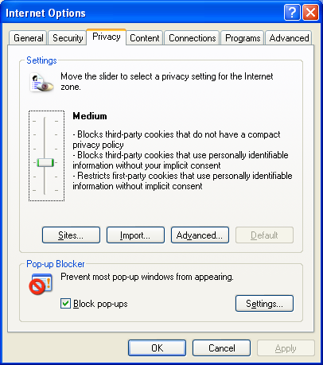
Price Comparisons

Pricingcentral.com (Link Ch 5d)

Travelocity.com (Link Ch 5e)

Cookies

A small text file stored on your computer system

Used so a Web site can remember who you are as you move from page to page

You must allow cookies to use Web mail

Cookies cannot contain viruses, but may compromise your privacy (Link Ch 5g)

In IE: Tools, Internet Options, Privacy

Online Banking

Bill payments

Account statements

The main danger is Phishing

E-mails trick you into signing onto spoofed sites to steal your username & password

Only log on to secure sites, if possible

Online Stock Trading

Online Trading

Buying and selling of stocks and mutual funds through an online brokerage

Day Trading

Buying and selling stocks on the same day

That way you don’t actually ever pay for the stocks

Can be very risky if you use borrowed money to buy stocks (Link Ch 5f)

Direct Access Trading (DAT)

A method of trading stocks that allows traders to directly trade without waiting for the broker to buy or sell

realtick.com (Link Ch 5h) Last revised 9-26-05

