Web Pages and Web Browser

Web pages

HTML documents that can be viewed with a Web browser

Composed of text, Images and multimedia content

Can contain scripts and other advanced features

Web browser

The software used to download and view Web pages
What is HTML?

HyperText Markup Language (HMTL)

The markup language used to construct Web pages

Hypertext

Text written with special hyperlinks that can be used to jump to other pages

A hypertext document consists of many documents linked together

HyperText link (hyperlink)

A document that contains clickable text or images

Items you click in order to load another Web page

Markup Language

A type of computer language that defines the layout of text and images on a page

Not a programming language, because there are no variables, loops, or decisions like IF

Comprised of tags that do things like make text bold or italic

DreamWeaver and other WYSIWYG (What You See Is What You Get) editors are used to construct Web pages without writing the HTML

You can’t use them to do the HTML homework in this class
Development of HTML and Web Browsers

1940’s -- academics discussed the concepts

1960’s –computerized hypertext and the mouse

1980’s – Hypercard let Apple users navigate through cards with the mouse

1988 – Tim Berners-Lee developed hypertext documents and Hypertext Transfer Protocol (http)

World Wide Web Consortium (w3c.org)

Nonprofit research organization

Promotes standards and innovations in Web-based communication, including HTML

NCSA Mosaic

A Web browser developed in 1993 by Marc Andreeson

Allowed both images and text

Andreeson later founded Netscape, now owned by AOL

HTML Innovations

Compatibility

The same HTML page can be viewed on many different computer platforms

A platform is a combination of hardware, Operating System, and browser

Global Communication

http and TCP/IP work all over the world

Interactivity and multimedia (sound, animation, and video)

XHTML (eXtensible Hypertext Markup Language)

The last version of HTML is HTML 4.01

The next generation of markup languages is XHTML

XHTML conforms to XML (eXtensible Markup Language) standards, and was intended to replace HTML

HTML is here to stay, however, because of the billions of HTML pages already in existence
Creating Web Pages with HTML

You need two programs:

Text editor

Notepad on PCs, SimpleText on Macs

Web browser

Internet Explorer, Safari, Firefox, Opera, or any other browser

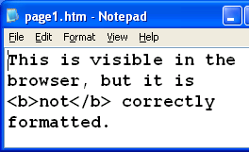
How to Create a Web Page

Open Notepad

Start, Programs, Accessories, NotePad

Type in some HTML text

Save the file on the desktop with any name ending in .htm or .html

Double-click the file on the desktop to open it in a browser

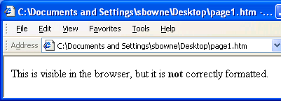
Resize the windows so you can see them both

A Badly Formed HTML Page

This works, but it is missing <HTML>, <HEAD>, and other tags that should be there

Note how the opening tag <B> and the closing tag </B> work together

Web page development cycle

Type the HTML code in Notepad

Save file

Refresh the browser

Basic Web Page Structure
<HTML>
<HEAD>
<TITLE>

</TITLE>
</HEAD>
<BODY>

</BODY>
</HTML>
Head section
Body section

Every HTML page has these tags, in this order

HTML is not case sensitive

Head and Body Sections

Head section

Title to appear in title bar of browser

Meta tags to guide search engines

Scripts and other advanced features beyond this course

Body section

Everything that appears in the main browser window

Text and images

White Space in the Source Code

Browsers ignore white space in source code

Extra spaces or line breaks
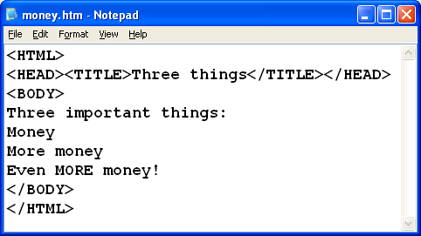
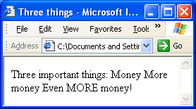

<P> tags

<P> makes block paragraphs

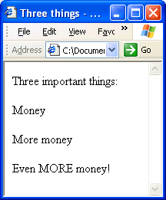
A blank line above and below

Closing <P> tag is optional
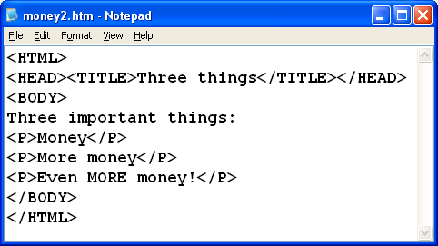

Multiple <P> tags

Multiple <P> tags have no effect

Text in a paragraph has a blank line above and below it, but not more than one blank line
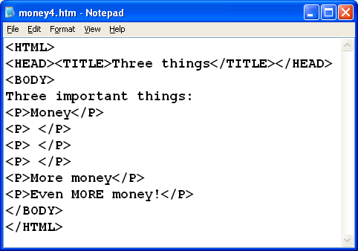
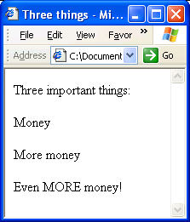

<BR> tags

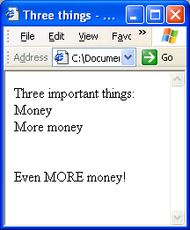
<BR> makes a line break

Multiple <BR> tags make blank lines

There is no closing </BR> tag
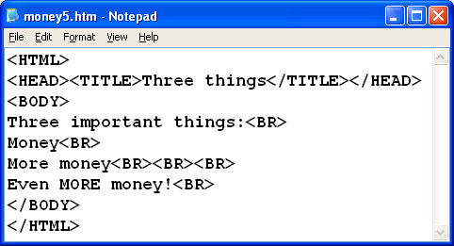

Heading Tags

Heading tags change font and also assure a blank line above and below the heading

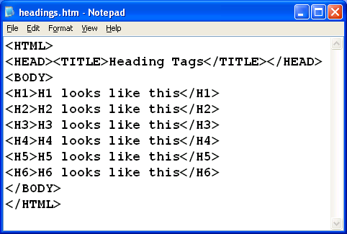
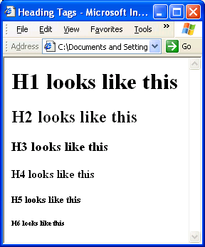

Formatting Tags

<I> italics

<B> bold

<U> underline

And, of course, the corresponding closing tags

</P> </I> </B> </U>

Adding an Image to Your Page

<IMG SRC=“duck.gif”>

Adds an image named duck.gif to the page

Use any image filename instead of duck.gif

On the Web, the most common image formats are .GIF and .JPG

Other formats like .TIF are usually not visible in browsers

Last modified 9-27-05

