Images in Folders

<IMG SRC="filename"> looks for filename in the same directory as the HTML source

<IMG SRC="subdir/filename"> looks for filename in the subdirectory subdir

<IMG SRC="../filename"> looks for filename in the parent directory
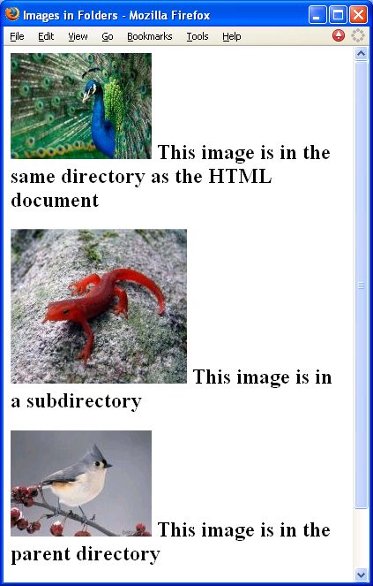
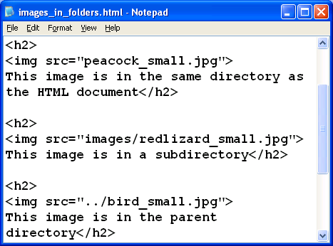

Those Files Look Like This in SSH Secure File Transfer

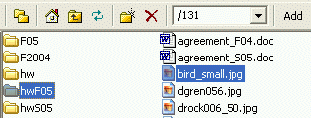

Parent directory

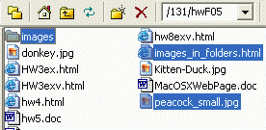

Directory containing HTML

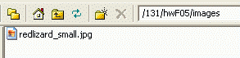

Subdirectory

Image Alignment: Horizontal

Horizontal alignment: use the align attribute.

align=“left” and align=“right” both cause text to wrap around the image

To center an image, or to prevent text wrapping, put it in a paragraph

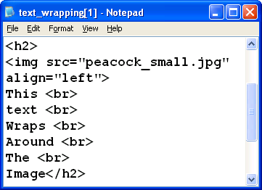

Image Alignment: Vertical

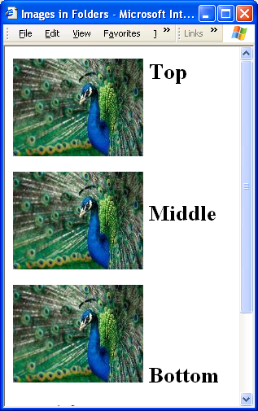
Vertical alignment: use the align attribute

align=“top”, align=“middle”, or align=“bottom” adjust the vertical location of an image on a line of text

Rarely used, because you can do this better with tables

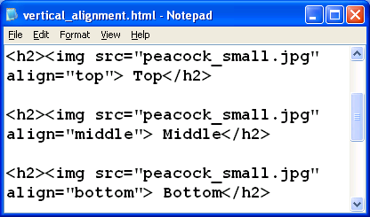

“White” Space Around an Image

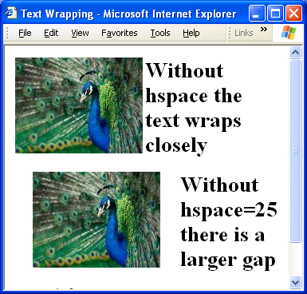
Attribute of image tag

Use vspace=“10” for 10 pixels of vertical space

Use hspace=“20” for 20 pixels of horizontal space

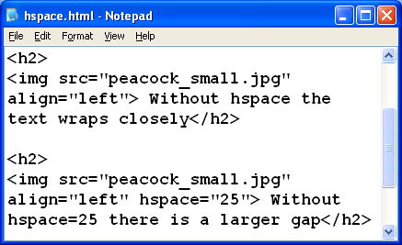

Image as a Link

Just put the <IMG SRC> tag inside an <A HREF> -- it becomes “hot” just like text does


“Hot” Images show a blue border
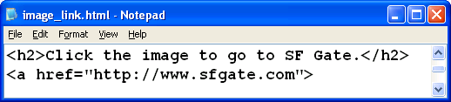

Lists: <ol>, <ul>, and <li>

<ol> -- ordered list (numbered)

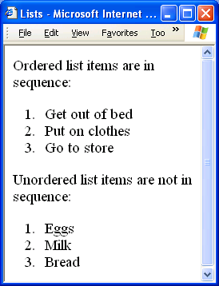
<ul> -- unordered list (bullets)

<li> -- List Item, same for both types of lists
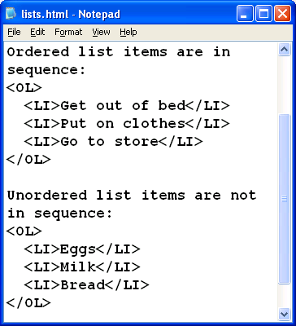

Comment Tag


Visible in source code, not rendered in the browser

<!-- -->

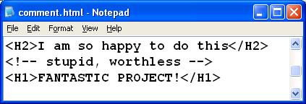

Browser Specific Issues

HTML and XHTML developed by W3C

Extra tags and attributes were added by browser makers

Size of monitor or browser window also affects the way a page looks

Number of Colors displayed varies (less of a problem these days)

Optimizing for Search Engines

Put the <META NAME> and <META KEYWORDS> tags in the header section of your page to help search engines

<meta name=description content=“ …”>

<meta name=keywords content=“ …”>

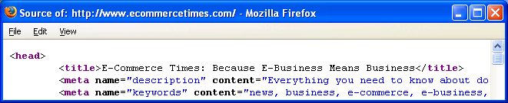

Do

Include short, meaningful <title>

Put keywords in main page

100 words or more on a page, keywords repeated many times

Comment tags can contain keywords too

Use keywords for file names

Use Themes

Arrange for other sites to link to you

Searchengines.com has more tips

Don’t

Repeat a keyword in the title more than twice

Repeat keywords many times in comments or other invisible text

Last modified 10-18-05

