Text Editors

Text editors don't have word processing features like formatting text and spell-check

Notepad is the Windows text editor

Textpad, Notetab, and EditPad are others

Programming Editors

Designed for writing code in specific languages

Color coded tags, scripts, browser preview

Ex: HTML-KIT

Described in last class

Skip CoffeeCup (p. 228-245)
WYSIWYG Editors

WYSIWYG

(What You See Is What You Get)

What you see on the screen is what will appear on the printer (or on the Web)

Word Processing Applications

They do the job, but generate a lot of extra code

Demonstration: Microsoft Word, File, Save as Web Page
NVU

An enhanced version of Netscape Composer, which is not included in Netscape 8

Free, Suitable for single pages and medium-sized Web sites

Download it from www.nvu.com

Works on Windows, Mac, or Linux

NVU Screen Image

Basic Formatting

Similar to word processing, Highlight and change

Tabs available:

Normal

HTML Tags

Source

Preview

Using a Table for Layout

Use a table to align an image with a list of items

Table will keep elements together in a block and can be flexible

Align an image with a list of items

Cell width changes as you add text

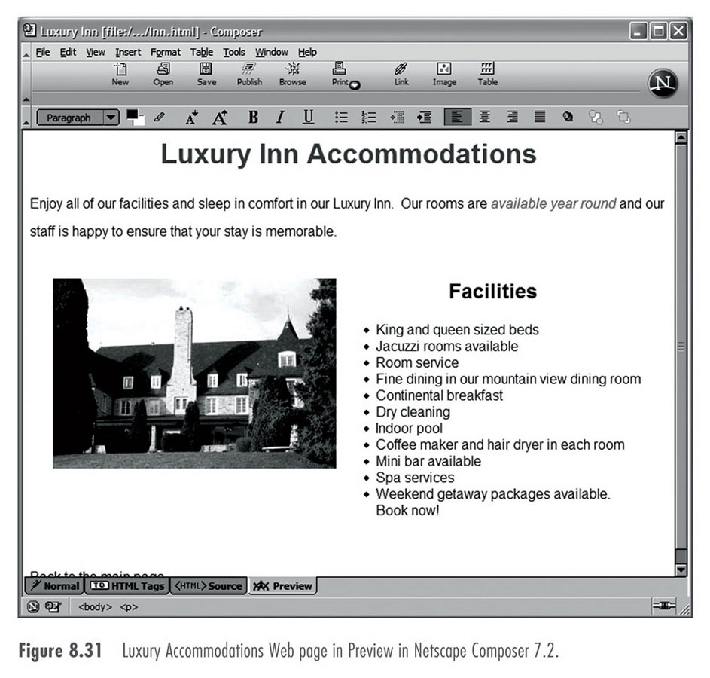
Table and Cell Alignment

Table, table properties

Cells tab

Preview

Hyperlinks

Highlight text and click the Links tool

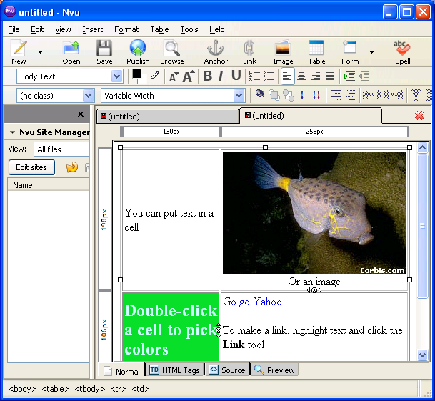

NVU Table Example

Macromedia Dreamweaver

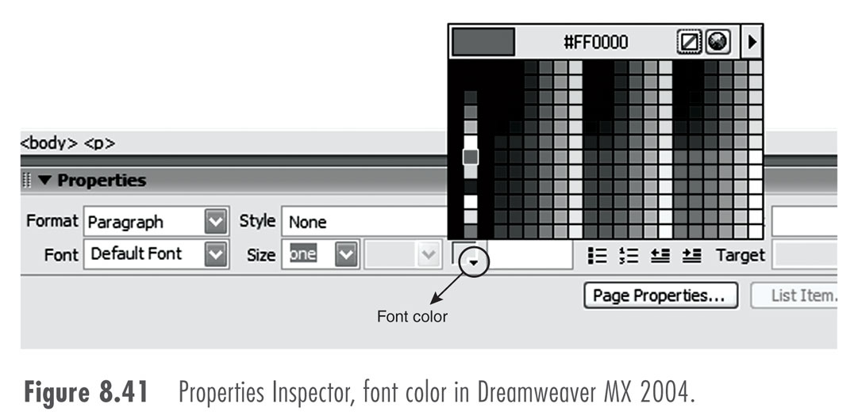
When websites become more complex, you need to maintain consistency among many pages

Use a template

Use synchronization (recent updates are stored locally and updated to the server automatically by FTP)

Basic Formatting

Property inspector

Paragraph format, color, font, alignment and others

Properties of the image

See the design panel

Style sheet

Formatting

Adding an Image

Images folder

Drag and select

Align

Adding a Table
Microsoft FrontPage

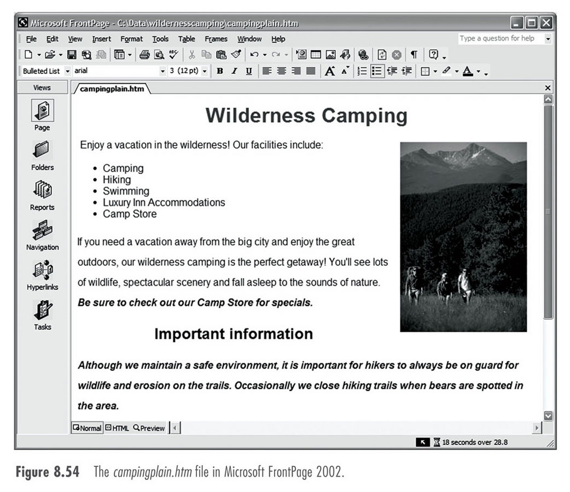
FrontPage and Dreamweaver have similar features

Similar to

Microsoft Office

Last modified 10-25-05

