Mass Communication

One person or agency communicating to many people through technological means

Mass Media

Newspapers, magazines, radio, television and movies

On the Internet

Mailing lists

Newsgroups

Web boards

Blogs
Mailing Lists

Email-based discussion groups where email messages are delivered to those who subscribe to the list

How Do Mailing Lists Work?

Must subscribe

Either via e-mail or at a Web page

Usually you must confirm the subscription by replying to an email message

Software at the mail server manages the list

Examples: Listserv, Majordomo

Mailing Lists: Moderated or Unmoderated?

Moderated

There is a moderator who decides whether or not to post a message on the list

Unmoderated

Messages can be freely posted to the mailing list without editorial restraint

Therefore, there is more spam

Mailing Lists: Restricted or Open?

Restricted

Moderator or list administrator must approve your subscription

Open

Open- anyone can join

What is the Difference between a Mailing List and a Newsletter?

How the list is used

Newsletters – publications that are produced by an agency or organization, and you subscribe to receive them

Mailing Lists allow you to post messages

Finding a Listserv List

Comprehensive global list of public listservs- Catalist (Link Ch 10a)

Demonstration: Subscribe to a list like OXYGEN3COM

Subscribing to a Newsletter Mailing List

Send a message to the listserv address

Sends a command to the listserv software program

Receive a confirmation

You will receive emails, but not send them

Subscribing to a Discussion Mailing List

You can send and receive messages

Such lists have two addresses:

Administrator Address – for commands, like subscribe and unsubscribe

List Address – for messages that will be sent to all other list members

Sending a Message to a Mailing List

Send to the List Address

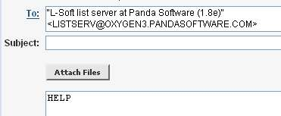
If the list is moderated, you will have to wait for approval before your message is sent to the list members

Mailing List Commands

Get a list of commands with HELP command

Can group or suspend messages

Some lists can be controlled through Web interfaces

Digest Mode

to receive only one message from the list per day

Unsubscribing from a Mailing List

To unsubscribe send an email message to the administrator address with the UNSUBSCRIBE command

Listserv, Majordomo, Listproc, and Other Mailing List Software

Important information is available in the subscription confirmation message

Discussion Lists with Web Access

Yahoo! Groups

Topica

Finding Mailing Lists

Use a search engine for mailing list topic

Search a mailing list directory like tile.net

Some Discussion List Etiquette and Tips You Need to Know

Always keep a copy of your mailing list welcome letter

Check your mailing list emails daily

Please participate

Please identify your messages posted to the mailing list with a meaningful subject line

Do not send an attachment to a mailing list

Unsubscribe from the group if you are going to be away

Look at the reply addresses when you are responding to a mailing list message – don't send private replies to the whole list

HW 12a is "Subscribing to a Mailing List"

Newsgroups

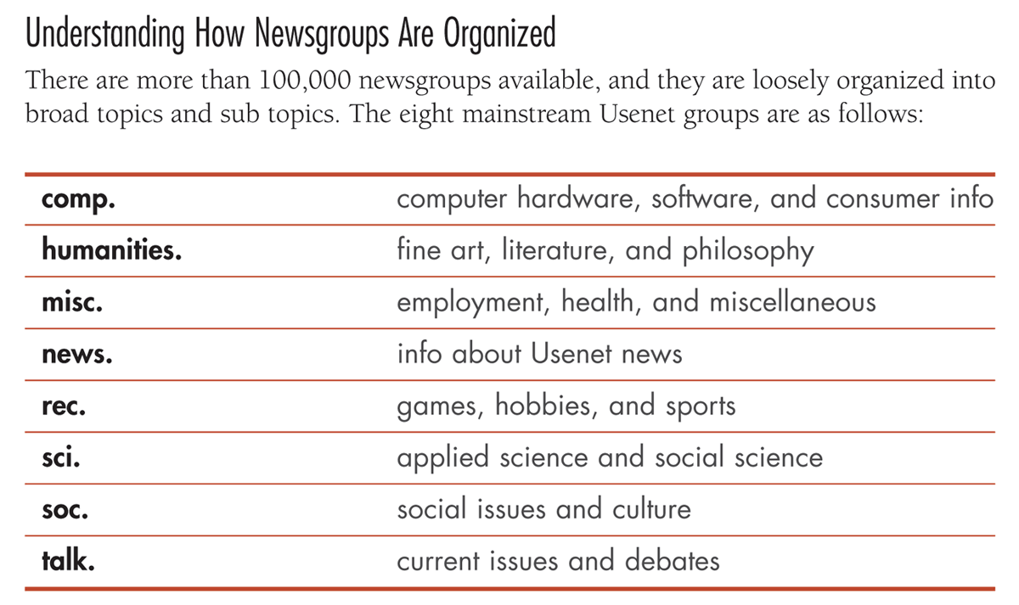
Newsgroups

An online discussion group

Also Called Usenet

Newsreader

Software that sends email postings to various newsgroups

Binaries

A non-text file such as a spreadsheet, word processing document, image, video or audio file

Usenet is one level of "Internet Underground"

Much more mainstream since Google bought the archives

alt. is the most popular and crazy topic

New groups can be added in the alt. category without a vote

In the other caterories, a vote is required

Newsgroups With Binaries

Typically have binaries in the group name

Binaries

A binary file type is attached (binary is a non-text file)

Audio, video, or image

Accessing Newsgroups Using the Web

Google.com, click on Groups

Click on Learn more about Google Groups

Google has greatly changed the USENET traditional structure

Threads

Posts are organized by date and by Thread

An online discussion; when the user posts a reply, the reply is grouped with the original message and any further replies

Threading

Method of grouping messages

Frequently Asked Questions (FAQ) Pages

Compilations of the most frequently asked questions (and their answers), pertaining to a given topic, usually assembled on a single Web page. FAQ documents are usually very thorough and well organized, evolving over time as a result of much online dialogue in special interest groups

Archived at www.faqs.org (Link Ch 10b)

Demonstration: click By newsgroups to see the original Usenet hierarchy

Searching Usenet With Google

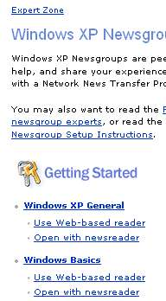
Do a sample search

Flame War

An email conversation wherein disgruntled parties use abusive communication to attempt to convey their point

Windows XP Help System connects to Usenet

Start, Help and Support, Get Support, Go to a Windows Web Site Forum, Go to Windows Newsgroups

Using Your ISP Newsfeed

News server

Set up through Outlook

Subscribing to a Newsgroup

Selecting a newsgroup in a newsreader

HW 12b is Using Usenet Newsgroups

Subscription Based Newsfeeds

Some newsgroup services don't give you access to all the newsgroups

To get them all, you can use a paid service

100 Proof News, All the Newsgroups, Usenet.com, Usenet ROCKET

Some Newsgroup Etiquette You Need to Know

Lurk – Listen before posting

Review the FAQ

Avoid flame wars and DON’T YELL

Don’t leave a lengthy message and simply reply “yes” – remove unnecessary parts of the message

Keep it short and simple

Be aware of copyright issues

Don’t be ethnocentric – Postings are global

Do not post advertisements

Ignore “trolls” : Trolls

Trolls make statements made to ignite people to respond in anger

Web-Based Discussion Boards

Discussion board

Web-based discussion list, which is neither a mailing list nor a Usenet newsgroup

Feedback, comment board, discussion forum

Start Your Own Discussion Board

EZBoard (Link Ch 10c)
Blogs

Short for Weblogs

Personal Web diaries and journals that are frequently updated and designed for public viewing

Blogger.com

The author of a blog can tell you the blog address

Searching for Blogs

Blogwise

HW 12c is Making a Blog

RSS

(Rich Site Summary, Really Simple Syndication) An XML-based method of sending headlines or summaries of sites to your desktop

Aggregator

A type of newsfeed that consolidates all headlines of a particular subject over a particular time

Searching for RSS Feeds- Sindic8.com (Link Ch 10d)

RSS Desktop Headline Viewer- FeedReader (Link Ch 10e)

Atom

Adopted by Google as a format for sending blog feeds

Other RSS and Atom Feed Readers

Pluck

Dogpile

Newsgator

HW 12d is RSS

Last modified 11-8-05

