Introduction

Asynchronous communication (Flex-time)

Users communicate at different times, waiting for a response before replying.

Examples: Email, Weblogs, Message boards

Synchronous communication (Real time)

Communication that happens at the same time

Examples: Telephone, Instant Messaging, Videoconferencing, Chat Rooms
Instant Messaging (IM) / Chat programs

Programs that allow you to type text and send it instantly to someone else who is using an IM program. In return, the person will be able to see your message and respond to it immediately

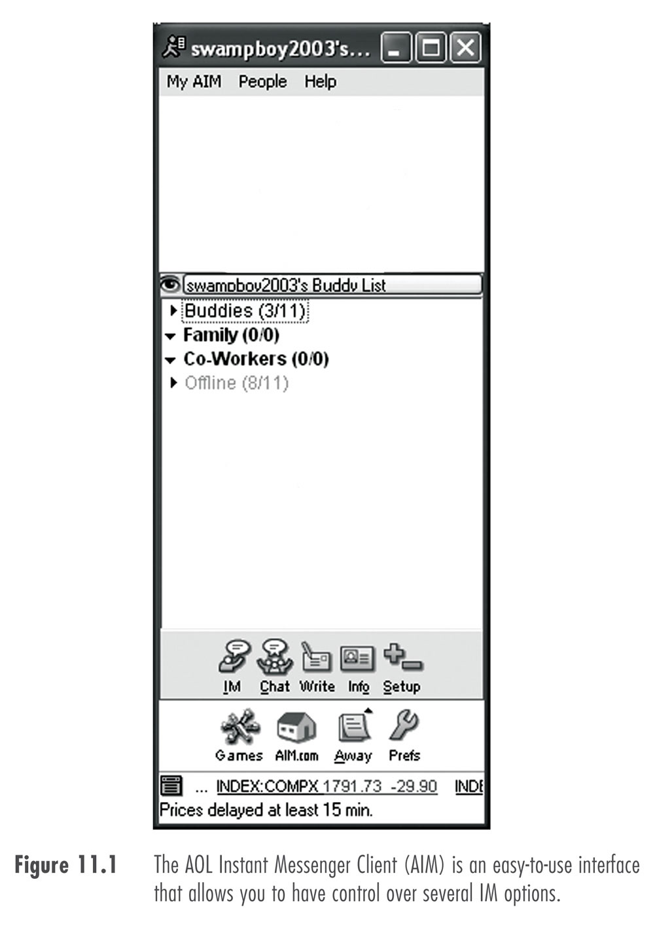
“Send me an IM” or “Someone is IMing me”

All chat programs have same essential features

AIM

America Online Instant Messenger (AIM)

Adware

Create a nickname and password

Buddies- Buddy name- Buddy List

Add a buddy

Send a chat

AIM Features

Blocking

Allows you to block IM’s from a contact or buddy you are blocking

Private Chat Rooms

Places where small groups of people can meet and discuss issues in real time

create a multiple party chat room

Sending Files

Send a file to someone on your buddy list

Security and Sending Files

Be careful-- files can contain viruses

Use anti-virus software

Firewall may block file transfers

A combination of software and hardware that filters traffic between the user and the Internet, or acts as a gateway to a network, protecting the network from unwanted traffic from other networks or the internet
Audio Chat

Voice over Internet Protocol (VoIP)

Turns the analog signals of voice and sound into a digital signal that can be transmitted over a network.

what equipment is required

advantages and disadvantages

Need a microphone, speakers and a full-duplex sound card

Half-duplex

Data can travel only one way at a time

Full-duplex

Data is transferred in both directions simultaneously

Videoconferencing

A communication with video and audio

Web Cams are commonly used to send low-quality video along with the voice

Demonstration of video chat in classroom

See links Ch 11 a – d, including the Iowa Corn Cam
Other Chat Clients

MSN Messenger

Features

Can send message to cell phones

Application sharing

Allows you and another user to share an application, such as a spreadsheet program

Whiteboard

A feature that allows you to post text to, or draw items on, a whiteboard shared by multiple users

Yahoo! Messenger

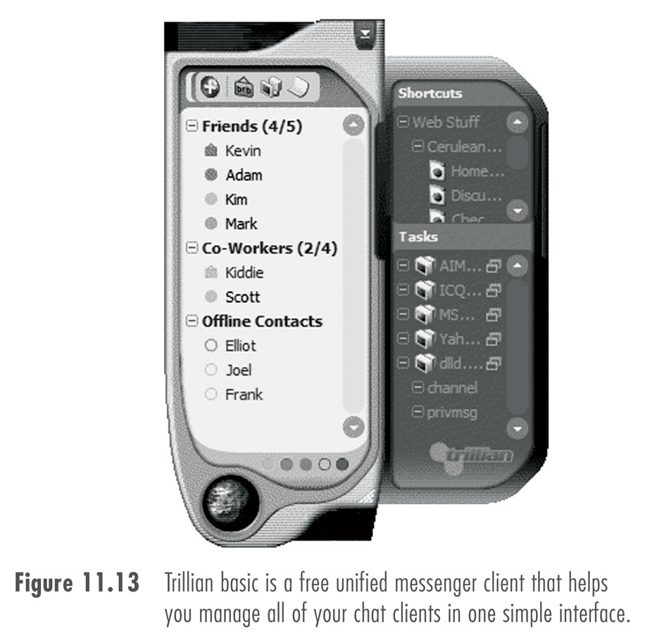
Same basic functionality

Advanced features

Trillian

Stock quotes

News from around the world

Weather updates

Direct news alerts

ICQ (I seek you)

Has the Same Basic features

Contact list management

Video-conferencing

Interface is different

Has special features

There is an ICQ Community

You can chat with random other ICQ users

Trillian

Popular unified messenger

Unifies your Yahoo, AOL, ICQ, and MSN contacts into one program

You need a userid and password for each service

Effective Chatting
A Brief History of Text Chat

Talk

A simple program that allowed users on networked computers to type messages to one another in real time

Talk heavily used in the late 1960s – APRANET

Affected productivity

IRC (Internet Relay Chat)

In 1988 Oikarinen wrote the Internet Relay Chat daemon (IRC-d)

IRC chat still exists; see Link Ch 11f for a simple Web interface

IRC is usually accessed with a special program like mIRC or BersIRC

IRC is blocked by many firewalls now because of an incredible amount of criminal activity

(see Link Ch 11g)
Chat Etiquette and Culture

There is not much etiquette or politeness

People are commonly rude and insulting

Keep 10% of the room on ignore at all times or risk serious brain damage!

Rules

Do not use ALL CAPS

Use emoticons and abbreviations with friends

Be streetwise – don’t give out personal information

Chat rooms are fraught with adult chat

People come and go quickly
Videoconferencing

1964 AT&T Picturephone introduced at World’s Fair

1970s and 1980s Develop high-end, expensive conferencing systems

1990s became available for the average user

With Intel- Internet conferencing came to life

1995 NetMeeting, QuickTime Conferencing

1996 Video Phone

Technical Developments

For net conferencing to be practical and affordable, these things were needed:

Compression standards for video signals

Inexpensive Video Cameras (Webcams)

Digital Signal Processors (DSPs)

Videoconferencing Etiquette: Setting

Appearance

Dress according to the situation

Avoid white or light colors and narrow stripes, busy prints, or shiny jewelry

Lighting

Don’t just rely on fluorescents

Don’t shine light directly on your face

Use a variety of indirect light sources

Background

Neutral dark plain background is best

Avoid movement in the background

Videoconferencing Etiquette: Conversation

Eye Contact

Same as face-to-face, look directly in the camera

Distance

How close or far you are from the camera

Audio is Usually More Important than Video

Audio Quality

Both people use headsets

Place speakers far enough from microphone to avoid echo

Video is more important than audio sometimes

Show them, don’t tell them

Etiquette

Shake Hands- “smile and a wave”

First contact best over telephone

Introduce people outside of the camera’s eye
IM in the Workplace

Social and business applications

Business versions of IM clients

Improve productivity

Security concerns

Spim (IM equivalent of spam)

Chat is usually unencrypted and easily intercepted, like Email

Chat sessions can be archived
Voice Over IP

Sends telephone traffic through your Internet connection

Can be free for PC-to-PC calls, and very cheap for PC-to-phone or Phone-to-Phone

911 calls are a potential hazard, because your location may be hard to determine

VOIP phones go out during power failures

Skype is extremely popular worldwide

See links Ch 11h, I, j, k

Last modified 11-15-05

