Adopting a Medium

New Communications Media

Printing Press With Movable Type – 1540

Wireless Telegraph – 1896

Elite-Popularization-Specialization (EPS) Cycle

A theory of mass media adoption

Introduced to (or by) elites

Dispersed among the popular masses

Expanded in availability so that content can become specialized

Phase One: Elites

Expensive at first, so the traditional power structures get it first

Government, military, higher education

The Internet was in this phase until the 1990s

Federal Communications Commission

Regulates both national and international communication in the U.S.

Phase Two: Popularization

Medium becomes part of the culture

Grass-roots communication

Informal self-literacy movement

Economic forces – medium is cheap enough for home use

Phase Three: Specialization

Demassification

Moves away from being a mass medium

Mass media saturate a given market and then shift perspective to capture niche audiences

Example: Google Ads – reaching only interested people

The Role of Change Agents in the Diffusion of Innovations

Interpersonal networks sometimes have more to do with the adoption of new ideas than the ideas themselves

Innovators 2.5% Adventurous, rich

Early Adopters 13.5% Respected, innovative

Early Majority 34% Conformist, less wealthy

Late Majority 34% Skeptical, cautious

Laggards 16% Suspicious, poor

Change agent

An individual who influences clients’ innovation-decisions in a direction deemed desirable by a change agency

Decentralizing Our World

Decentralizing Government

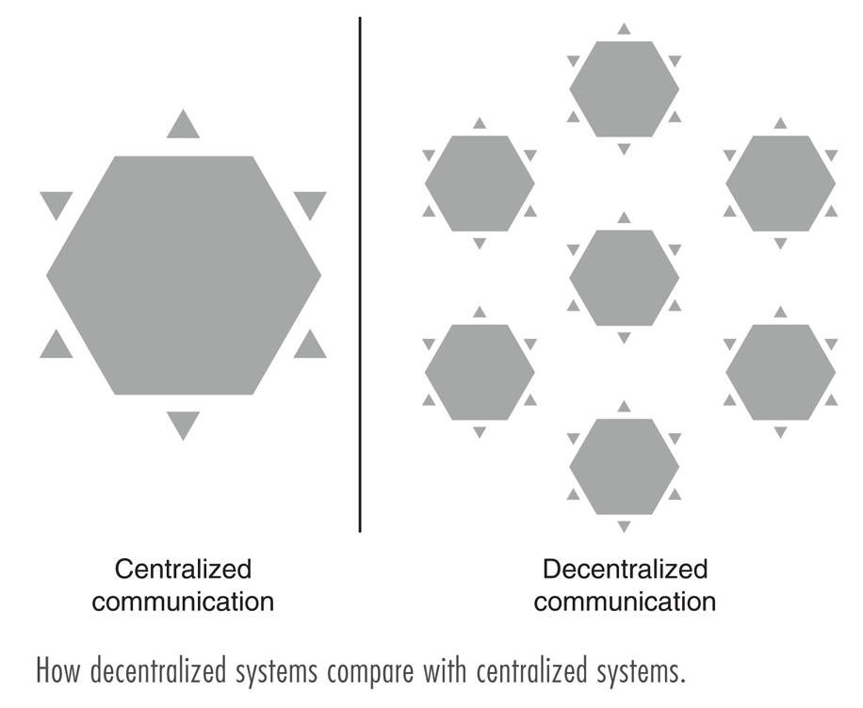
Finding Government Information Online

http://www.state.ca.us/

Gate-Keeping

Many officials can be located and contacted directly, rather than having to pass through official channels

Bypassing the Traditional Media

Candidates and officials can publish directly to the people without going through media channels

Howard Dean campaign used the Web to run a campaign with very little funding

Decentralizing Education

Self-Instruction

The user can teach himself or herself

Decentralizing the Institution and the Classroom

Large rise in equipment being used

Decentralized campus

The Rise of the Virtual University

Distance Learning

Courses delivered to students who are not physically on campus

Decentralizing the Children

Internet access in every school and classroom

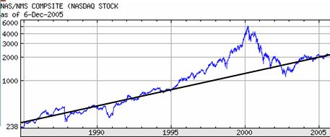
Decentralizing the Economy

The dot com era

The information technology sector

Figure from Yahoo.com; line is approx. 10% annual growth

The Virtual Office

Work anywhere, anytime

Email is commonplace

Intranet

An internal TCP/IP network for employees to access information about a company; not meant for public consumption

Decentralizing the Community

Community discussions can be online

Community networks may provide Web access, and advance local issues

Concept of community changes – communities are not just people physically near one another

“Interest communities”

Decentralizing the Individual

Logical Diversity and Desensitization

On the Internet, a person can see much information and also a lot of misleading or false data

This could lead to Sensitization or Desensitization

Social Isolation

Blessing & Curse

Lifestyle Impacts

Less time with friends and family

Less time away from home at actual events
Resources: Keeping Pace with the Internet

Mailing Lists, Discussion Groups, and Online Journals for topics of interest

Internet Scout Report (http://scout.wisc.edu)

Slashdot.org

Digg.com

News Alerts

Keep current with real-time news: Google, more, alerts

Bookmark Web Sites

Remember favorites

Magazines

Computer magazines

Books

Greater depth

Last modified 12-6-05

