Checklist to setup a C218 workstation for Eagle Server labs.
(This looks like a lot of steps at first, but it gets easy after you do it a few times.)

The basic idea is to "patch" a workstation through to a dedicated switch that connects to the Eagle
Server. We use "structured cabling". That is where we have a long, fixed cable run from in the room to an equipment cabinet, & use a short “patch cable” on each end to connect the workstation to a switch. Structured cabling provides a lot of flexibility that we use later on.
=========================================================================
Lab Physical Layout:
Each C218 workstation has two NICs
-the NIC in center of the back of the computer is called CCSF & goes to the Internet.
-the NIC in the left of the back of the computer is called CISCO & goes to the cabinets in the back.
-A yellow cable connects the CISCO NIC to the structured cabling.
-The structured cabling connects to patch panels in 4 cabinets in the back of the room.
-The patch panel “port#” used by a workstation is on a label on each computer.
In each of the four cabinets in the back:
-“patch panels” are near the top of a cabinet (port# is shown by paper labels):
-ports 1-12 are in the 1st (nearest the windows) cabinet.
-ports 13-24 are in the 2nd cabinet.
-ports 25-36 are in the 3rd cabinet.
-ports 37-48 are in the 4th (nearest the door) cabinet.
=========================================================================
Steps to do:
Boot up your workstation. Note the “patch panel port number” to connect to.
Get a straight through patch cable (in our lab, one that is NOT orange or striped orange).
Go to the cabinets in the back of the room:
-find your port# in one of the four cabinets according to the chart above
-connect one end of the patch cable to the your workstation’s port#
-connect the second end of the patch cable into an eagle server switch (there are two):
-for ports 1-24, use any open port on the switch at the bottom of the leftmost cabinet.
-for ports 25-48, use any open port on the switch near the top of the rightmost cabinet.

-the light above where you connect on the switch turns first yellow, then green.
(If it does not turn green after a few minutes, then check the port# you plugged into,
that you have a straight through cable, & that your computer is turned on.)

- back at the workstation...

- if you want access to the lab manual while you do the labs...
go to http://fog.ccsf.edu/~pwood/c201E-calgen.html
in the upper right is link to a pdf of the full lab manual. (username/password: cisco/class)

- disable the "ccsf" NIC
-click Start and type in Connections. Click "View network connections".
Right-click on the NIC labeled "CCSF", and "Disable" it.
- turn off the firewall
-click Start and type in Firewall. Click "Windows Firewall".
On the left side of the "Windows Firewall" box, click "Turn Windows Firewall on or off"
Select both "Turn off Windows Firewall (not recommended)" buttons and click OK.
- open up a DOS command window & test your connection.
- check the current nic config by typing: ipconfig (only the "cisco" nic configuration will show)
- check that you can ping the "gateway ip address" (shown by ipconfig)
(this shows that you are cabled up correctly & have the firewall off.)
- check that you can ping through to the eagle server ip address (192.168.254.254)
(this shows that you have the correct default gateway in your routing table.)
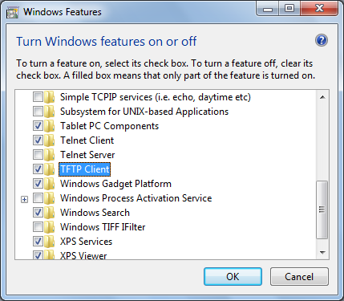
Now you are ready to begin the labs.

Installing TFTP and TELNET
Windows 7 no longer includes these clients by default. You need to add them with this procedure:
Click Start, and type FEATURES
Click "Turn windows features on or off"
Check both the "Telnet Client" and "TFTP Client" items, as shown to the right on this page.
Click OK.

When you are done with your labs,
-reset the workstation to its original configuration by rebooting it.
-after the reboot, test it by:
-starting a web browser,
-refreshing the home page, and
-going to some off-campus website, like http://cisco.netacad.net

Last modified 2-13-10

