How to Get CCSF E-mail

If you are already using pine or GroupWise, continue getting it that way.

You need to know your HP-UNIX ID and password. Your instructor has a list of your IDs, but you can usually figure it out this way:
Use the first letter of your first name, then the first five letters of your last name, then a number which is usually 01.All letters are lowercase. So Joe Green’s HP-UNIX ID would be jgreen01. The only problem is that if several students have similar names, one of them is 01 and the next is 02 and so on, so if your name is a common one you won’t know the number.

Your first-time password is your birthday, in this format: three letters for the month, two numbers for the day of the month, two numbers for the year. So a birthday of March 13, 1978 is mar1378 and a birthday of Nov 2, 1960 is nov0260.

If you access your HP-UNIX account using Telnet or SSH Secure Shell, you will be forced to change your password to a new one you make up the first time you log in. If you use the WebIMAP page described below, you will not be forced to change your password.

WebIMAP

Start a browser and go to hills.ccsf.edu/mail

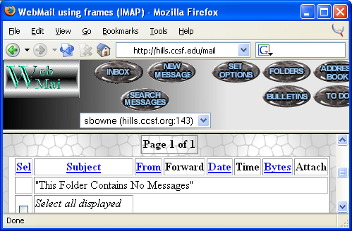
Enter your HP-UNIX ID and password. The first time you use it you will see a configuration page – just accept the defaults and go on to the main MAIL page shown below. It’s a normal Web mail interface like Hotmail or Yahoo mail.

