Setting up for lab 10.6.1
Using the Console Server to Connect to a Router
- Decide which router you are using. For lab 10.6.1, choose one of the 1841 routers. Get the router’s number off its front panel—it will be something like R16. Turn the router off and back on again.
- Use a PC connected to the Internet.
- Click Start, Run. Type in this command, and then press the Enter key:
telnet 147.144.51.244
- A Telnet window opens. Type in your router’s number—something like r16 and then press the Enter key. Another message appears. Press Enter again.
- If you see a message asking “Would you like to enter the initial configuration dialog? [yes/no]:”, type no, and then press the Enter key.
Configuring a Router
- When you see a Router> prompt, type enable and press the Enter key. If it asks for a password, try cisco or class.
- When you see a Router# prompt, type in this command, and then press the Enter key:
configure terminal
- Type in these commands, pressing Enter after each one:
interface FastEthernet0/0
ip address 172.20.0.202 255.255.255.252
no shutdown
interface FastEthernet0/1
ip address 172.20.0.198 255.255.255.248
no shutdown
- Type Ctrl+Z.
- Type in this command, and then press the Enter key:
show ip interface brief
- Compare the results to the figure below on this page. If it is correct, your router is now configured.
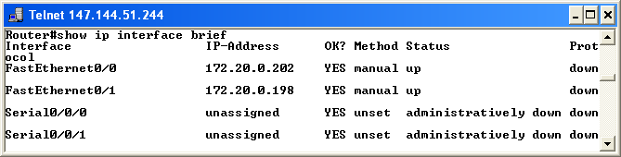

Ending the Console Server Session
- Press Ctrl+W. Then press X. .
- Type disconnect and then press the Enter key. Press the Enter key again.

