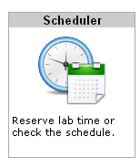
NETLAB is a software and hardware system that lets you remotely control real routers, switches, and virtual PCs through a Web browser, so you can do Cisco projects anytime from any computer that has an Internet connection.
- To connect: open a browser and go to http://147.144.51.247
- Log in with the username and password your instructor gave you.
- Click on the Scheduler icon, as shown to the right on this page.
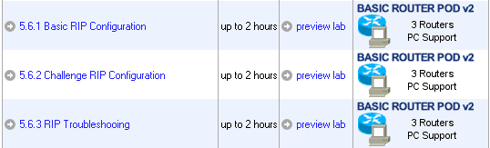
- At the Select Class screen appears, click on your class, such as CNIT_201E_S10_TR
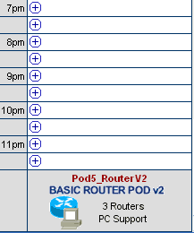
- At the next screen, click the desired exercise, as shown to the right on this page.
- If you are in CNIT 201E, use column titled "NETWORK FUNDAMENTALS POD". If you are in CNIT202E, use a column titled "BASIC ROUTER POD v2" columns, as shown to the right on this page. Click on an available time.

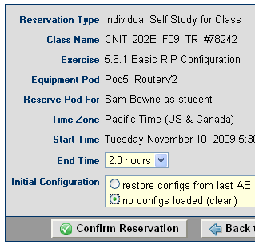
- On the next page, adjust the End Time so you have at least 2.0 hours. If you are in CNIT 201E, set the Initial Configuration to "load default configs for exercise". If you are in CNIT 202E, set the Initial Configuration to "no configs loaded (clean)". Click "Confirm Reservation".
- On the next page, click "I'm Done".
- If your reservation was for a future time, you need to wait till that time.
- When the scheduled time comes, log in to NETLAB and click "ENTER LAB".
- You have to wait for 5-10 minutes for the lab to initialize.
- If you are in CNIT 201E, the labs include an EAGLE SERVER. The EAGLE SERVER often requires manual input to start properly. To do that, clicking on the EAGLE SERVER icon, and press “1” followed by the Enter key.
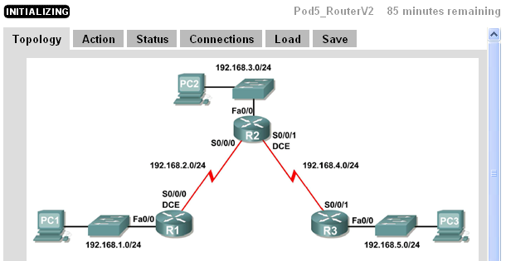
- If you are in CNIT 201E, do this step first: click on one of the PCs. On the PC’s desktop, click Start, Run, type in CMD and press Enter. In the Command Prompt window, type IPCONFIG and then press the Enter key. If your IP Address does not start with 172, you won’t be able to connect to the EAGLE SERVER, so type IPCONFIG /RENEW and then press the Enter key. After that, type ping eagle-server.example.com and then press the Enter key. You should get replies. If you can’t ping the EAGLE SERVER, you won’t be able to do any labs that require it.
- When the lab is ready, click on the PCs, Routers, and Switches (if any) to control the devices. The router logins are cisco and class
- When you are done, click the “I’M DONE” button, so other students can use the pods.

Last modified 2-13-10

