Eagle Server Orientation and Setup Lab

Topology Diagram
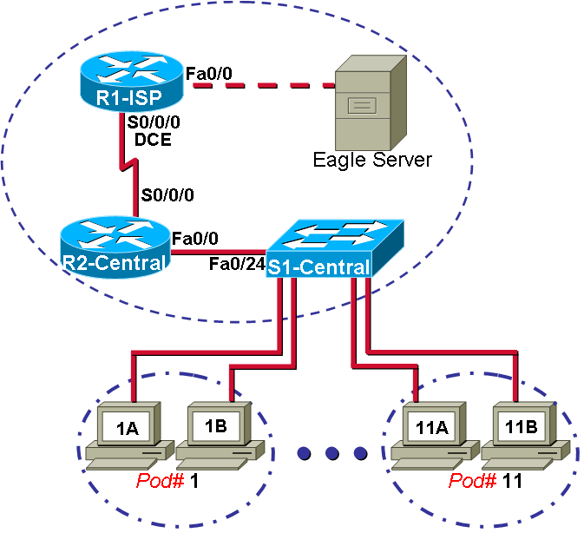

Addressing Table
Device | Interface | IP Address | Subnet Mask | Default Gateway
R1-ISP | S0/0/0 | 10.10.10.6 | 255.255.255.252 | N/A
R1-ISP | Fa0/0 | 192.168.254.253 | 255.255.255.0 | N/A
R2-Central | S0/0/0 | 10.10.10.5 | 255.255.255.252 | 10.10.10.6
R2-Central | Fa0/0 | 172.16.255.254 | 255.255.0.0 | N/A
Eagle Server | N/A | 192.168.254.254 | 255.255.255.0 | 192.168.254.253
Eagle Server | N/A | 172.31.24.254 | 255.255.255.0 | N/A
hostPod#A | N/A | 172.16.Pod#.1 | 255.255.0.0 | 172.16.255.254
hostPod#B | N/A | 172.16.Pod#.2 | 255.255.0.0 | 172.16.255.254
S1-Central | N/A | 172.16.254.1 | 255.255.0.0 | 172.16.255.254

Learning Objectives
Upon completion of this lab, you will be able to:
- Understand the purpose of the lab devices.
- Understand and cable the lab physical topology.
- Understand and configure the logical network and configure Cisco devices.
- Verify end-to-end network connectivity.

Background
Labs are designed to reinforce computer networking concepts that are taught in curriculum. The labs provide discovery and experience in configuring Cisco switches and routers to construct a functional computer network. In addition to the simulated network labs used with Packet Tracer, students also gain valuable hands-on experience with real equipment. This lab orientation is an examination of the lab topology, network components, logical network addressing, and connectivity testing.
The lab environment is self-contained, and requires no outside connectivity to the Internet to perform labs. Student labs consist of configuring host computers to connect different devices on the local area network (LAN), configure connectivity to the wide area network (WAN), and use typical network services such as DNS to access network services.
In later labs, students use the real equipment to capture and analyze data communications and troubleshoot common network configuration issues on computer hosts, Cisco switches, and Cisco routers.
The lab environment is designed to be separate from a production network, and requires no additional connectivity to any other network to complete student labs. All resources that the students will use to complete labs are shown in the above topology diagram. Some network client software for host computers such as Wireshark, may need to be installed but is available on Eagle Server for download. The Eagle Server FAQs contains a complete list of software required for students to complete lab exercises.

Scenario
One of the best ways to examine and understand the lab topology is to actually cable the devices, which involves connecting the devices as shown in the topology graphic. The instructor may demonstrate to the class how the Cisco devices are configured for WAN connectivity, along with installing Eagle Server software for network services. If desired, the class can participate in building the lab environment and verifying end-to-end connectivity between each computer host and Eagle Server.

Purpose of the lab devices

Host computer
Host computers provide students with network access and services. The computer is used as a client for popular network services, enabling the student to analyze those protocols. As a data capture tool, the computer is used to monitor data communication between itself and a network server. The data communication is examined to give an understanding of the underlying protocols. Finally, the host computer is used as a troubleshooting tool in labs that teach troubleshooting skills.

S1-Central switch
S1-Central switch provides LAN connectivity in the lab environment. The switch routes frames between the host computers and network end devices.

R2-Central router
R2-Central router acts as the LAN gateway, enabling host computers to connect to devices outside of the LAN. The router may be configured as a DHCP server, responding to host computer DHCP requests for IP addresses. The router may be configured with additional IP addresses to simulate different computer networks prior to accessing the network edge router, R1-ISP. Finally, the router has an enabled web-server that students use for router configuration and connectivity testing.

R1-ISP router
R1-ISP router is the classroom edge router, simulating the Internet service provider (ISP) role in a computer network. Additional IP addresses may be configured on R1-ISP to simulate external Internet sites, test correct routing protocol configuration, and as another link in the data communication path during troubleshooting exercises. Finally, the router has an enabled web-server that students use for router configuration and connectivity testing.

Eagle Server
The Eagle Server has several roles in the lab. It acts as network server for the class, enabling students to connect host computer client applications to the network service. It is a name server, translating lab domain names to IP addresses. When the host computer has networking correctly configured, students may use a web client application such as Mozilla Firefox, enter URL http://eagle-server.example.com, and receive a web page from Eagle Server. Email servers, SMTP and IMAP, permit students to configure an Email client on the host computer and send Email to each other. FTP and TFTP servers are enabled. An Internet relay chat (IRC) server permits host computers with chat clients to connect. When students learn about Web logs (blogging) and Wikis, Eagle Server may be used to teach Wiki use.

Eagle Server is provided to Cisco Network Academies on CD, or available for download as an ISO image. The CD contains a bootable Linux file system, and may run network services directly from RAM. Unfortunately, any modifications made to Eagle Server are lost when the computer is rebooted. If the instructor desires a more permanent installation, the file system may be installed on spare Linux or Windows FAT partitions on the Eagle Server hard disk drive. Instructions for use are displayed when the Eagle Server CD is booted, and detailed information is available in the Eagle Server FAQs.

Instructors are encouraged to change the system administrator password, user root, before students access Eagle Server. Other user passwords may be changed if required. Instructions for changing passwords are displayed in the opening screen.

Physical lab topology and cabling
The physical topology for the lab environment supports curriculum and labs in chapters one through nine. It is a fixed topology, and requires no additional cabling between labs. The number of host computers may vary in classrooms, depending on the number of students.

Each host is connected to the S1-Central Cisco switch through a straight-through CAT-5 or better UTP cable. Different classroom constraints may require the students to connect host computers to a patch panel or a wall outlet, but the final cable destination will be to S1-Central.

S1-Central is directly connected to router R2-Central with a straight-through CAT-5 or better UTP cable. The combination of host computers, S1-Central, and R2-Central interface fa0/0 constitutes the LAN configuration.

R2-Central interface fa0/0 is the host computer gateway to other networks in the lab environment. R2-Central is directly connected to router R1-ISP through serial DTE and DCE cables, respectively. This topology simulates multiple hops, or routers, between the host computer and Internet, simulated by Eagle Server.

R1-ISP is connected to Eagle Server with a cross-over CAT-5 or better UTP cable. Different classroom constraints may require the students to connect the devices through a patch panel, but the final cable destination will be to Eagle Server.

The following steps detail the lab equipment and physical connectivity.

Step 1. Lab equipment requirements

Hardware | Qty | Description
Cisco Router, Model 1841 | 2 | Part of CCNA Lab bundle.
Cisco Switch, Model 2960-24 | 1 | Part of CCNA Lab bundle.
*Computer (host) | Minimum 2 | Generic computer
**Computer (Eagle Server) | 1 | Generic computer
CAT-5 or better straight-through UTP cables | Minimum 3 | Length dependent on equipment location. Number is dependent on the number of host computers.
CAT-5 cross-over UTP cable | 1 | Connects Eagle Server to R1-ISP
Cisco DCE serial cable | 1 | Part of CCNA Lab bundle.
Cisco DTE serial cable | 1 | Part of CCNA Lab bundle.
Table 1. Equipment and hardware for lab

Gather the necessary equipment and cables. To configure the lab network, the following equipment and hardware is required. Refer to Table 1.

* Host computer requirements:
CPU: Minimum Pentium 3 or equivalent
RAM: Minimum 256 MB
HDD: Minimum 15 GB
NIC: (network interface card), Qty 1
OS: Minimum Microsoft Windows 2000

** Eagle Server computer requirements:
CPU: Minimum Pentium 3 or equivalent, Pentium 4 or equivalent recommended

RAM: Minimum 512 MB, 1 GB recommended
HDD: Minimum 15 GB, 4 GB required to install Eagle-server on HDD.
CD-ROM: Minimum 40x CD-ROM
NIC: (network interface card), Qty 1
OS: Minimum Microsoft Windows 2000

Step 2. Physically connect devices in lab.

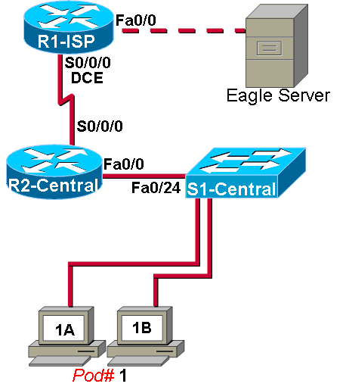

Figure 1. Physical topology

Network devices are physically connected with the proper cables, as shown in Figure 1. Additional Pod computers have been removed for clarity, but are connected similarly. The dashed line between R1-ISP and Eagle Server is a CAT-5 cross-over cable. All connections to S1-Central are with made with CAT-5 or better straight-through UTP cables.

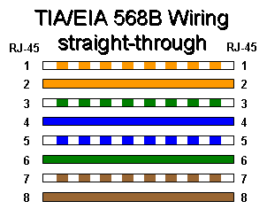 | 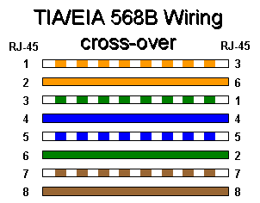

If cables must be constructed, the wiring graphics above can serve as a wiring reminder.

Remember to observe standard safety practices when working around energized equipment. Power state is normally not an issue with the switch and computers, but the instructor may decide to power off routers when connecting serial cables.

College rules for classrooms may exclude drinks or liquids, which cause electrical explosions when spilled inside energized electrical equipment. Cables strewn about the floor pose a trip hazard, and should be run outside of normal walk areas. The instructor may add to college rules, ensuring the students are safe.

Physically connect the equipment according to the network topology shown in Figure 1. For example, host Pod1A would be connected to S1-Central port fa0/1, host Pod1B would connect to S1-Central port fa0/2, etc. When connecting host computers to S1-Central, it is a good idea to connect the computers sequentially to switch ports. While network connectivity would not be affected by connecting host computers to any open port, troubleshooting time will be significantly increased because each cable would have to be checked against the host computer. Also, labeling cables is more than simple cosmetics. LAN cables are normally labeled to expedite troubleshooting. If cable labeling equipment is available, one or two students may create the labels and apply them to the cables as they are connected to S1-Central. Neatly written labels, wrapped in tape, are also sufficient.

R1-ISP acts as the DCE device for R2-Central, and must originate the serial timing signal. The DCE device uses a female serial cable. The DTE device, R2-Central, uses a male serial cable. It is normally beyond the current knowledge of students to understand the meaning of serial clocking, but it is important for students to be aware of serial cable differences. Later, the clock signal must be configured on the R1-ISP serial 0/0/0 interface. If desired, configuration can be demonstrated to the class.

Step 3. Visually inspect connections for proper location.
Perform a visual inspection to insure proper connections. Depending on the power state of the devices, S1-Central may not show a green link for every host connection. When the host is powered on and the interface has been enabled, the corresponding switch port should transition from amber to green after a few moments.

Logical network addressing and Cisco device configuration

Device | Interface | IP Address | Subnet Mask | Default Gateway
R1-ISP | S0/0/0 | 10.10.10.6 | 255.255.255.252 | N/A
R1-ISP | Fa0/0 | 192.168.254.253 | 255.255.255.0 | N/A
R2-Central | S0/0/0 | 10.10.10.5 | 255.255.255.252 | 10.10.10.6
R2-Central | Fa0/0 | 172.16.255.254 | 255.255.0.0 | N/A
Eagle Server | N/A | 192.168.254.254 | 255.255.255.0 | 192.168.254.253
Eagle Server | N/A | 172.31.24.254 | 255.255.255.0 | N/A
hostPod#A | N/A | 172.16.Pod#.1 | 255.255.0.0 | 172.16.255.254
hostPod#B | N/A | 172.16.Pod#.2 | 255.255.0.0 | 172.16.255.254
S1-Central | N/A | 172.16.254.1 | 255.255.0.0 | 172.16.255.254
Table 2. Lab logical IP addresses

Logically configuring each device in lab is essential for end-to-end network connectivity. Use the IP addressing scheme in Table 2, above, to configure each device.

Step 1. Logically configure host computers.
Host computer network configuration depends on the placement of the computer in the network. Also, R2-Central may provide IP addresses through DHCP, but the media access control (MAC) address of each host must be set in R2-Central for correctly matching the host computer to the diagram. To manually assign an IP address to a host computer, perform the following:

On the host computer, select start | Control Panel | Network Connections.

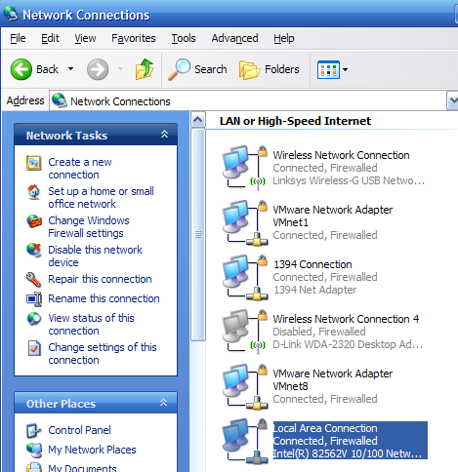

Figure 2. Local Area Connection icon

Identify the Local Area Connection device icon, shown in Figure 2. Move the mouse pointer to icon, right-click, and select properties.
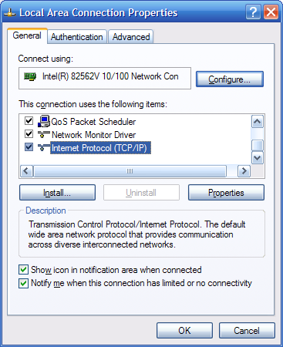

Figure 3. Local Area Connection properties screen.

Highlight Internet Protocol (TCP/IP) as shown in Figure 3, and select Properties.

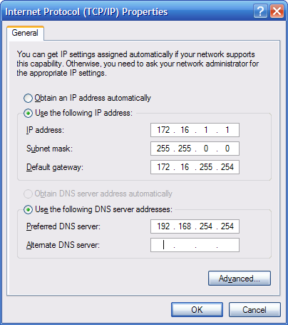

Figure 4. Manually configure an IP address.

Refer to Figure 4. The following configuration is for computer A in Pod 1. Follow these steps to manually configure the logical IP address information:

Click radio button for “Use the following IP address:”
IP address: 172.16.1.1
Subnet mask: 255.255.0.0
Default gateway: 172.16.255.254
Click radio button for “Use the following DNS server address:”
Preferred DNS server: 192.168.254.254

If R2-Central has been configured to provide IP addresses via DHCP, follow these steps:

Click radio button for “Obtain an IP address automatically”

Click radio button for “Obtain DNS server address automatically”

Select OK. The computer may require reboot for changes to be effective.

Note: R2-Central is configured as a DHCP server, responding to DHCP requests from host computers. In this case, a table should be created that lists the host computer pod number, computer letter, and corresponding MAC address information. The host computer MAC address can be obtained from start | run | cmd. Execute the command ipconfig, shown in the following command output, and record the entry in a table:

C:\Documents and Settings\Owner.GW-DESKTOP-HOM>ipconfig /all

<output omitted>
Ethernet adapter Local Area Connection:
Connection-specific DNS Suffix . :
Description . . . . . . . . . . . : Intel(R) 82562V 10/100 Network Connection
Physical Address. . . . . . . . . : 00-16-76-AC-A7-6A

Dhcp Enabled. . . . . . . . . . . : No
IP Address. . . . . . . . . . . . : 172.16.1.1

Subnet Mask . . . . . . . . . . . : 255.255.0.0
Default Gateway . . . . . . . . . : 172.16.255.254
DNS Servers . . . . . . . . . . . : 192.168.255.254
C:\Documents and Settings\Owner.GW-DESKTOP-HOM>

Host Computer Pod # | Computer | MAC address
1 | A | 00-16-76-AC-A7-6A
2 | B | 00-16-76-D1-02-3F

Step 2. Configure S1-Central switch.
To configure S1-Central Cisco switch, first insure that the switch has no current configuration. It is a good habit to first erase any existing configuration file in NVRAM, delete the vlan.dat file, and reload the switch before applying a new configuration.

Switch> enable

Switch# erase startup-config

Switch# delete vlan.dat

Switch# reload

An abbreviated Cisco 2960 switch configuration that supports lab connectivity is provided in Appendix 1. The instructor should change the enable secret and instructor passwords, and possibly add additional configuration.

Step 3. Configure R2-Central router.
To configure R2-Central Cisco router, again, it is a good habit to first erase any existing configuration file in NVRAM and reload the router before applying a new configuration.

Router> enable

Router# erase startup-config

Router# reload

An abbreviated Cisco 1841 router configuration that supports lab connectivity is provided in Appendix 2. Please note that the module/port numbers may need to be changed if using a different router or module slot. The instructor should change the enable secret and instructor passwords, and possibly add additional configuration.

Step 4. Configure R1-ISP router.
Configure R1-ISP Cisco router, following the above procedure.

Router> enable

Router# erase startup-config

Router# reload

An abbreviated Cisco 1841 router configuration that supports lab connectivity is provided in Appendix 3. Please note that the module/port numbers may need to be changed if using a different router or module slot. The instructor should change the enable secret password, and possibly add additional configuration.

Step 5. Start Eagle Server.
Enable Eagle Server. Eagle Server should be connected to R1-ISP and the router configured prior to starting Eagle Server. Server configuration can be as simple as booting the computer from the Eagle Server CD, and following startup instructions.

The instructor should change the system administrator password for root and other user passwords as appropriate. Refer to Eagle Server FAQs for changing passwords.

Verify end-to-end connectivity.
From each host computer, open a web browser to URL http://eagle-server.example.com. A welcoming message should be displayed. A web browser is not normally used to troubleshoot network connectivity issues, but can be very useful when verifying LAN and WAN connectivity and domain name translation.

If the web page is not displayed, use the following steps to logically troubleshoot the network.

Step 1. Test connectivity between host computers and S1-Central.

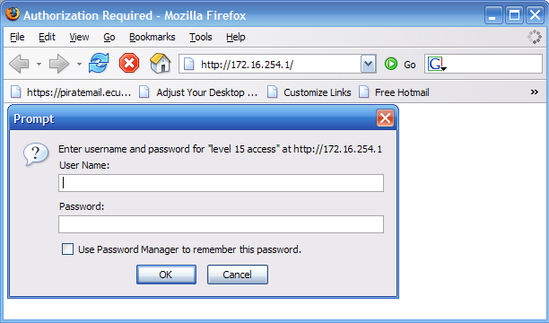

Figure 5. Web server screen on S1-Central

Test host computer connectivity with S1-Central. Use a web browser and connect to URL http://172.16.254.1. Figure 5 shows the web server authorization screen. NOTE: Login is not necessary and may not be possible. This test insures proper configuration of the host computer to S1-Central.

If the S1-Central web page is not displayed, apply simple troubleshooting procedures:

- Layer 1 troubleshooting: check cabling between the host computer and S1-Central. A green link light should be present on the appropriate S1-Central port. If it is not, replace the cable and retest.
- Layer 3 troubleshooting: reconfigure the host computer IP address and IP mask.
- If everything checks good, there may be a configuration error on S1-Central.

Step 2. Test connectivity between host computers and R2-Central.

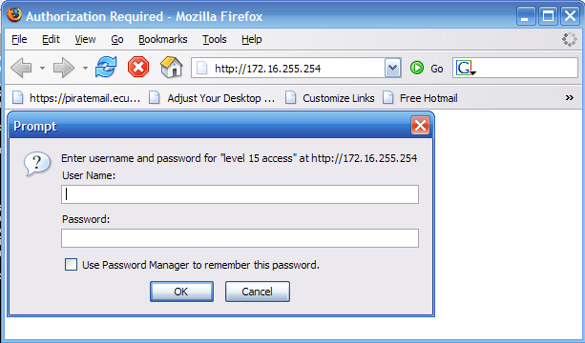

Figure 6. Web server screen on R2-Central

Test host computer connectivity to R2-Central. Use a web browser and connect to URL http://172.16.255.254 . Figure 6 shows the web server authorization screen. NOTE: Login is not necessary and may not be possible. This test verifies proper configuration of the host computer to R2-Central, the LAN edge device.

The R2-Central web page should be displayed. If not, fix the connection between R2-Central and S1-Central.

If the connection is good, there may be a configuration error on R2-Central.

Step 3. Test connectivity between host computers and R1-ISP.

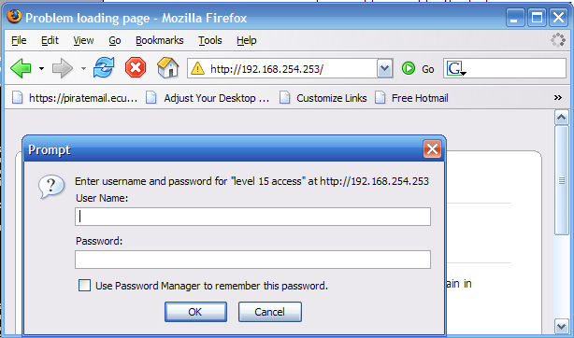

Figure 7. Web server screen on R1-ISP

Test host computer connectivity to R1-ISP. Use a web browser and connect to URL http://192.168.254.253. Figure 7 shows the web server authorization screen. NOTE: Login is not necessary and may not be possible. This test insures proper configuration of the host computer gateway IP address.

R1-ISP web page should be displayed. If not, reconfigure the gateway IP address and retest.

If the gateway configuration is correct, verify cabling between R2-Central and R1-ISP. Also, there may be a configuration error on either router.

Step 4. Test connectivity between host computers and eagle-server.example.com

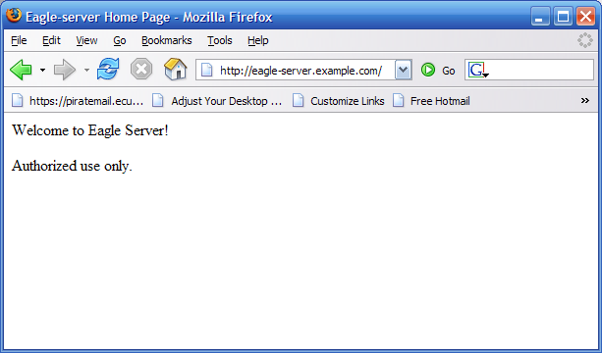

Figure 8. Web server screen on Eagle Server

Test host computer connectivity to Eagle Server. Use a web browser and connect to URL http://eagle-server.example.com/. Figure 8 shows a valid connection. This tests the host computer DNS settings.

Eagle Server web page should be displayed. If not, reconfigure the DNS IP address and retest.

If the DNS configuration is correct, there may be a configuration error on R1-ISP or Eagle Server may be down.

During troubleshooting, the IP address for each network device was used instead of the domain name, such as R1-Central.example.com. Domain name resolution depends on proper network operation. Since Eagle Server is the domain name server and resides on a distant network, any LAN or WAN network interruption would cause name resolution to fail and could complicate the troubleshooting process.

Reflection

The lab environment provides an excellent secure and stable computer network for students to learn basic computer network skills. A logical setup approach was used to enable connectivity between host computers, network devices, and Eagle Server. Finally, end-to-end testing verified proper configuration and cabling.

Appendices
These are basic configurations to which you may add. At a minimum, change the passwords so that the students do not know the enable secret or instructor passwords

Appendix 1

S1-Central Cisco switch configuration.
!
service timestamps debug uptime
service timestamps log uptime
no service password-encryption
!
hostname S1-Central
!
enable secret cisco
!
username instructor privilege 15 password cisco
username ccna1 privilege 7 password cisco
username ccna2 privilege 7 password cisco
username ccna3 privilege 7 password cisco
username ccna4 privilege 7 password cisco
username ccna5 privilege 7 password cisco
username ccna6 privilege 7 password cisco
username ccna7 privilege 7 password cisco
username ccna8 privilege 7 password cisco
username ccna9 privilege 7 password cisco
username ccna10 privilege 7 password cisco
username ccna11 privilege 7 password cisco
!
ip subnet-zero
!
ip name-server 192.168.254.254
!
spanning-tree mode pvst
no spanning-tree optimize bpdu transmission
spanning-tree extend system-id
!
interface FastEthernet0/1
description connection to host1A
!
interface FastEthernet0/2
description connection to host1B
!
interface FastEthernet0/3
description connection to host2A
!
interface FastEthernet0/4
description connection to host2B
!
interface FastEthernet0/5
description connection to host3A
!
interface FastEthernet0/6
description connection to host3B
!
interface FastEthernet0/7
description connection to host4A
!
interface FastEthernet0/8
description connection to host4B
!
interface FastEthernet0/9
description connection to host5A
!
interface FastEthernet0/10
description connection to host5B
!
interface FastEthernet0/11
description connection to host6A
!
interface FastEthernet0/12
description connection to host6B
!
interface FastEthernet0/13
description connection to host7A
!
interface FastEthernet0/14
description connection to host7B
!
interface FastEthernet0/15
description connection to host8A
!
interface FastEthernet0/16
description connection to host8B
!
interface FastEthernet0/17
description connection to host9A
!
interface FastEthernet0/18
description connection to host9B
!
interface FastEthernet0/19
description connection to host10A
!
interface FastEthernet0/20
description connection to host10B
!
interface FastEthernet0/21
description connection to host11A
!
interface FastEthernet0/22
description connection to host11B
!
interface FastEthernet0/23
!
interface FastEthernet0/24
description connection to R2-Central
!
interface GigabitEthernet0/1
!
interface GigabitEthernet0/2
!
interface Vlan1
ip address 172.16.254.1 255.255.0.0
no ip route-cache
no shutdown
!
ip default-gateway 172.16.255.254
ip http server
ip http authentication local
privilege exec level 7 show mac-address-table
privilege exec level 7 clear mac-address-table dynamic

!
banner motd %
*******************************************************************

This is Lab switch S1-Central.
Authorized access only.

*******************************************************************
%
!
line con 0
login local
line vty 0 4
login local
line vty 5 15
login local
!

end

Appendix 2

R2-Central router configuration
service timestamps debug uptime
service timestamps log uptime
no service password-encryption
!
hostname R2-Central
!
enable secret cisco
!
ip name-server 192.168.254.254
ip dhcp excluded-address 172.16.0.0 172.16.253.255
ip dhcp excluded-address 172.16.255.0 172.16.255.254
!
ip dhcp pool ccnapods
network 172.16.0.0 255.255.0.0
default-router 172.16.255.254
dns-server 192.168.254.254
domain-name example.com
lease 3
!
username instructor privilege 15 password cisco
username ccna1 privilege 7 password cisco
username ccna2 privilege 7 password cisco
username ccna3 privilege 7 password cisco
username ccna4 privilege 7 password cisco
username ccna5 privilege 7 password cisco
username ccna6 privilege 7 password cisco
username ccna7 privilege 7 password cisco
username ccna8 privilege 7 password cisco
username ccna9 privilege 7 password cisco
username ccna10 privilege 7 password cisco
username ccna11 privilege 7 password cisco
!
interface FastEthernet0/0
description connection to S1-Central
ip address 172.16.255.254 255.255.0.0
no shutdown
!
interface Serial0/0/0
description DTE connection to R1-ISP
ip address 10.10.10.5 255.255.255.252
no shutdown
!
ip route 0.0.0.0 0.0.0.0 10.10.10.6
!
ip classless
ip http server
ip http authentication local
privilege exec level 7 show ip route
!
banner motd %
*******************************************************************

This is Lab router R2-Central.
Authorized access only.

*******************************************************************
%
line con 0
login local
!
line aux 0
line vty 0 4
login local
!
end

Appendix 3

R1-ISP router configuration
!
service timestamps debug uptime
service timestamps log uptime
no service password-encryption
!
hostname R1-ISP
!
enable secret cisco
!
ip name-server 192.168.254.254
!
interface FastEthernet0/0
description connection to Eagle Server
ip address 192.168.254.253 255.255.255.0
no shutdown
!
interface Serial0/0/0
description DCE connection to R2-Central
clock rate 2000000
!clock rate should be set to the highest allowable rate for your lab equipment. 128000 or 4000000 can also be used.
ip address 10.10.10.6 255.255.255.252
no shutdown
!
ip route 172.16.0.0 255.255.0.0 10.10.10.5
ip route 172.31.24.0 255.255.255.0 192.168.254.254
!
ip classless
ip http server
ip http authentication enable
!
banner motd %
*******************************************************************

This is Lab router R1-ISP.
Authorized access only.

*******************************************************************
%
!
line con 0
password cisco
!
line con 0
password cisco
login
line aux 0
line vty 0 4
password cisco
login
!
end

