How to disable McAfee Antivirus so Cisco projects will work in S218
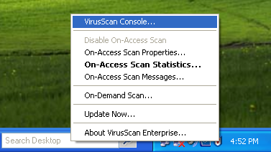
- In the lower right corner of the desktop, right-click the McAfee shield icon. In the context menu, click “VirusScan Console”, as shown to the right on this page.

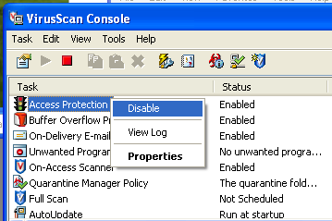
- In the”VirusScan Console” box, right-click “Access Protection” and click Disabled. Repeat for every item with a Status of Enabled.

