What You Need for This Project
- A computer with an Internet connection. The instructions below assume you are using Windows 7 in the C218 lab.

Start Your Computer--You Need Administrative Privileges
- Ask your instructor to log in with Administrative privileges in C218.

Installing Apache Web Server
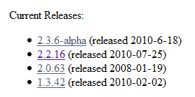
- Open Firefox and go to apache.org
- On the right side, in the "Apache Projects" section, click "HTTP Server".
- On the left side, in the "Download!" section, click "from a mirror".
- In the "Current Releases" section, click the latest stable version. When I wrote this (8-24-10), it was "2.2.16".
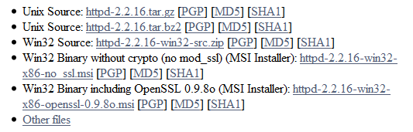
- On the "Win32 Binary without crypto" line, click "httpd-2.2.16-win32-x86-no_ssl.msi".
- Download and install the software with the default options.
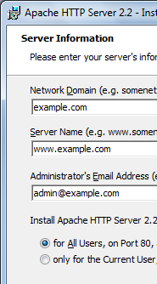
- When the "Server Information" page appears, enter a domain of example.com, as shown to the right on this page.
- If a Command Prompt window appears with an error message saying "alloc_listener: failed to set up sockaddr for [::]", don't worry. That means that Apache can't listen on IPv6, which won't be a problem for this lab because we are only using IPv4.
- If a Windows Security Alert box appears, asking if Apache should be blocked, click Unblock.

Verifying that Apache Web Server is Listening
- Click Start, type in CMD and then press the Enter key.
- In the Command Prompt window, type this command, and then press the Enter key:
netstat -a
- In the Command Prompt window, scroll back to see the start of the output. You should see a Local Address of "0.0.0.0:80" in a State of "Listening", as shown below on this page.
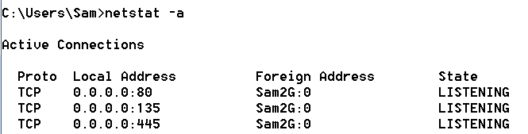

Finding your IPv4 Address
- In the Command Prompt window, type this command, and then press the Enter key:
ipconfig | more
The pipe character, |, is a shift-backslash. Piping the output through more will stop it from scrolling down the screen too far.
- Find the adapter that connects to the Internet. In S214, it's the one with an IPv4 address starting with 147.144, as shown below on this page. Write your IPv4 address in the box to the right on this page.

IPv4: _______________________________
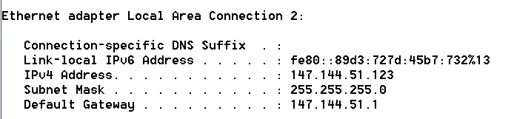

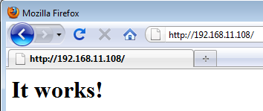
Connecting to your Web Server
- Open Firefox and type the IP address you wrote in the box in an earlier step of these instructions into the Address bar. Press Enter. You should see a page saying "It works!", as shown to the right on this page.

Testing Loopback Addresses
- The 127.0.0.0 class A address range is reserved for loopback addresses. Enter these addresses into Firefox and record the results, with your explanation why you see what you do.
IP Address Result Explanation
127.0.0.1 __________ ________________________________________________
127.255.255.254 __________ ________________________________________________
127. 255.255.255 __________ ________________________________________________
127.0.0.0 __________ ________________________________________________

Modify the Web Server Default Page
- Click Start. In the Search box, type notepad and then press Shift+Ctrl+Enter. In the User Account Control box, click Yes. This starts Notepad with administrative privileges.
- In Notepad, click File, Open.
- Navigate to C:\Program Files\Apache Software Foundation\Apache2.2\htdocs
- In the Open box, in the lower right, change the file type from "Text Documents (*.txt)" to "All Files (*.*)". Double-click index.html
- The default Web page opens, showing some HTML tags and "It works!". Change "It works!" to "YOUR NAME Apache server", replacing YOUR NAME with your own name, as shown below on this page. Click File, Save. Close Notepad.
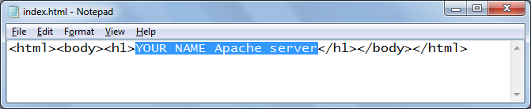

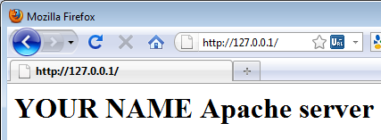
- In Firefox, go to 127.0.0.1. Press the F5 key to refresh the page. You should see your modified page, as shown to the right on this page.

Modifying the Listening Port
- Click Start. In the Search box, type notepad and then press Shift+Ctrl+Enter. In the User Account Control box, click Yes. This starts Notepad with administrative privileges.
- In Notepad, click File, Open.
- Navigate to C:\Program Files\Apache Software Foundation\Apache2.2\conf
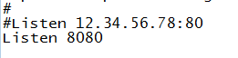
- In the Open box, in the lower right, change the file type from "Text Documents (*.txt)" to "All Files (*.*)". Double-click httpd.conf
- Find the line that says "Listen 80" and change it to "Listen 8080" as shown to the right on this page. Save the file. Close Notepad.
- When you change the configuration, you need to restart Apache.
- Click Start, "All Programs", "Apache HTTP Server 2.2", "Control Apache Server". Right-click Restart and click "Run as Administrator".

View the Page on Port 8080
- In Firefox, go to 127.0.0.1. Press the F5 key to refresh the page. You should see an error message, because there isn't a Web page on port 80 anymore .
- In Firefox, change the address to 127.0.0.1:8080 Press the F5 key to refresh the page. You should see the Web page with your name, as shown to the right on this page.

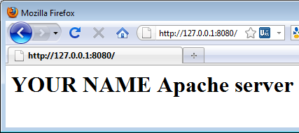
Saving a Screen Image
- Make sure the Firefox window is visible showing your name and an address on port 8080.
- Press the PrintScrn key. Open Paint and paste in the image. Save the image with the filename Your Name Proj 3-HO. Select a Save as type of JPEG or PNG.

Turning in Your Project
- Email the JPEG image to me as an attachment to an e-mail message. Send it to: cnit.201e@gmail.com with a subject line of Proj 3-HO From Your Name, replacing Your Name with your own first and last name. Send a Cc to yourself.

Last Modified: 8-24-10

