What You Need for This Project
- A computer with any OS and an Internet connection. The instructions below assume you are using Windows 7 in the C218 lab.

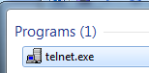
Is Telnet Installed?
- Telnet is not installed by default in Windows 7. To see if it has been installed, click Start and type in TELNET
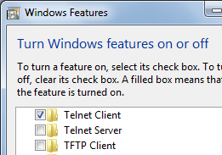
- Look at the top of the Search pane. If you see "telnet.exe" in the Programs section, as shown to the right on this page, telnet is installed and you can proceed to the next section. If telnet.exe is not found, you need to install it with these steps:
  - Ask your instructor to log in with Administrative privileges in C218
  - Click Start, "Control Panel", Programs, "Turn Windows features on or off". Check the "Telnet Client" box, as shown to the right on this page, and click OK.

Making a Telnet Connection
- Click Start, type in CMD and then press Enter.
- In the Command Prompt window, type this command, and then press the Enter key:
telnet hills.ccsf.cc.ca.us
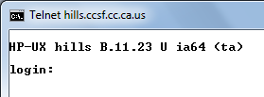
- A Telnet login prompt appears, as shown to the right on this page. This is a Telnet session, which lets you send commands to the server.
- Leaving the Telnet login window open, click Start, type in CMD and then press Enter.
- In the Command Prompt window, type this command, and then press the Enter key:
netstat -a
- Scroll through the output until you find the hills:telnet session that is ESTABLISHED, as shown below on this page. If you can't find it, your Telnet session may have timed out. In the other window, repeat the telnet hills.ccsf.cc.ca.us command and then repeat the netstat -a command to find it.
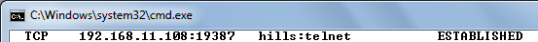
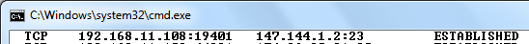

- For us, numbers are more useful than the text descriptions, so it's better to use the -n switch with netstat. Re-establish the telnet session, and repeat the netstat command with the -an switch. You should see a connection to 147.144.1.2:23, as shown below on this page.

Saving a Screen Image
- Make sure the connection to 147.144.1.2:23 is visible, with a status of ESTABLISHED.
- Press the PrintScrn key to copy the whole desktop to the clipboard. Paste the image into Paint and save it with the filename Your Name Proj 4a-HO. Select a Save as type of JPEG or PNG.

Making a Telnet Connection to a FTP Server
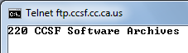
- In a Command Prompt window, type this command, and then press the Enter key:
telnet ftp.ccsf.cc.ca.us 21
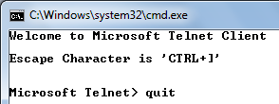
- This uses the Telnet program to open a connection to port 21, which is used by FTP. A "220 CCSF Software Archives" prompt appears, as shown to the right on this page.
- To close the telnet session, press Ctrl+] to open the Microsoft Telnet Client prompt, as shown to the right on this page, and type in quit followed by the Enter key.

Capturing a DNS Request and Responsed with WireShark
- Click the Start button. In the Search box, type WIRE
- At the top of the menu, a Wireshark item appears. Right-click Wireshark and click "Run as Administrator". If a User Account Control box appears, allow the program to run.
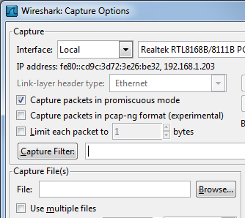
- From the Wireshark menu bar, click Capture, Interfaces. If your computer has several network cards, you may see several items here. Just look to see which one shows an increasing number of packers. In the example shown to the right on this page, it's the Realtek interface. On the line showing the increasing number of packets, click Options.
- In the "Wireshark: Capture Options" box, make sure the "Capture Filter" box is empty, as shown to the right on this page. Click Start.

Using NSLOOKUP to Resolve a Domain Name
- Click Start. In the Search box, type CMD and then press the Enter key.
- In the Command Prompt window, type the following commands, pressing Enter after each one.
IPCONFIG /FLUSHDNS
NSLOOKUP GOOGLE.COM
- In Wireshark, click Capture, Stop. You should see a packet with a Protocol of DNS and an Info of "Standard query A google.com", as shown below on this page. In the middle section, click on the "User Datagram Protocol" line. Notice the highlighted hexadecimal values in the bottom pane--the UDP header is only 8 bytes long, much simpler than the TCP header. Examine the DNS section of both the query and the response using the middle pane, and compare it to the TCP traffic you saw in project 2.
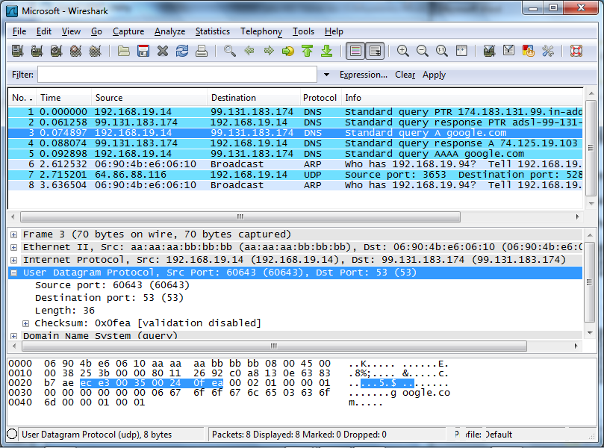

Saving a Screen Image
- Make sure the "Standard query A google.com" line is visible.
- Press the PrintScrn key. Open Paint and paste in the image. Save it with the filename Your Name Proj 4b-HO. Select a Save as type of JPEG or PNG.

Turning in Your Project
- Email the JPEG images to me as attachments to a single e-mail message. Send it to: cnit.201e@gmail.com with a subject line of Proj 4-HO From Your Name, replacing Your Name with your own first and last name. Send a Cc to yourself.

Last modified 9-1-10 1 pm

