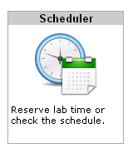
How to use NETLAB to do Cisco projects
NETLAB is a software and hardware system that lets you remotely control real routers, switches, and virtual PCs through a Web browser, so you can do Cisco projects anytime from any computer that has an Internet connection.
- To connect: open a browser and go to http://147.144.51.247
- Log in with the username and password your instructor gave you.
- Click on the Scheduler icon, as shown to the right on this page.
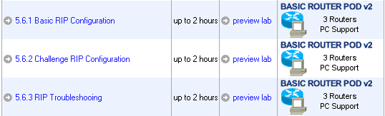
- At the Select Class screen appears, click CNIT_202E_F09_TR_#78242
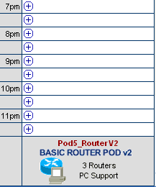
- At the next screen, click the desired exercise, as shown to the right on this page.
- Select one of the "BASIC ROUTER POD v2" columns, as shown to the right on this page, and click on an available time.

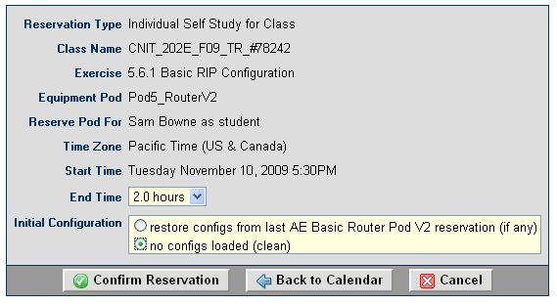
- On the next page, set the End Time to 2.0 hours, and set the Initial Configuration to "no configs loaded (clean)", as shown to the right on this page. Click "Confirm Reservation".
- On the next page, click "I'm Done".
- If your reservation was for a future time, you need to wait till that time.
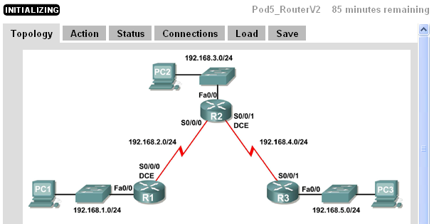
- When the scheduled time comes, log in to NETLAB and click "ENTER LAB".
- You have to wait for 5-10 minutes for the lab to initialize.
- When the lab is ready, click on the PCs, Routers, and Switches (if any) to control the devices. The router logins are cisco and class
- When you are done, click the “I’M DONE” button, so other students can use the pods.

