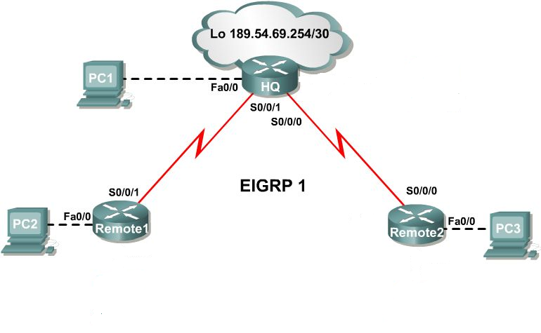
Case 1: Create an Addressing Scheme.
Step 1: Use the 147.144.0.0/16 address to create an addressing scheme to accommodate all hosts on the network. Begin the address assignments with the 147.144.64.0 address. Start with the largest subnet and assign address blocks in decreasing order of size, without skipping any addresses.
Document all subnet addresses in Table 1.

Table 1
Device | Interface | Number of Hosts | Subnet | Subnet Mask
HQ | Fa0/0 | 14000
HQ | S0/0/1 | 2
HQ | S0/0/0 | 2
Remote1 | Fa0/0 | 8191
Remote1 | S0/0/1 | 2
Remote2 | Fa0/0 | 127
Remote2 | S0/0/0 | 2

Step 2: Document router interface and PC addresses in Table 2.

Assign the last usable IP address of each subnet to each PC. Assign the first usable IP address of each subnet to each default gateway.

Table 2
Device | Interface | IP Address | Subnet Mask | Default Gateway
HQ | Fa0/0 |  |  | N/A
HQ | S0/0/1 |  |  | N/A
HQ | S0/0/0 |  |  | N/A
HQ | Lo0 | 189.54.69.254 | 255.255.255.252 | N/A
Remote1 | Fa0/0 |  |  | N/A
Remote1 | S0/0/1 |  |  | N/A
Remote2 | Fa0/0 |  |  | N/A
Remote2 | S0/0/0 |  |  | N/A
PC1 | Ethernet
PC2 | Ethernet
PC3 | Ethernet

Case 2: Create an Addressing Scheme.
Step 1: Use the 10.17.0.0/16 address to create an addressing scheme to accommodate all hosts on the network. Begin the address assignments with the 10.17.128.0 address. Start with the largest subnet and assign address blocks in decreasing order of size, without skipping any addresses.
Document all subnet addresses in Table 1.

Table 1
Device | Interface | Number of Hosts | Subnet | Subnet Mask
HQ | Fa0/0 | 3600
HQ | S0/0/1 | 2
HQ | S0/0/0 | 2
Remote1 | Fa0/0 | 256
Remote1 | S0/0/1 | 2
Remote2 | Fa0/0 | 43
Remote2 | S0/0/0 | 2

Step 2: Document router interface and PC addresses in Table 2.

Assign the last usable IP address of each subnet to each PC. Assign the first usable IP address of each subnet to each default gateway.

Table 2
Device | Interface | IP Address | Subnet Mask | Default Gateway
HQ | Fa0/0 |  |  | N/A
HQ | S0/0/1 |  |  | N/A
HQ | S0/0/0 |  |  | N/A
HQ | Lo0 | 189.54.69.254 | 255.255.255.252 | N/A
Remote1 | Fa0/0 |  |  | N/A
Remote1 | S0/0/1 |  |  | N/A
Remote2 | Fa0/0 |  |  | N/A
Remote2 | S0/0/0 |  |  | N/A
PC1 | Ethernet
PC2 | Ethernet
PC3 | Ethernet

Case 3: Create an Addressing Scheme.
Step 1: Use the 192.99.0.0/16 address to create an addressing scheme to accommodate all hosts on the network. Begin the address assignments with the 192.99.0.0 address. Start with the largest subnet and assign address blocks in decreasing order of size, without skipping any addresses.
Document all subnet addresses in Table 1.

Table 1
Device | Interface | Number of Hosts | Subnet | Subnet Mask
HQ | Fa0/0 | 1100
HQ | S0/0/1 | 2
HQ | S0/0/0 | 2
Remote1 | Fa0/0 | 15
Remote1 | S0/0/1 | 2
Remote2 | Fa0/0 | 30000
Remote2 | S0/0/0 | 2

Step 2: Document router interface and PC addresses in Table 2.

Assign the last usable IP address of each subnet to each PC. Assign the first usable IP address of each subnet to each default gateway.

Table 2
Device | Interface | IP Address | Subnet Mask | Default Gateway
HQ | Fa0/0 |  |  | N/A
HQ | S0/0/1 |  |  | N/A
HQ | S0/0/0 |  |  | N/A
HQ | Lo0 | 189.54.69.254 | 255.255.255.252 | N/A
Remote1 | Fa0/0 |  |  | N/A
Remote1 | S0/0/1 |  |  | N/A
Remote2 | Fa0/0 |  |  | N/A
Remote2 | S0/0/0 |  |  | N/A
PC1 | Ethernet
PC2 | Ethernet
PC3 | Ethernet

Case 4: Create an Addressing Scheme.
Step 1: Use the 223.255.0/16 address to create an addressing scheme to accommodate all hosts on the network. Begin the address assignments with the 223.255.192.0 address. Start with the largest subnet and assign address blocks in decreasing order of size, without skipping any addresses.
Document all subnet addresses in Table 1.

Table 1
Device | Interface | Number of Hosts | Subnet | Subnet Mask
HQ | Fa0/0 | 4191
HQ | S0/0/1 | 2
HQ | S0/0/0 | 2
Remote1 | Fa0/0 | 2047
Remote1 | S0/0/1 | 2
Remote2 | Fa0/0 | 15
Remote2 | S0/0/0 | 2

Step 2: Document router interface and PC addresses in Table 2.

Assign the last usable IP address of each subnet to each PC. Assign the first usable IP address of each subnet to each default gateway.

Table 2
Device | Interface | IP Address | Subnet Mask | Default Gateway
HQ | Fa0/0 |  |  | N/A
HQ | S0/0/1 |  |  | N/A
HQ | S0/0/0 |  |  | N/A
HQ | Lo0 | 189.54.69.254 | 255.255.255.252 | N/A
Remote1 | Fa0/0 |  |  | N/A
Remote1 | S0/0/1 |  |  | N/A
Remote2 | Fa0/0 |  |  | N/A
Remote2 | S0/0/0 |  |  | N/A
PC1 | Ethernet
PC2 | Ethernet
PC3 | Ethernet

