A Chain of Four Routers with OSPF Routes
- Assemble a team of at four students.
  - Teams of 3, 5, or 6 are OK too
- Each student needs a PC, a Router, and a Switch.
  - If you prefer, students in the middle of the chain can use a loopback instead of a switch and a PC, but the two end devices must be PCs.
- Configure the network as shown. The specific addresses for the interfaces are up to you to choose.
- If the Serial ports on the 1841s flap, replace those links with Ethernet links.
- Configure all the routers and PCs with appropriate hostnames and IP addresses.
- Put a Loopback interface on Router A to simulate an Internet connection.
- Configure EIGRP on all the routers so the end devices can ping one another. Redistribute the Loopback on Router A to all the other routers with OSPF.
- When your network can ping end-to-end, and all the devices can ping the Loopback interface, call an instructor over to record your success.
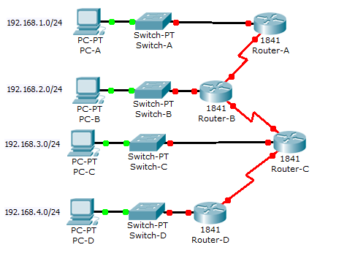
192.168.1.0/28
192.168.1.16/28
192.168.1.32/28
192.168.1.48/28
192.168.1.64/30
192.168.1.68/30
192.168.1.72/30
Loop0
10.0.0.1/30

