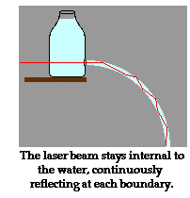
Early Optical Communications

The French used semaphores to transmit messages in the 1790s

Later systems also sent optical signals through the air

But clouds, rain, and other atmospheric disturbances can disrupt optical signals sent through the air

Electric signals through wires avoid that problem

Guiding Light With Water

Light in a stream of water stays inside the water and bends with it

This was first demonstrated in the 1840s

Image from glenbrook.k12.il.us/gbssci

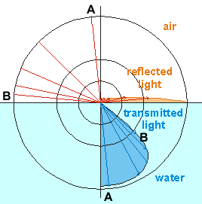

Refraction (Bending) of Light

Ray A comes from straight up and does not bend much

Ray B comes at a shallow angle and bends a lot more

Image from seafriends.org.nz

The View From Underwater

Underwater, the light always shines down steeply, even when the Sun is low in the sky

The whole sky appears in a limited round area called “Snells Window”

Image from seafriends.org.nz
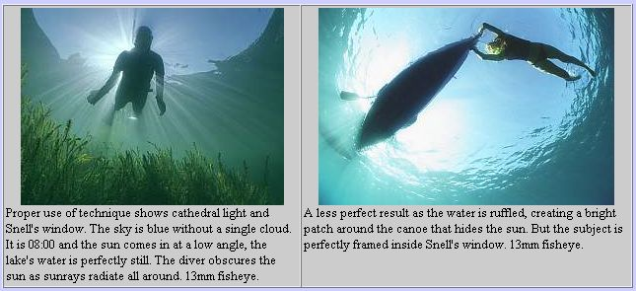

Light Coming Out of Water

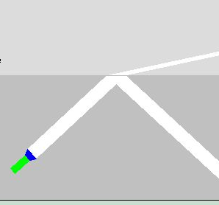
Animation on link Ch 1b on my Web page (samsclass.info)
Water
Air

http://www.phy.ntnu.edu.tw/ntnujava/viewtopic.php?t=66

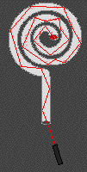
Total Internal Reflection

There is a critical angle at which no light can be refracted at all, so 100% of the light is reflected

Light is trapped in the water and cannot escape into the air

This works with any dense medium, such as plastic or glass, the same way it works with water

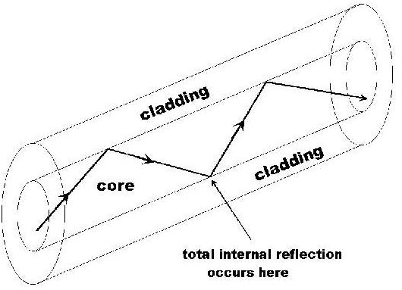
Image from glenbrook.k12.il.us

How Light Travels in Fiber

Image from ece.umd.edu/~davis

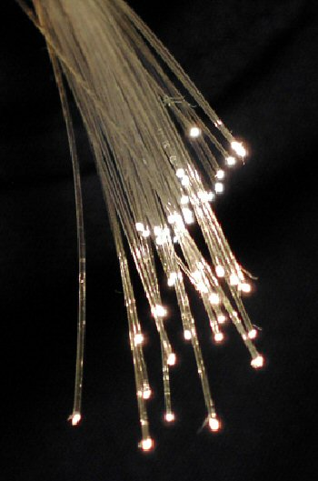
Bare Fiber

During 1920-1950, thin, flexible rods of glass or plastic were used to guide light

Such “bare” fibers require air outside each fiber

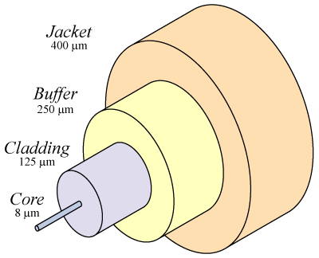
Image from Wikipedia

Fiber With Cladding

Developed in 1954 by van Heel, Hopkins & Kapany

Cladding is a glass or plastic cover around the core

Protects the total-reflection surface contamination

Reduces cross-talk from fibers in bundles

Medical Imaging

By 1960, glass-clad fibers were available for medical instruments, to look inside the body

The glass was unable to transmit light far enough for communications, because of impurities

Attenuation (loss of light) was 1 decibel per meter

Decibels

Decibels are a logarithmic scale of power

Abbreviated dB

A loss of 10 decibels means only 10% of the light gets through

A loss of 20 dB means 1% of the light gets through

Sunglasses stop 99% of light, so they cause a loss of 20 dB

For communications, loss must be no more than 10 or 20 decibels per kilometer

Optical Fiber in 1966

Charles Kao developed a fiber that could transmit 1 GHz (One billion bits per second)

But attenuation was 1000 dB/km, so it could not transmit light far enough for practical communications

Corning

Corning scientists developed low-attenuation silica glass fibers in 1970

Corning Video: At The Speed of Light

Link Ch 1c on my Web page (samsclass.info)

Singlemode and Multimode Fiber

Singlemode fiber has a core diameter of 8 to 9 microns

Multimode fiber has a core diameter of 50 or 62.5 microns

Both have a cladding diameter of 125 microns

Optical Fiber in 1977

Telephone signals used infrared light with a wavelength of 850 nm to send data at 6.2 Mbps and 45 Mbps

Loss was 2 dB per km

Repeaters were required every few kilometers

The repeaters were electro-optical – converting the light to electricity and then back to light

TAT-8

In 1988 AT&T laid the first fiber-optic transatlantic telephony cable

3,148 miles long

Connected North America to France

Repeaters every 40 miles

565 Mbps bandwidth

Used 1300 nm light

Attenuation 0.4 dB/km

Info from link Ch 1e www.greatachievements.org/?id=3706

Fiber Amplifier

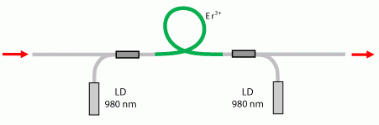
Special fiber with Erbium atoms in it is used to amplify light without changing it to an electrical signal first

Uses stimulated emission, the same principle that makes lasers work

Image from rp-photonics.com (Link Ch 1g)

Wavelength Division Multiplexing (WDM)

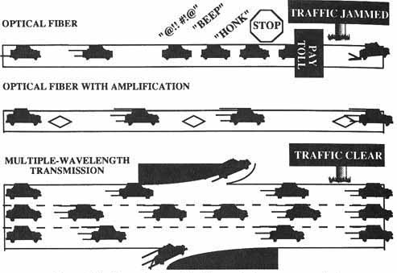
Several signals can be sent through the same fiber simultaneously by using different wavelengths (colors) of light

That means more bandwidth—more data per second

Freeway Analogy

TAT-8 in 1980

565 Mbps

Electro-optical repeaters

TAT-12/13 in 1996

2.5 Gbps

Optical amplifiers

1998

20 Gbps

WDM with 8 wavelengths

Image from www2.rad.com (Link Ch 1j)

Dense Wavelength Division Multiplexing (DWDM)

Uses up to 100 wavelengths through a single fiber

Bandwidth up to 1 Tbps (1000 Gbps)

Lennie Lightwave's Guide To Fiber Optics: Basics

From jimhayes.com/lennielw

Fiber Optics History

Fiber optics began about 30 years ago in the R&D labs (Corning, Bell Labs, ITT UK, etc.)

First installed in Chicago in 1976

By the early 1980s, fiber networks connected the major cities on each coast.

The 1980s

By the mid-80s, fiber was replacing all the telco copper, microwave and satellite links

In the 90s, CATV started using fiber to enhance the reliability of their networks

CATV companies also discovered they could offer phone and Internet service on that same fiber and greatly enlarged their markets

Computers and LANs

Started using fiber about the same time as the telcos

Industrial links were among the first as the noise immunity of fiber and its distance capability make it ideal for the factory floor

Mainframe storage networks came next, the predecessors of today's fiber SANs (storage area networks.)

Other Applications

Aircraft, ship and automobile data buses

CCTV for security

Links for consumer digital stereo

Today fiber optics is either the dominant medium or a logical choice for every communication system

Which Fiber Optics?

"Outside Plant" fiber optics are used in telephone networks or CATV

"Premises" fiber optics are usedin buildings and campuses

Just like "wire" which can mean lots of different things - power, security, HVAC, CCTV, LAN or telephone - fiber optics is not all the same.

Installing Fiber Optics

Fiber is harder to install than 100 Mbps copper Ethernet cable

But fiber is MUCH faster, so the infrastructure won’t need to be upgraded so soon

And gigabit Ethernet is harder to install

LAN copper cable is delicate. It only has a 25 pound pulling tension limit and kinks will ruin the high speed performance

Fiber has more strength and greater tolerance to abuse than copper wire

Safety First!

The light in the fiber can burn your retina

NEVER look into a fiber unless you know no light is present - use a power meter to check it

The infrared light is invisible

Fiber Shards

When you cleave fiber, there are small scraps of glass produced.

These scraps are very dangerous!

The cleaved ends are extremely sharp and can easily penetrate your skin

They are even worse in your eyes, mouth, etc.

Safety Rules

Wear glasses or safety glasses

Dispose of all scraps properly: put them on black tape and then into a properly marked trashcan

Work on a black pad which makes the slivers of glass easier to spot

Do not drop scraps on the floor

Do not eat or drink anywhere near the work area

Chemical Safety

Fiber optic splicing and termination use various chemical adhesives and cleaners

Follow the instructions for use carefully

Isopropyl alcohol, used as a cleaner, is flammable

Zero Tolerance for Dirt

Airborne particles are about the size of the core of Single Mode fiber

They absorb lots of light and may scratch connectors if not removed

Dirt on connectors is the biggest cause of scratches on polished connectors and high loss measurements

Hygiene Rules

Work in a clean area – avoid dust

Keep dust caps on all connectors

Use lint free pads and isopropyl alcohol to clean connectors

Last modified 1-20-06

