Ch 11: Fiber Optic Installation Safety

Bare Fiber Safety

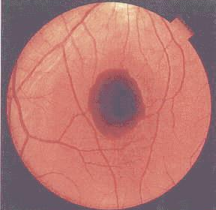
If the shards get into your skin, you will have to wait for them to work out

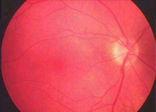
Wear eye protection!

Put shards on sticky tape

Account for all shards

Eye Safety (Laser Damage)

Most sources are low-power and no great risk

High power sources might burn the retina with invisible light

Images from tsogalveston.com and chppm-www.apgea.army.mil (Links Ch 11c-e)

Never look into the end of a cable that might be in use
Normal retina
Laser Damage

Cap unused connectors

Tape unterminated fiber ends

Mark enclosures with warning labels

Laser test sources are dangerous, don’t leave them lying around

Chemical Safety

MSDS: Material Safety Data Sheet – a document that lists the risks of a chemical

Alcohol – flammable

Adhesives – irritate skin, require ventilation

Index matching gel – irritate eyes

Silicone adhesives like RTV are used as mechanical sealant – can irritate skin or eyes

UV Light Sources

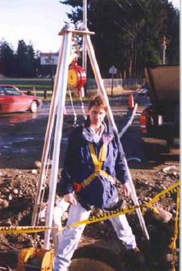
Used to cure some adhesives

Harmful to eyes

Causes skin cancer

Canned Compressed Air

Can explode if heated or damaged

Some use flammable propellant

Gas in Manholes

There may be no oxygen in the hole

Working Alone – test the space first

Working as a Crew

One worker in the hole, wearing a harness

One above hole

Image from cpchem.com (Link Ch 11a)

Tools and Equipment

Step Ladders

Don’t stand on top step

Must be in good repair

Extension Ladders

Must reach three feet beyond bearing point

Angle: 1 foot of spacing for every 3 or 4 feet of height

Knives

Hook blade is most common

Cut away from yourself

Syringes and Needles

They are blunt and not a medical hazard

Microscopes

Use a power meter first to make sure there is no light coming out of the fiber

Cable Installation Equipment

Trenchers, backhoes, boring machines

Obvious big-equipment hazards

Toolbox

Have a container for spare knife blades

Prevent liquid spills, battery shorts, etc.

Personal Safety Equipment

Gloves protect you from

Corrugated armor sheaths

Fiberglass splinters

Safety Glasses

Safe Working Area

Enough table space

Good Lighting

Don’t eat or drink in work area

Prevent falls – loose cables, open holes

Measuring Wheel

Image from englo.ee (link Ch 11g)

Clean work area after you are done, properly dispose of all shards

Aerial Installation Hazards

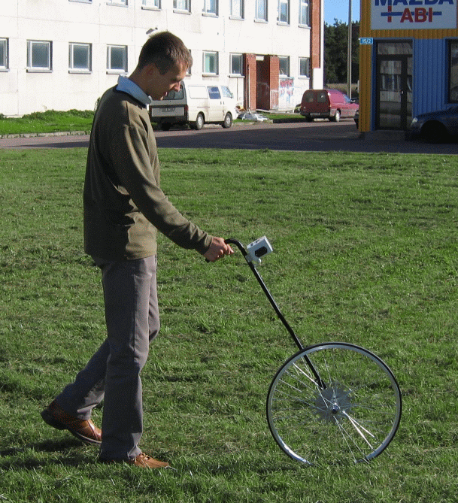
Ladder safety

Electric power lines

Weather

Employee Training
Ch 12: Planning the Installation

Why is Planning Necessary?

Construction is not repetitive

Each job is different

By the time you perfect your procedure, it’s time for the next job

You must avoid mistakes through planning

Measuring for Conduit Pulls

Avoid unneeded splices – they lose signal and cost time and money

Measuring from prints

Inaccurate, so you waste cable

With a Wheel On-Site

Much more accurate

Measurement/Pull Tape

Measurement/Pull Tape

Image from arncocorp.com (Link Ch 11f)

Most accurate

Extra Length

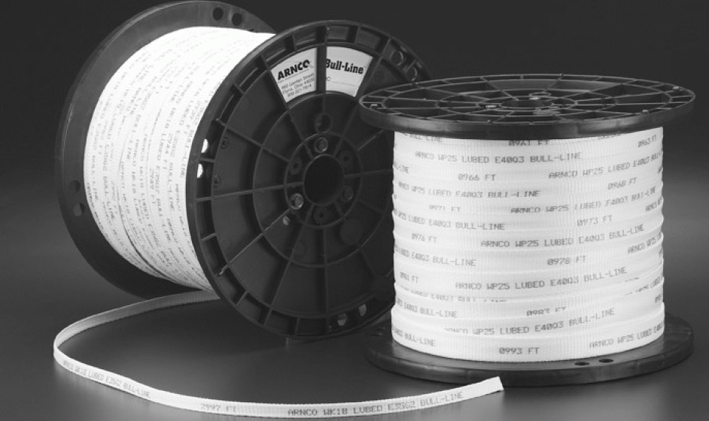
Leave 7 to 10 feet extra for termination

Access or repair coils are needed

Michigan State U. required 30 feet extra cable in conduit at each termination point (link Ch 11h)

Allow 1% extra length outside

Allow 5% - 7% extra length inside

Splicing

Fusion splicing cannot be done in manholes

So 30 feet slack needed on each side of the splice (60 feet extra cable)

Mechanical splices can be done in manholes

Only 10 feet of extra cable needed

Innerduct

Image from

store.cablesplususa.com

(link Ch 11i)

Efficient Pulling

If a pull is too long, the tension will grow too high

Break up the pull with figure-eighting in locations with enough room

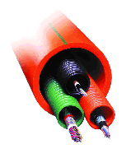
Don’t leave reels of cable unprotected

Cable can cost thousands of dollars

Duct Space

Large ducts are divided by innerduct

Protects the fiber cable

Reduces friction

Initial Planning Walkout

Project Engineer

Knows customer’s needs

Lead Technician

An experienced fiber installer

Project Superintendent

Must coordinate activities of workers

All obstacles should be found and planned for, so crews don’t sit idle waiting during the job

Last modified 3-29-06

