Ch 13: Fiber Optic Cable Plant Documentation

Why Document?

Save time and material during installation

Help in planning upgrades and troubleshooting

Test data with loss measurements are usually required for acceptance by end user

Required Data

Cable manufacturer, type, length

Fiber type and size, splices and termination points, losses

Connections: types, locations, losses

Path of every cable

Store all this in a database, often with OTDR traces

Cable Plant Record Keeping

Designing

Plan each cable run, patch panel, etc.

Bidding

Installing

Tape patch panel printouts inside panel covers

Unless the records are clear, time and money will be wasted

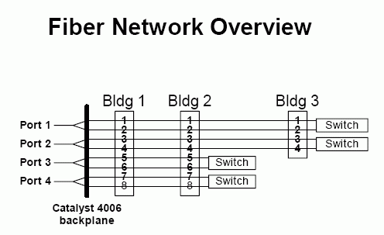
Testing

Test each link and keep the loss data

Future changes can be guided by comparing to the original data

Cable Plant Record Keeping

Troubleshooting

Good documentation helps greatly

Documenting for Customer Acceptance

If you document properly all along, you can just print a copy for the customer

The Documentation Process

Network Diagram

Sketch for small network

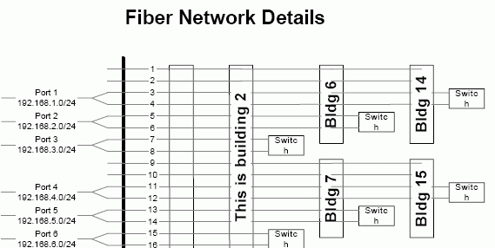
CAD (Computer-aided Design) for large projects

Such as Visio -- see link Ch 13a

Image from TechRepublic.com

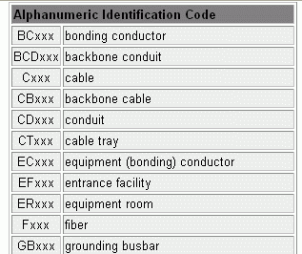
Items to Document

Where all cables go

What every fiber connects to

Specifications of every cable and fiber

Lengths and installation techniques

Panels and closet hardware types

What end equipment is connected

Dark fibers (dark fibers are unused fibers available for future use)

Computers and Software

Spreadsheets

Databases

Visio drawings

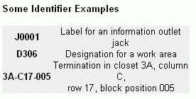
Give end user electronic and paper copies

Keep backup copies

Store instructions for use with files

Documentation Nomenclature

TIA/EIA-606 Administration Standard

Alphanumeric ID codes are used for each item

These codes are only examples

From anixter.com

Link Ch_13b
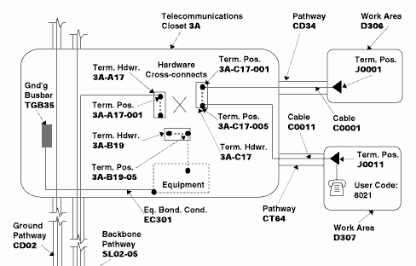

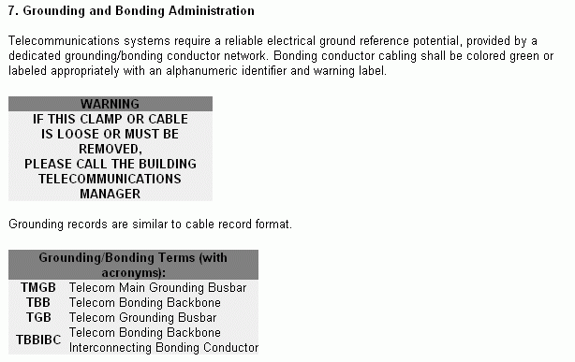

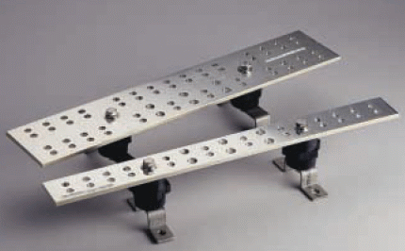

Grounding Busbars

Required in each closet and in the main telco entrance

Document grounding so it can be inspected to meet codes

Ch 14: Estimating and Bidding Fiber Optic Installation

Required Skills

Arithmetic (not math)

Command of language and acronyms

Others will need to read and understand your notes and calculations

Imagination

Visualize the project and portions of it

Understanding of On-Site Expenses

You will need experience with all installation procedures and products

Handwriting

If your writing is illegible, PRINT

Computer Skills

Database, spreadsheet, or estimating software

Email

Tools

Pencil

Printing Calculator

Tape recorder

Camera

Lined estimating sheets

See example: link

Computer estimating software

Site Visit

You need to notice locations, routing, and elevations

Check for errors in the drawings

Notice construction in progress that may affect your job

Reality of Fiber Optic Installations

Usually you are upgrading old systems to a new high-speed infrastructure

Existing telco closets are usually small and crowded, and the different signals interfere

The cure is to consolidate it all onto fiber – this is network convergence

Estimating Process

Takeoff

Taking information off the plans and transferring it to estimating sheets

Writing up the estimate

Summarizing the estimate

Takeoff

Review the symbol list and specifications

Mark all items – fill them in as they are counted

Count the most expensive items first

Later passes may reveal missed items

Obtain a quantity from a quantity

Count length, calculate straps from it

Don’t rush

Work in a quiet comfortable area

Develop mental pictures of the project

Writing Up the Estimate

Transfer the takeoff information to sheets

Assign material and labor costs

Subtotal each sheet

Summarizing the Estimate

Add all the pricing sheets

Add other costs, overhead and profit

Result is the bid price

Labor Units

Normal conditions

Average worker

Max. working height 12 feet

Normal availability of workers

Reasonably accessible work area

Proper tools and equipment

Building not exceeding three stories

Normal weather condition

Fiber Optic Labor Units Normal — Difficult

Installing cable in conduit, 1-4 fibers 0.016 – 0.02 hours per foot

Installing cable in conduit, 144 fibers 0.05 – 0.065 hours per foot

Testing, per fiber 0.12 – 0.24 hours

Terminating (polish required) 0.40 – 0.6 hours apiece

Removal of Abandoned Cables

Required by NEC starting in 2002

Can be much more difficult than installing new cable

Because you must avoid harming other cables still in use

Training

You may have to teach the owners or their representatives how to use the system

You will also have to handle phone calls from them later

It’s best to incorporate these costs in the bid, as special labor

Don’t try to skimp or avoid this cost!

Overhead

Overhead is indirect costs

Site security

On-site trailers

Health and safety

Office space (rent, utilities, etc.)

Insurance

Equipment & software

From links Ch 13d & 13e

High-tech work has a higher overhead

Because it’s more complex and less established

Higher risk

Last modified 4-21-06

