Ch 15: Fiber Optic Cable Pulling

Avoiding Disaster

Tensile stress (pulling load)

Bending radius

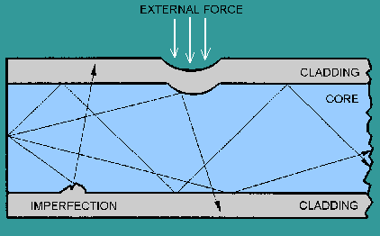
Despooling Cable

Pull the cable to the side, not over the top of the reel

Pull only from the strength member

Avoids excessive force on the cable

That would stretch the jacket and cause fiber compression when the tension is released

Produces macrobends and attenuation

Also avoids twists in the cable

Microbends (not in textbook)

Deviation of the core as measured from the axis of the fiber.

Causes loss

See links Ch_15a, Ch_15b

Sources of stress can create microbends, such as:

Irregularities during fiber manufacturing

Manipulation of the fiber during cable manufacturing

Installation operations and equipment (tie wraps, clamps)

Environmental stresses (pressure, hits)

Macrobends

Bending the cable too tightly (violating the minimum bend radius)

During pull – no less than 20 diameters

Otherwise you can damage the cable

Static – no less than 10 diameters

Causes loss

Pulling Force

Usually 600 lb. for outside plant cable

300 lb or less for indoor cable

Must not be exceeded

Pull should be smooth, not jerky

Pull on strength member only

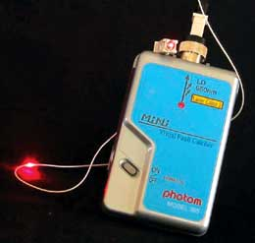
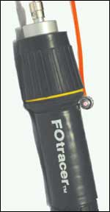
Test Cable Before Pulling

Avoids quality problems and finger-pointing after installation

Continuity is often enough

Does it transmit light?

Images from link Ch 15c

Interference from Other Installations

Ways to protect the fiber:

Put it under other cables in duct

Put fiber in last, on top
Flashlight
(Continuity
Tester)
Visible Laser Tester

Be careful about sharp edges in duct

Use innerduct

Procedures for Pulling Cable

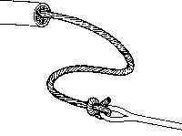
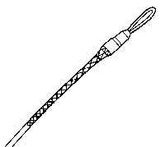
Do long pulls from the middle

Do very long pulls in stages with figure-8s

Two ways to attach rope:

Direct attachment to strength member

Kellems grip to grab whole cable from outside

Or both at once

Images from link Ch 15d

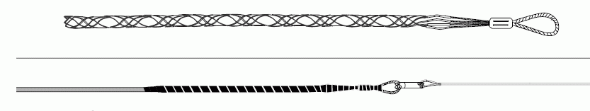
Using the Kellems Grip

Corning recommends using both the strength member and a Kellems grip to distribute tension

Cover the grip with vinyl tape

See link Ch 15e

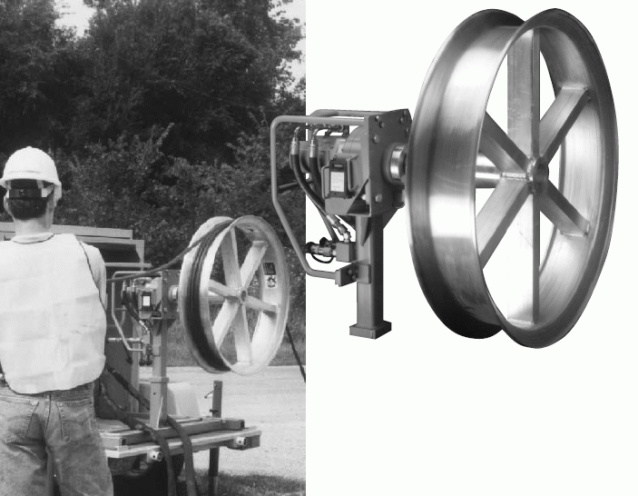
Puller Works Like a Capstan

From Link Ch 15f

Lubricant

Use lubricant designed for the cable

Avoid lubricating the part of the cable that will be handled

Pull Speed

Max. speed 2 mph when using rope

You can pull 3 x as fast with measurement/pull tape than with rope because the rope cuts grooves in conduit

Image from arncocorp.com (Link Ch 11f)

Racking and Labelling

“Rack” cable – lash it to the sides of a manhole or pull box with cable ties

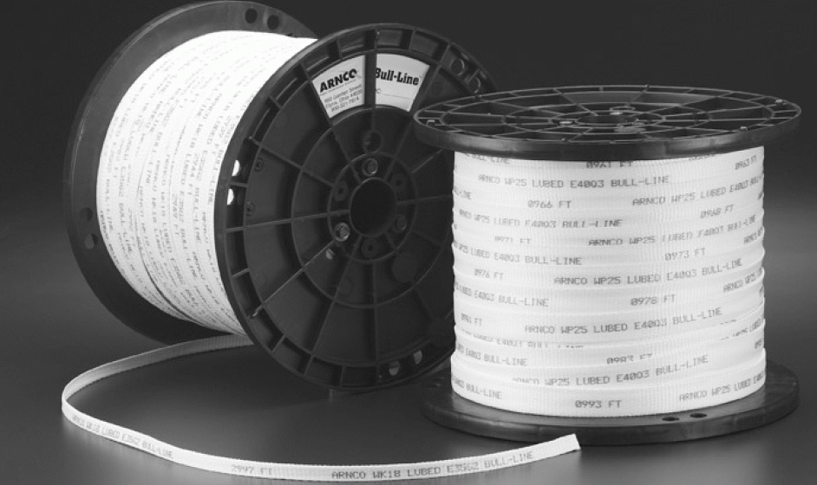
Attach cable ID tags anywhere people might see the cable

State fiber core size, where it is accessible on both ends, and who the owner is

Premises Cables

They are more fragile than outdoor cables

Avoid kinks and snags

Heavy copper cables can put pressure on fiber sharing the same trays

One solution is innerduct

Innerduct with pull tape already installed is very easy to install

Premises Cables

Use cables with proper fire ratings

Remove old cables

Leave service loops – extra length

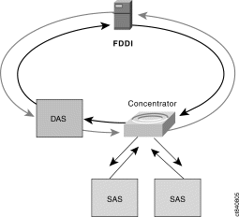
Ch 16: Fiber Optic Restoration

Proactive Planning

Designing a network that is reliable

FDDI is reliable because it uses two counter-rotating rings

“self-healing”

Route Diversity

More than one path for the data

No single point of failure

Increases network cost, but also increases reliability

Faults at the Patch Panel

Improper dressing of jumpers and cables

Dressing the cable involves properly aligning and positioning the cables in a neat and orderly manner for termination

From Link Ch 16a

Improper keying or dirty connectors

Local damage

Faults of System

Under- or over-driving the optical transmission causes problems

On LANs, under-driving is more likely (too many dB of loss)

Some high-power laser sources can saturate the receiver if the network has too little loss

Faults from Installation

Improper bend radius

Clamping too tight

Dressing, termination, routing

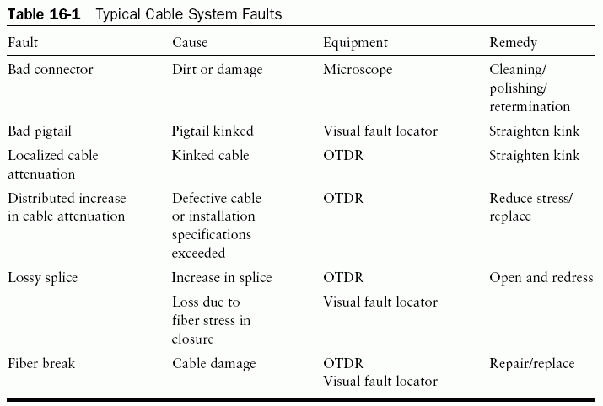
Faults from Construction

Backhoes digging up cable

Typical Cable System Faults

Aerial cables falling down

Lightning, falling trees, etc.

Cutting through walls or ceilings in LANs

Equipment Used in Restoration

Cleaning kit

Microscope

Light source and power meter

Visual Fault Locator

Bright laser VFLs are best for finding internal breaks

OTDR

Essential for outside plant work to locate faults

Less common for LANs

High cost

Short networks

Restoration Flow Chart
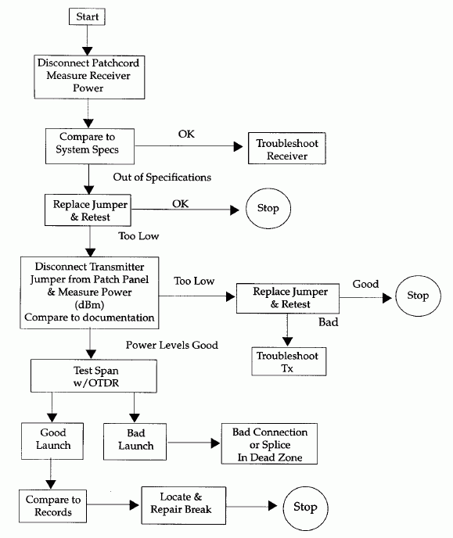

First test power to receiver

Then power from transmitter

That will determine if the problem is in the electronics or the fiber

Locating a Cable Plant Problem

Use a VFL to locate the problem

Sometimes you will see the red light escaping at a break or bad connection

You can also just see how far down the cable plant the red light goes before it stops

For longer runs, good documentation is extremely important so you can follow the cable route

OTDR

If a cable is over 500 m or underground, an OTDR may be necessary

Use a launch cable to eliminate the dead zone

Use the 850-nm range to get best distance resolution

Restoring Service

Protect repair points with closures or patch panels

New hardware may be needed

Can the system handle the added loss of the new connectors, splices, and cable length?

Can you run a temporary span of cable through the ceiling, over the roof, etc. to restore service quickly?

Storage Loops

Buildings change a lot, so do networks

Slack should be stored on the wall or ceiling, considering aesthetics and size

Emergency Restoration (With Retrievable Slack)

Use a VFL to find the break

Test from both ends to make sure there is only one break

Choose best point and method to repair fiber

Pull cables back to ceiling, floor, post etc. for physical mounting

Document the Repair

Test the repaired span

Emergency Restoration(No Retrievable Slack)

Would it be quicker to pull in a new cable or segment?

To repair, you must add in more cable

Two termination points, double the labor and material

New cable must have at least as many fibers as the existing cable

Restoration for Singlemode Networks

More difficult to repair than multimode networks

Higher speeds and greater distances

Cable is often buried, aerial-placed, or in long conduit

Problem often caused by a natural disaster or construction work

Many users are affected, large revenue losses

Singlemode Restoration Suggestions

Prioritize fibers – then fix most important fibers first

Have a kit ready with spare connectors, connectorization kit, mechanical splices

Have a trained restoration crew with emergency phone numbers

Have test equipment and tools ready

Restoring Service

A single broken fiber can be replaced using a dark fiber (if one is available)

Is there enough slack to make a repair point?

Would replacing the span be easier, quicker, cheaper than repairing it?

Install connectors or splice?

Recommended Restoration Posture

Document fiber routes

Patch panel designations, signal type, interconnect routing

Document transmitters’ and receivers’ power levels

Both minimum and maximum power for detectors

Document optical loss for all spans

At both wavelengths (850/1300 nm for multimode and 1310/1550 nm for singlemode)

Document fiber size and manufacturer

Copies of OTDR traces (if any)

Document actual cable length in meters or feet for each segment from cable markings

Prioritize fibers

Restoration Planning

Flow of information – who detects the problem, and who do they call?

Is an emergency restoration needed, or can we do a planned restoration

Make sure you have records, kits, trained staff

Prioritize your customer and fibers

What is the time allowance for restoration?

Temporary or permanent repair? How much loss is tolerable?

Arrange for communications between OTDR operators and splicers

Restoration (Misc.)

Keep the restoration plan and staff current

Test existing dark fibers regularly

Evaluate each cable segment for worst case failures

Do you photograph/film your restorations? The use of film and/or pictures provides a good learning and review tool. In the case of litigation the pictures can be invaluable.

Postrestoration

Redocument and retest your splices, spans, and segments.

Adjust your “as built” drawings

Have a meeting to review all aspects of the restoration.

What happened? What were the cause and impacts?

What did we do well?

What did not work? (Technique, equipment, products, staff)

How can this be resolved?

How can we improve?

What needs to be done to rebuild kits and replenish inventory?

Color Codes (not in textbook)

For loose-tube cables, both the individual fibers and the buffer tubes are color-coded

TIA/EIA-598 Color Code
Position | Color
1 | Blue
2 | Orange
3 | Green
4 | Brown
5 | Slate
6 | White
7 | Red
8 | Black
9 | Yellow
10 | Violet
11 | Rose
12 | Aqua

Cable Jacket Colors

Cable jackets also have a color code, although not all manufacturers obey it

Multimode indoor cable: orange

Singlemode indoor cable: yellow

Outdoor cable: black

Laser-optimized: aqua

See links Ch 16c, Ch 16d

Last modified 4-28-06

