Testing Requirements
Parameter | Example | Instrument
Optical power | Source output, receiver signal level | Power meter
Attenuation or loss | Fibers, cables, connectors | Power meter and source, or Optical Loss Test Set (OLTS)
Back reflection or Optical Return Loss (ORL) |  | OTDR or OCWR
Source wavelength |  | Spectrum analyzer
Backscatter | Loss, length, fault location | OTDR
Fault location |  | OTDR, VFL
Bandwidth/dispersion |  | Bandwidth tester

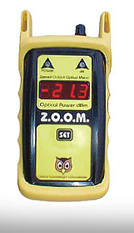
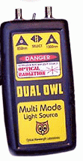

Power Meters

The power meter by itself can be use to measure source power

With a source, it can measure the loss of a cable plant, called insertion loss

Most power measurements are in the range +10 dBm to -40 dBm

Analog CATV (cable TV) or DWDM (Dense Wavelength Division Multiplexing) systems can have power up to +30 dBm (1 watt)

Wavelengths

Power meters are calibrated at three standard wavelengths

850 nm, 1300 nm, 1550 nm

Typical measurement uncertainty is 5% (0.2 dB)

Sources
Images from lanshack.com

Sources are either LED or laser

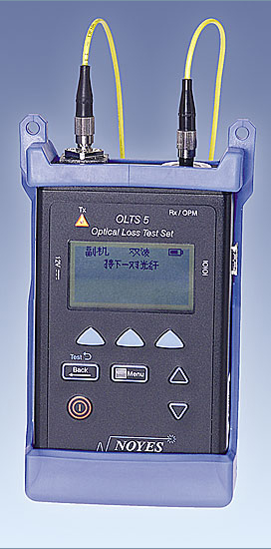
665 nm for plastic optical fiber

850 nm or 1300 nm for multimode

1310 nm or 1550 nm for singlemode

Test your system with a source similar to the one that will be actually used to send data

Optical Loss Test Set

Power meter and source in a single unit

Normally used in pairs

Automated, more complex and expensive than the combination of a source and a power meter

Rare in field testing

Image from aflfiber.com

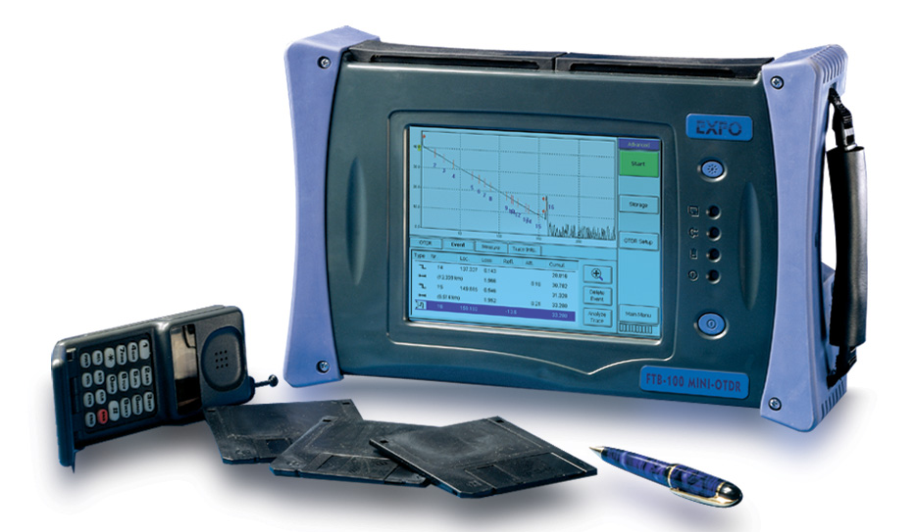
OTDR (Optical Time-Domain Reflectometer)

Image from exfo.com

OTDR Uses

Measure loss

Locate breaks, splices, and connectors

Produces graphic display of fiber status

Can be stored for documentation and later reference

Cable can be measured from one end

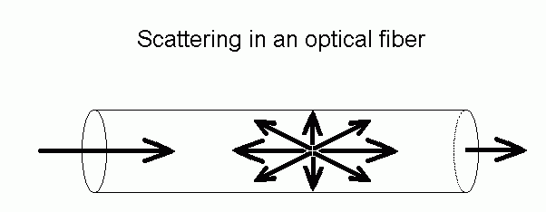

Backscatter

A small amount of light is scattered back to the source from the fiber itself

Splices or connector pairs cause a larger reflection of light back to the source

Figure from techoptics.com (link Ch 17a)

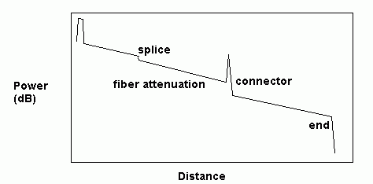
Dead
zone

OTDR Display

OTDR Accuracy

OTDR can give false loss values when coupling different fibers together

Splices can even show more light on the other side “gainer”

This is an illusion caused by increased scattering on the other side

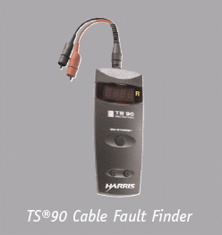
Splice loss uncertainty up to 0.8 dB

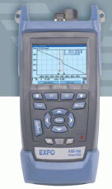
Types of OTDR

Full-size

Complex, powerful, expensive

Mini-OTDR

Fewer features

Fault Finder

Simplified, shows distance to a fault

Links Ch 17c, d, e

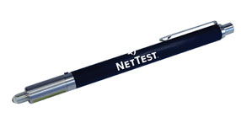
Visual Cable Tracers and Visual Fault Locators

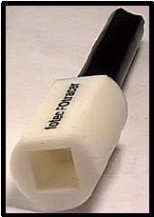
Cable tracer is just a flashlight

VFL uses an LED or Laser source to get more light into the fiber

Useful to test a fiber for continuity

To check to make sure the correct fiber is connected

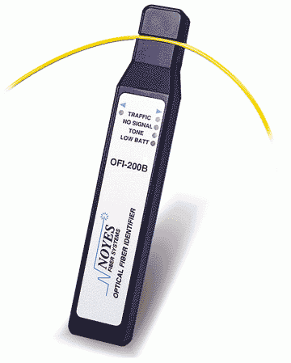
With bright sources, you can find the break by looking for light shining through the jacket

Visible light only goes 3-5 km through fiber

Images from links Ch 17 e & f

Fiber Identifiers

Bends the fiber to detect the light

Can be used on live fiber without interrupting service

Can detect a special modulated tone sent down a fiber

Image from tecratools.com (link Ch 17d)

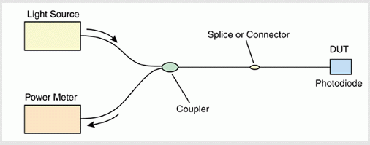
Cable to be Tested

Optical Continuous Wave Reflectometer (OCWR)

Measures optical return loss (reflectance) of connectors

Inaccurate on installed systems because it includes backscatter and all sources of reflectance

See link Ch 17h
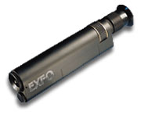

Microscope

Used to inspect fibers and connectors

Particularly during epoxy-polish process

Image from link Ch 17g

Talkset

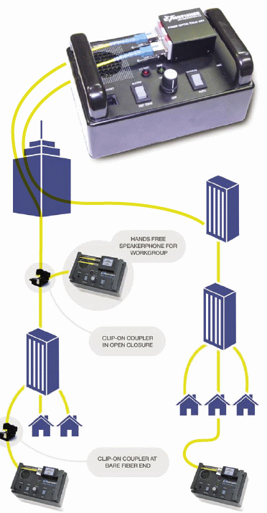
Telephone calls over unused fibers

Rarely needed now that we have cellphones

See link Ch 17i

Attenuators

Simulates the loss of a long fiber run

Variable attenuators allow testing a network to see how much loss it can withstand

Can use a gap, bending, or inserting optical filters

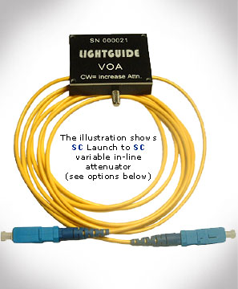
Image from link Ch 17j

Reference Cables

Test cables are needed to connect the cables to be tested to the test instruments

Must have correct connectors, be clean, and high-quality (low loss)

Use high-quality mating adapters

Ceramic or metal – not plastic

Singlemode rated are most accurate

Optical Power Levels

Detectors are Silicon, Germanium, or Indium-Gallium-Arsenide semiconductors
Network Type | Wavelength | Power Range (dBm)
Telecom | 1330, 1550 | +3 to -45
Telecom DWDM | 1550 | +20 to -30
Data | 665, 790, 850, 1300 | -10 to -30
CATV | 1300, 1550 | +10 to -6

Calibrations

NIST is a standards laboratory

Offers power calibration services at 850, 1300, and 1550 nm wavelengths

Instruments should be returned to the manufacturer for calibration annually

Uncertainties

Absolute power: 5% or 0.2 dB

Insertion loss: 0.5 dB or more

OTDR: up to several dB

Optical return loss: 1 dB or more

Although meters show a reading with hundredths of a decibel, they don’t mean anything

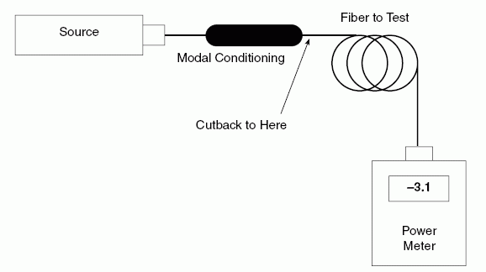
A 2.13 dB loss might well re-measure as 2.54 dB

Optical Fiber Testing

Before installation

Test continuity with cable tracer or VFL

Measure attenuation with cutback method

Cut off known length, measure power increase

Sources for Loss Measurements

Most multimode systems use LED sources

High-speed multimode often uses VCSELs (1 Gbps and higher)

See link Ch 17k

Singlemode systems use laser sources

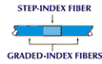
Test with the source you will really use

BUT Argilent says you should test all Multimode with LEDs (link Ch 17l)

Modal Effects in Multimode Fiber

Mode scramblers mix modes to equalize power in all modes

Can be made with a section of step-index fiber

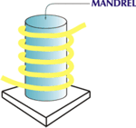
Mode filters remove higher-order modes to reach equilibrium modal distribution

Can be made with a mandrel wrap

Singlemode fibers shorter than 10 meters may have extra modes

Use a launch cord to avoid that problem

OTDR Pulse Width

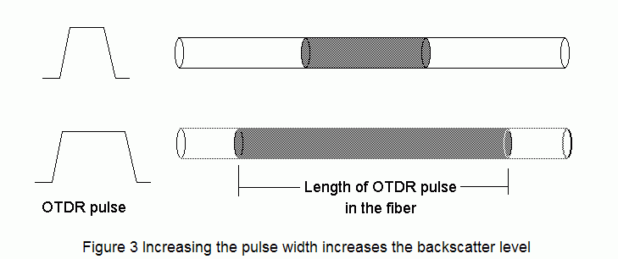
Longer pulses can see further down the cable because they have more light

But they have less accuracy finding locations

From link Ch 17a

OTDR Uncertainties

Dead zone

Nothing can be measured for the first 100 meters or so

Distance Resolution

Two events too close together cannot be resolved

Especially with long pulses

OTDR Distance Errors

Speed of light in fiber

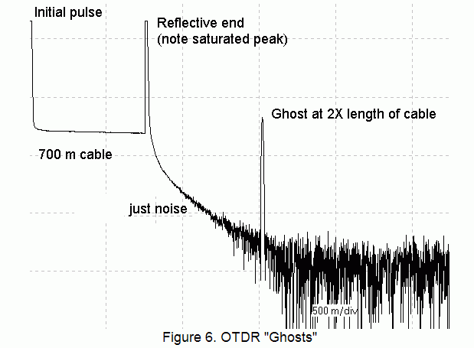
May not be exactly what the OTDR expects, distorting distances

Slack in fiber

OTDR measures length along the fiber, which is usually 1% - 2% longer than the length along the cable

OTDR Loss Errors

Joining two fibers with different backscatter coefficients will cause:

Too high a loss when measured in one direction

Too low a loss in the other direction

For accurate loss measurements, measure from both ends and average the results

OTDR Ghosts

Secondary reflection appears at double the real cable length

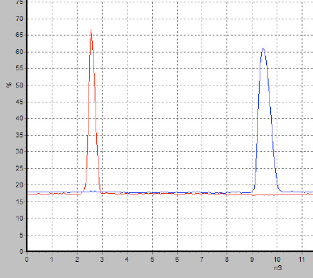
Using index-matching gel will eliminate ghosts

Dispersion

Multimode fibers suffer from modal dispersion

All fibers suffer from chromatic dispersion

Because different wavelengths travel at different speeds, and no source is completely monochromatic

In very long singlemode networks, polarization mode dispersion also matters

Bandwidth Testers

There is a new unit available to test bandwidth in the field, but it is not commonly done yet (link Ch 17 k)

Connector Insertion Loss Test

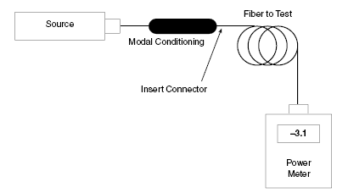
This test gives the typical loss of a connector type

Modal Distribution

The insertion loss test

FOTP-34 by the TIA

Three options of modal distribution

EMD or steady state

After a mandrel wrap

Fully filled

After a mode scrambler

Any other specified conditions

Microscopes

Used to inspect the ends of polished connectors

Helpful to view the connector at an angle while lighting it from the side

Only defects over the core really matter

Optical Return Loss in Connectors

A pair of glass-air interfaces for nonphysical contact connectors without index-matching gel

4% reflectance – loss of 0.3 dB

PC connectors can have a reflectance of 1% or an ORL of 20 dB

Much less with the best PC connectors – 40 to 60 dB

Reflectance can be a problem in high bitrate singlemode systems

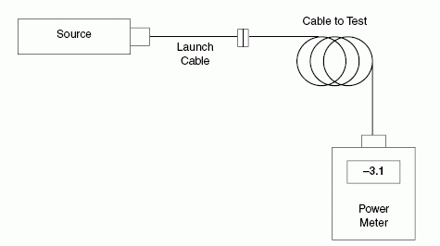
Basic Cable Loss Test

Test FOTP-171

Measure power through launch cable

Then add cable to test

This tests only one connector – turn the cable around to test the other end

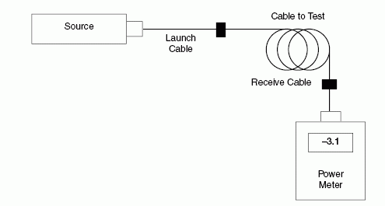
Double-Ended Loss Test

Uses both a launch and receive cable

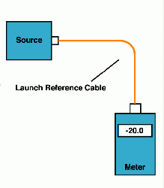
Single-Cable Reference

Refer to this condition:

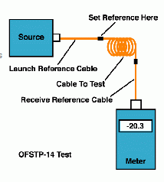

Test this way

EIA/TIA 568 requires this

See link Ch 17m

Why Use Single-Cable Reference?

It gives highest loss and lowest uncertainty

Choosing a Launch Cable for Testing

Choose cables with low loss

It is not necessary to get connectors and fiber with tighter specifications

Handle the launch cables carefully

Inspect them with a microscope

Keep them clean

Use splice bushings with metal or ceramic alignment sleeves

Mismatched Fibers

Coupling a smaller fiber to a larger one causes only a small loss (0.3 dB or so)

Connecting large fiber to small fiber causes a large loss

Both because of diameter and numerical aperture

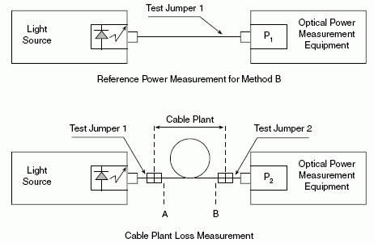
Testing the Installed Cable Plant

Can use one-cable reference, or two-cable, or three-cable, but the type of reference must be documented

Wavelengths

Usually test multimode at both 850 and 1300 nm with LED sources

Singlemode test is usually at 1300 nm only

1550 nm is sometimes required also

For long-distance, and to show that WDM can be performed later

Also shows microbends – 1550 test is much more sensitive to bending loss
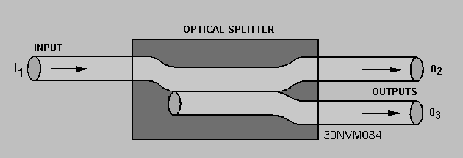

Optical Splitter

Splits light signal from one fiber into two fibers

Figures from tpub.com (link Ch 17n)

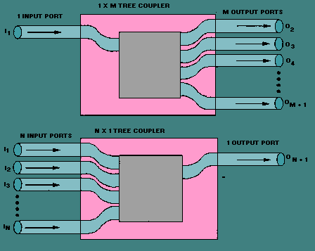

Couplers Can Split or Combine

You can also split one to M, or combine M to 1

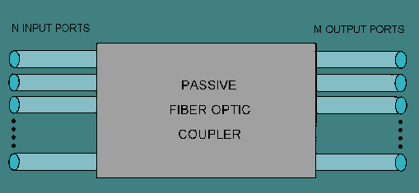
M to N Coupler

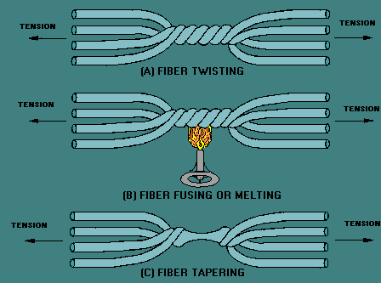

Making Couplers



Wavelength Division Multiplexers

Light entering from the left containing two wavelengths is separated into the two fibers on the right

Combining the two signals is also possible

Requires special equipment and techniques to test

Image from link Ch 17o

Fiber Optic Amplifiers

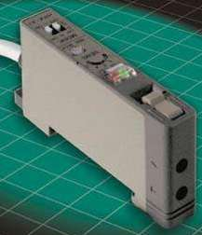
Boosts signal without converting it to electricity

Complicated to test, require special equipment

Image from link Ch 17p

Fiber Optic Switch

See links Ch 17q and 17r
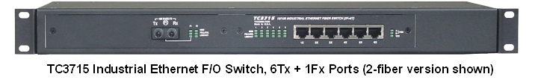
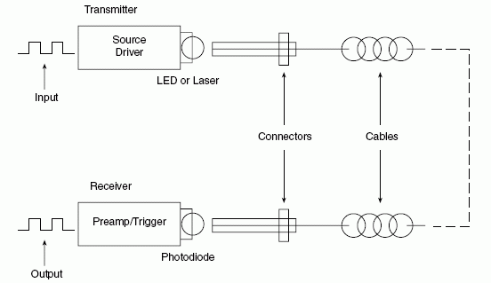

Fiber Optic Datalinks

The diagram shows a single link

Most networks will be bidirectional (full duplex) with two links working in opposite directions

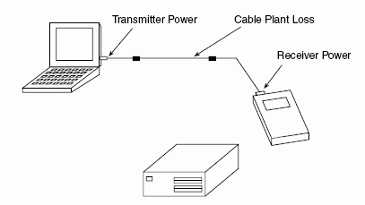

Bit Error Rate

The receiver power must be within the operating range

Too little power leads to high bit error rates (wrong data at receiver)

Too much power saturates the detector and also leads to high bit error rates

Use an attenuator in this case

What Goes Wrong?

Often the two fibers are connected backwards – check them with a visual tracer

Check receiver power level

Check plant loss with double-ended method

Don’t Use an OTDR to Measure Plant Loss

OTDR does not see the loss of the end connectors

Its power source is not the same as normal LAN power sources

OTDR measurements are affected by backscatter coefficient which may not be the same for all the cables in a network

Back Reflection

Back reflection can cause networks to fail even though the loss is low

Power meter can’t measure reflection

Use an OTDR or OCWR

Cure it by splicing in low-reflection patch cords to replace high-reflectance connectors

Angled PC connectors are designed to minimize reflectance for this reason (not mentioned in textbook)

Reliability

Once installed, the fiber optics should work for a long time

People break the cable by accident

Mark where cables are buried

Bury a marker tape above the cable

Use orange or yellow jacket cable indoors

A broken cable just behind a connector in a patch panel is hard to find

Source Failure

LED in laser transmitter drops in power as it ages

Laser sources are feedback-stabilized so they remain constant in power till they fail

Last modified 5-6-06

