Optical Fiber

Fiber v. Copper

Optical fiber transmits light pulses

Can be used for analog or digital transmission

Voice, computer data, video, etc.

Copper wires (or other metals) can carry the same types of signals with electrical pulses

Advantages of Fiber

Fiber has these advantages compared with metal wires

Bandwidth – more data per second

Longer distance

Faster

Special applications like medical imaging and quantum key distribution are only possible with fiber because they use light directly

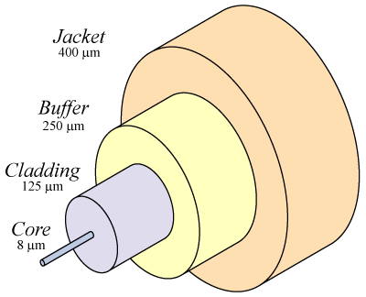
Elements of a Fiber Data Link

Transmitter emits light pulses (LED or Laser)

Connectors and Cables passively carry the pulses

Receiver detects the light pulses

Repeaters

For long links, repeaters are needed to compensate for signal loss

Optical Fiber

Core

Glass or plastic with a higher index of refraction than the cladding

Carries the signal

Cladding

Glass or plastic with a lower index of refraction than the core

Buffer

Protects the fiber from damage and moisture

Jacket

Holds one or more fibers in a cable

Singlemode Fiber

Singlemode fiber has a core diameter of 8 to 9 microns, which only allows one light path or mode

Images from arcelect.com (Link Ch 2a) 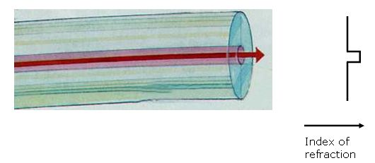

Multimode Step-Index Fiber

Multimode fiber has a core diameter of 50 or 62.5 microns (sometimes even larger)

Allows several light paths or modes

This causes modal dispersion – some modes take longer to pass through the fiber than others because they travel a longer distance
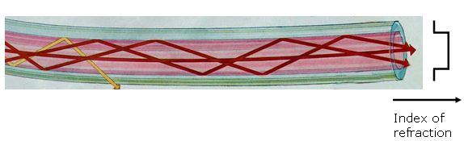

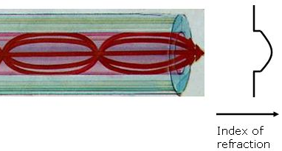
See animation at link Ch 2f

Multimode Graded-Index Fiber

The index of refraction gradually changes across the core

Modes that travel further also move faster

This reduces modal dispersion so the bandwidth is greatly increased

Step-index and Graded-index

Step index multimode was developed first, but rare today because it has a low bandwidth (50 MHz-km)

It has been replaced by graded-index multimode with a bandwidth up to 2 GHz-km

Plastic Optical Fiber

Large core (1 mm) step-index multimode fiber

Easy to cut and work with, but high attenuation (1 dB / meter) makes it useless for long distances

Sources and Wavelengths

Multimode fiber is used with

LED sources at wavelengths of 850 and 1300 nm for slower local area networks

Lasers at 850 and 1310 nm for networks running at gigabits per second or more

Sources and Wavelengths

Singlemode fiber is used with

Laser sources at 1300 and 1550 nm

Bandwidth is extremely high, around 100 THz-km

Fiber Optic Specifications

Attenuation

Loss of signal, measured in dB

Dispersion

Blurring of a signal, affects bandwidth

Bandwidth

The number of bits per second that can be sent through a data link

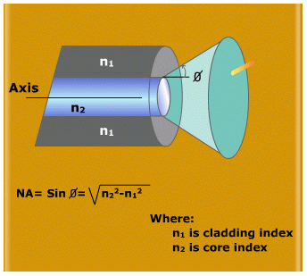
Numerical Aperture

Measures the largest angle of light that can be accepted into the core

Attenuation and Dispersion

See animation at link Ch 2e

Measuring Bandwidth

The bandwidth-distance product in units of MHz×km shows how fast data can be sent through a cable

A common multimode fiber with bandwidth-distance product of 500 MHz×km could carry

A 500 MHz signal for 1 km, or

A 1000 MHz signal for 0.5 km

From Wikipedia

Numerical Aperture

If the core and cladding have almost the same index of refraction, the numerical aperture will be small

This means that light must be shooting right down the center of the fiber to stay in the core

See Link Ch 4d

Fiber Types and Specifications

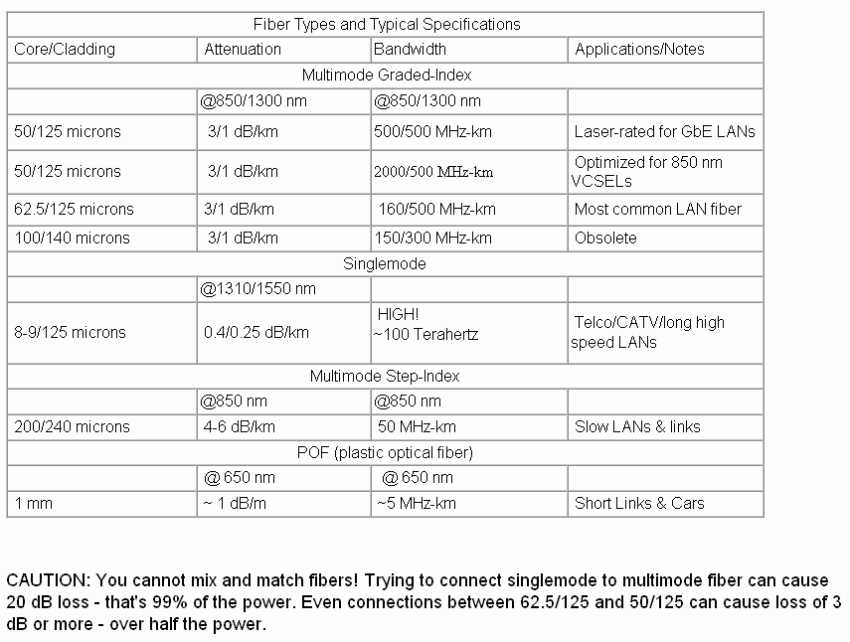

From Lennie Lightwave (www.jimhayes.com/lennielw/fiber.html)

Popular Fiber Types

At first there were only two common types of fiber

62.5 micron multimode, intended for LEDs and 100 Mbps networks

There is a large installed base of 62.5 micron fiber

8 micron single-mode for long distances or high bandwidths, requiring laser sources

Corning’s SMF-28 fiber is the largest base of installed fiber in the world (links Ch 2j, 2k)

Gigabit Ethernet

62.5 micron multimode fiber did not have enough bandwidth for Gigabit Ethernet (1000 Mbps)

LEDs cannot be used as sources for Gigabit Ethernet – they are too slow

So Gigabit Ethernet used a new, inexpensive source:

Vertical Cavity Surface Emitting Laser (VCSEL)

Multimode Fiber Designed for VCSELs

First came laser-rated 50 micron multimode

Bandwidth 500 MHz-km at 850 nm

Then came laser-optimized 50 micron multimode

Bandwidth 2000 MHz-km at 850 nm

Distinctive aqua-colored jacket

See links Ch 2g, 2h, 2i

Don’t Mix Fiber Types

You can’t mix singlemode and multimode fiber – you lose 20 dB at the junction (99% of the light!)

Mixing 50 micron and 62.5 micron multimode is not as bad, but you lose 3 dB (half the power) which is usually unacceptable

Flash Cards

To memorize this stuff, I use online flash cards

Go to samsclass.info

Click on CNIT 211

Click on Flashcards

Choose Ch 2a: Fiber Types
Fiber Manufacture

Three Methods

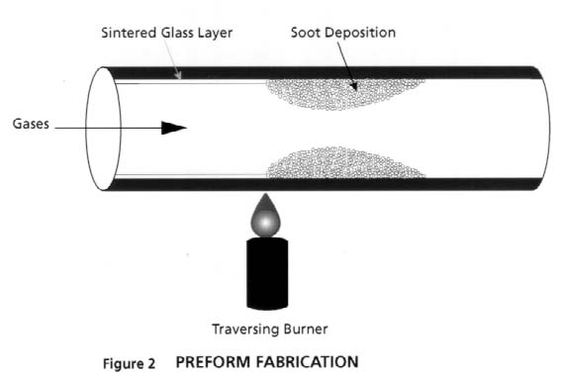
Modified Chemical Vapor Deposition (MCVD)

Outside Vapor Deposition (OVD)

Vapor Axial Deposition (VAD)

Modified Chemical Vapor Deposition (MCVD)

A hollow, rotating glass tube is heated with a torch

Chemicals inside the tube precipitate to form soot

Rod is collapsed to crate a preform

Preform is stretched in a drawing tower to form a single fiber up to 10 km long

Image from thefoa.org

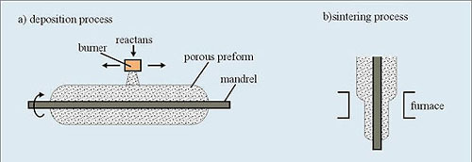
Outside Vapor Deposition (OVD)

A mandrel is coated with a porous preform in a furnace

Then the mandrel is removed and the preform is collapsed in a process called sintering

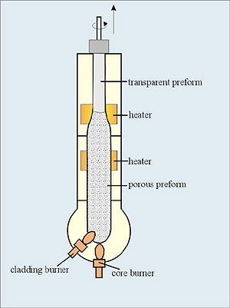
Image from csrg.ch.pw.edu.pl

Vapor Axial Deposition (VAD)

Preform is fabricated continuously

When the preform is long enough, it goes directly to the drawing tower

Image from csrg.ch.pw.edu.pl

Drawing

The fiber is drawn from the preform and then coated with a protective coating

Index of Refraction

When light enters a dense medium like glass or water, it slows down

The index of refraction (n) is the ratio of the speed of light in vacuum to the speed of light in the medium

Water has n = 1.3

Light takes 30% longer to travel through it

Fiber optic glass has n = 1.5

Light takes 50% longer to travel through it
Fiber Applications

Step-index Multimode

Large core size, so source power can be efficiently coupled to the fiber

High attenuation (4-6 dB / km)

Low bandwidth (50 MHz-km)

Used in short, low-speed datalinks

Also useful in high-radiation environments, because it can be made with pure silica core

Graded-index Multimode

Useful for “premises networks” like LANs, security systems, etc.

62.5/125 micron has been most widely used

Works well with LEDs, but cannot be used for Gigabit Ethernet

50/125 micron fiber and VSELS are used for faster networks

Singlemode FIber

Best for high speeds and long distances

Used by telephone companies and CATV

Fiber Performance

Attenuation

Modern fiber material is very pure, but there is still some attenuation

The wavelengths used are chosen to avoid absorption bands

850 nm, 1300 nm, and 1550 nm

Plastic fiber uses 660 nm LEDs

Image from iec.org (Link Ch 2n)

Three Types of Dispersion

Dispersion is the spreading out of a light pulse as it travels through the fiber

Three types:

Modal Dispersion

Chromatic Dispersion

Polarization Mode Dispersion (PMD)

Modal Dispersion

Modal Dispersion

Spreading of a pulse because different modes (paths) through the fiber take different times

Only happens in multimode fiber

Reduced, but not eliminated, with graded-index fiber

Chromatic Dispersion

Different wavelengths travel at different speeds through the fiber

This spreads a pulse in an effect named chromatic dispersion

Chromatic dispersion occurs in both singlemode and multimode fiber

Larger effect with LEDs than with lasers

A far smaller effect than modal dispersion

Polarization Mode Dispersion

Light with different polarization can travel at different speeds, if the fiber is not perfectly symmetric at the atomic level

This could come from imperfect circular geometry or stress on the cable, and there is no easy way to correct it

It can affect both singlemode and multimode fiber.

Modal Distribution

In graded-index fiber, the off-axis modes go a longer distance than the axial mode, but they travel faster, compensating for dispersion

But because the off-axis modes travel further, they suffer more attenuation

Equilibrium Modal Distribution

A long fiber that has lost the high-order modes is said to have an equilibrium modal distribution

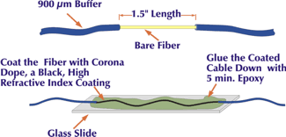
For testing fibers, devices can be used to condition the modal distribution so measurements will be accurate

Mode Stripper

An index-matching substance is put on the outside of the fiber to remove light travelling through the cladding

Figure from fiber-optics.info (Link Ch 2o)

Mode Scrambler

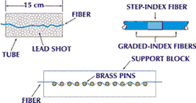
Mode scramblers mix light to excite every possible mode of transmission within the fiber

Used for accurate measurements of attenuation

Figure from fiber-optics.info (Link Ch 2o)

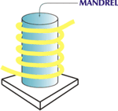

Mode Filter

Wrapping the fiber around a 12.5 mm mandrel

Exceeds the critical angle for total internal reflection for very oblique modes

The high-order modes leak into the cladding and are lost

That creates an equilibrium modal distribution

Allows an accurate test with a short test cable

Figure from fiber-optics.info (Link Ch 2o)
Decibel Units

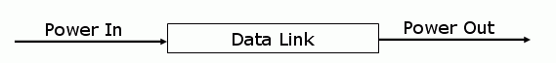
Optical Loss in dB (decibels)

If the data link is perfect, and loses no power

The loss is 0 dB

If the data link loses 50% of the power

The loss is 3 dB, or a change of – 3 dB

If the data link loses 90% of the power

The loss is 10 dB, or a change of – 10 dB

If the data link loses 99% of the power

The loss is 20 dB, or a change of – 20 dB

dB = 10 log (Power Out / Power In)

Absolute Power in dBm

The power of a light is measured in milliwatts

For convenience, we use the dBm units, where

-20 dBm = 0.01 milliwatt

-10 dBm = 0.1 milliwatt

0 dBm = 1 milliwatt

10 dBm = 10 milliwatts

20 dBm = 100 milliwatts
Last modified 1-30-06

