Where Fiber is Used

History

First fiber optic network installed in Chicago in 1976 (Link Ch 3k)

Now more than 90% of long-distance voice links use fiber optics

CATV is sent over fiber optics using an analog transmission

Soon it will convert to digital compressed video

The Internet backbone is also fiber

Where New Fiber is Going

“The Last Mile”

Fiber to the home

Fiber to the Curb

Fiber to the office

Fiber to the telephone

Fiber to the desktop

See links Ch 3a, 3b, 3c
Economics of Fiber

Telephony

A single strand of fiber can carry more traffic than thousands of copper pairs

Fiber saves in materials costs, installation, splicing labor and reliability, and uses less space in the conduits

Fiber is the clear choice for high traffic and long distance links

FTTC and FTTH

Fiber To The Curb and

Fiber To The Home

Not cost-efficient yet, but will become needed as customers demand more bandwidth

SONET

Synchronous Optical Network

A standard to enable telecommunications networks to interoperate

The international equivalent to SONET is SDH (Synchronous Digital Hierarchy)

Now that data traffic surpasses voice traffic, SONET is threatened by IP (Internet Protocol) and VoIP (Voice over IP)

Fiber To The Premises (FTTP)

Telcos are deploying FTTP

Verizon spent $1 billion in 2005 to deploy FTTP to 3 million homes and businesses in 16 states

It plans to continue spending $1 to $2 billion per year on FTTP until 2010

AT&T is spending $6 billion on FTTN (Fiber To The Neighborhood or Fiber To The Node) to be completed in 2008 (links Ch 3d, 3e)

CATV (Cable television)

CATV often converts from copper to fiber by overbuilding existing metal cable

Attaching fiber to existing hanging cables, or

Pulling fiber through existing underground ducts

LANs (Local Area Networks)

Most computer networks use UTP (Unshielded Twisted-Pair) copper cables

UTP has a maximum length of 100 meters, and a maximum speed of 1 Gbps

Fiber is not popular to the desktop because the electronics cost more

Fiber is popular on network backbones

Ethernet

Ethernet is the most popular LAN standard

Runs at 10 Mbps, 100 Mbps, 1 Gbps, or 10Gbps

Can run over copper or fiber

10 Gbps is new and slowly gaining acceptance, and may replace Fibre Channel for server clusters (link Ch 3f)

Media Converters

Convert UTP Ethernet to Fiber Optics

Allows an Ethernet network to be greatly extended, mixing fiber and copper on the LAN

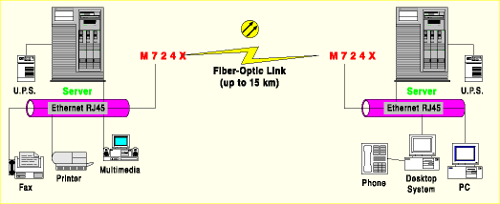
Image from link Ch 3g (versitron.com)

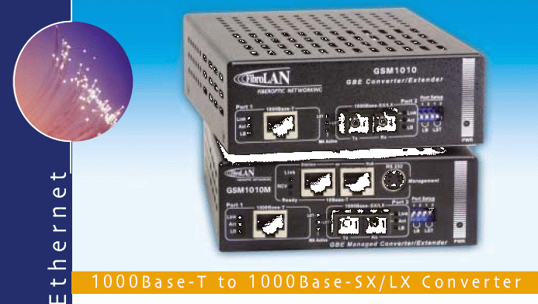

Media Converters

This is a 1 Gbps media converter

See links Ch 3h, 3i

Image from link Ch 3h (arcelect.com)

Specifications for the 1 Gbps Converter

Note error on last line – 500 km is impossible for multimode

From link Ch 3h (arcelect.com)

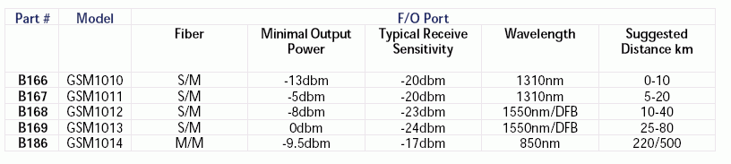

Older LAN Standards

All these obsolete LAN standards could run over either copper or fiber

ARCnet

WangNet

DECnet

Token Ring

Older Fiber LAN Standards

These obsolete LAN standards were designed for fiber

Fiber Distributed Data Interface (FDDI)

Replaced by Ethernet

Enterprise System Connection Architecture (ESCON)

Replaced by Fibre Channel

Fibre Channel

Fibre Channel is used for server clusters and storage area networks

Image from link Ch 3j (hsi.web.cern.ch)
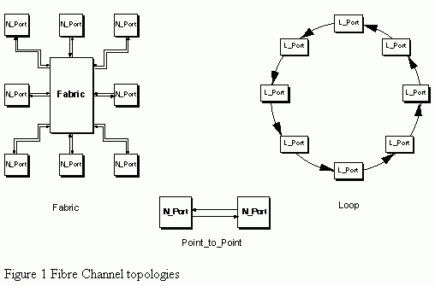

Specialized Networks

IEEE 1394 and TOSLINK

Used for consumer electronics over copper or plastic optical fiber

MOST (Media Oriented System Transport)

Automotive multimedia connecting media devices within the car

Flexray

Automotive network for safety devices like airbags

Other Applications of Fiber Optics

Surveillance and news cameras

Security devices like card readers

Electric utilities control the grid with fiber optics, to avoid electromagnetic interference (EMI)
Fiber v. Copper

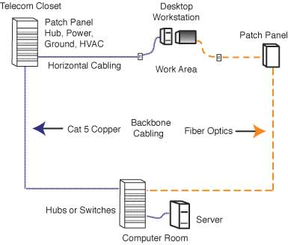
Copper cables must be 100 meters or less

That means you need a powered telecom closet on each floor

Fiber only needs one telecom closet per building

Image from Lennie Lightwave

Cost of Fiber v. Copper

Copper components are cheaper, but you need more total equipment and it uses more space

If you include everything, fiber may even be cheaper than copper

Cost model at fols.org (link Ch 3l)

Future-Proofing the Installation

Plan for growth

Install extra fibers

Most people still use 62.5/125 multimode

50/125 multimode runs faster and will make future expansion of bandwidth possible

Singlemode fiber is all the same

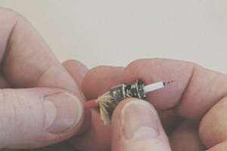
Except specialty dispersion-shifted or dispersion-flattened which are not recommended for general use

Termination

Termination is attaching connectors to the end of the fiber strands

Fiber cannot be used until it is terminated

Termination is the largest labor cost for fiber

Install extra strands, but don’t terminate them till you need them

Image from Lennie Lightwave
The Future of Fiber

Fiber offers the most bandwidth, which will be increasingly needed by:

Voice over IP

Video conferencing

Video and high-speed gaming over the Internet

Korean Internet users have 20 Mbps connections, and are currently installing 100 Mbps FTTH (see links Ch 2m, 2n, 2o)

Last modified 1-30-06

