Optical Fiber Cable Construction

Fiber and Acrylate Coating

Optical fiber is covered by an acrylate coating during manufacture

Coating protects the fiber from moisture and mechanical damage

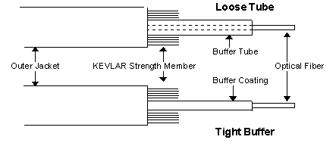
Three Cable Types

Tight-buffer

Loose-tube

Ribbon

Loose-Tube and Tight-Buffer

A cable has:

Optical fiber (core, cladding, and coating)

Buffer (loose or tight)

Kevlar strength member

Outer Jacket

Image from commspecial.com (link Ch 4a)

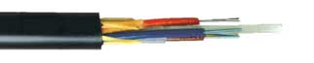

Loose-Tube Cable

Used for long distances and outside-plant

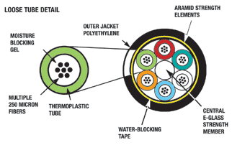
Low attenuation

High pulling strength

Fibers are completely separated from environment

Image from alphawire.com (link Ch 4e)

Tubes contain gel or absorbent tape to protect fibers from water

Image from alphawire.com (link Ch 4e)

Fibers must be terminated with breakout kits

Or fusion splicing to pre-connectorized pigtails

Image from fonetworks.com (link Ch 4d)

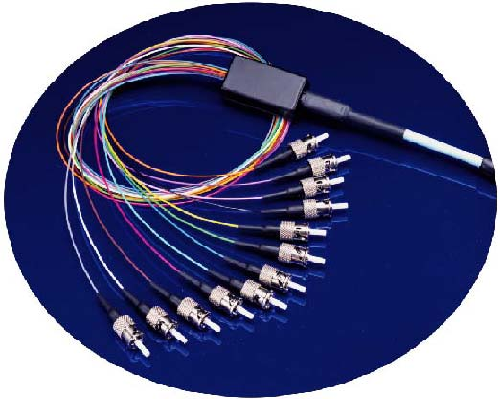
Used Outdoor

Ducts or conduits
Breakout Kit

Aerial lashed

Directly buried (armored)

Weather-resistant

From alphawire.com (link Ch 4k)
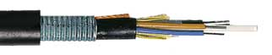
Armored cable

Tight-Buffer Cable

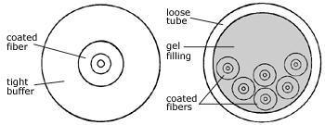
PVC Buffer is extruded directly onto the coating

Diameter is 900 microns

Makes cable more flexible

Easier to terminate

The most common indoor cable type

Not good for outside use

Because the buffer strains the fiber as temperature fluctuates, increasing attenuation

Image from mohawk-cdt.com (link Ch 4f)

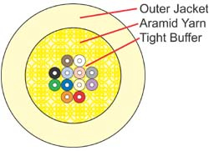

Distribution Cables

Several tight-buffer fibers

Kevlar reinforcement (Aramid)

One jacket

Contains tight-buffered fibers in bundles of up to 12 each

Used for Riser and Office Cabling

Must be terminated inside a patch panel or junction box

From alphawire.com (link Ch 4i)
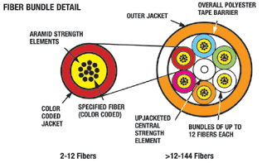

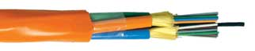

Breakout Cables

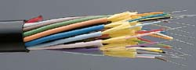
Reinforce each tight-buffer fiber with Kevlar and jacket it

Each fiber can be broken out and individually connectorized

Image from arcelect.com (link Ch 4g)

Several simplex units cabled together

Stronger, larger and more expensive than distribution cables

Used for Riser and Office Cabling

Cables can be terminated individually and connected directly to computers

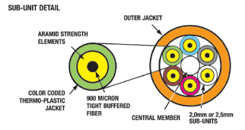
From alphawire.com (link Ch 4j)

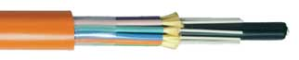

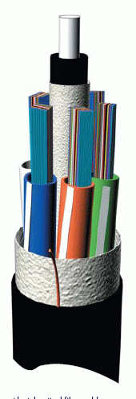
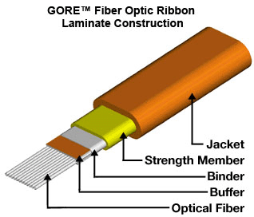

Ribbon cable

Dozens of fibers packed together

Can be mass fusion spliced or mass terminated

Images from gore.com (link Ch 4b) and alcatel.com (link Ch 4c)

Cable Jacketing

Chemical Resistance

Kynar, PFA, Teflon, Tefzel, or Halar

Aerospace

Wide temperature range, ½ inch sustained bend radius

Fire Safety

Inside cable must meet National Electric Code fire safety requirements

Horizontal Fire Propagation

Dripping of flaming material

Irradiated Hypalon or XLPE meets these requirements (plenum rated)

Use of black outside-plant cable in buildings is limited to 50 feet

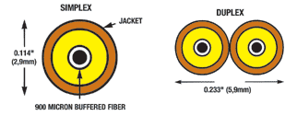
See link Ch 4l

Five Standard Cable Types

Simplex and Zipcord

Distribution

Breakout

Loose-tube

Hybrid or Composite

Simplex and Zipcord

Used For:

Patch Cables

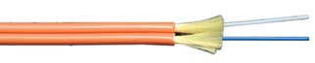
Short Run Office Cabling

Test Equipment

From alphawire.com (link Ch 4h)

Hybrid or Composite Cable

Hybrid cable

Contains both singlemode and multimode fibers

Composite cable

Contains both copper wires and fiber optics

The two terms are often confused
Choice of Cables

Choosing a Cable

From lanshack.com (link Ch 4m)
Cable Type | Application | Advantages
Tight Buffer | Premises | Makes rugged patch cords
Distribution | Premises | Small size for lots of fibers, inexpensive
Breakout | Premises | Rugged, easy to terminate, no hardware needed
Loose Tube | Outside Plant | Rugged, gel or dry water-blocking
Armored | Outside Plant | Prevents rodent damage
Ribbon | Outside Plant | Highest fiber count for small size

Factors to Consider when Choosing Cable

Bandwidth

Attenuation & Length

Cost

Mechanical & UL/NEC Requirements

Signal loss

Connectors

Cable Dimensions & Environment

Existing systems

Installing Fiber Optic Cable

Never pull on the fiber itself

Pull only from the strength members

Maximum pulling force 300 lb.

Never exceed bend radius

10 x diameter without tension

20 x diameter under tension

Images from Lennie Lightwave and bwcecom.belden.com (Link Ch 4n)

Vertical Installations

Clamp the cable to distribute weight evenly

Every 50 feet indoors

More often, up to every 3 feet, outdoors

Fiber migrates down, increasing attenuation

Place 1 foot loops at the top of the run, bottom of run, and every 500 ft in between

Pulling Cables through Conduits

Loose-buffer cables work best

Video from American Polywater (link Ch 4o)

Direct Burial

Armor is desirable to protect the cable from gophers, construction digging, etc.

Gel filling is a water barrier

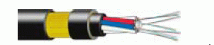
Aerial Installation

Supported by messenger wire, or

Self-supporting

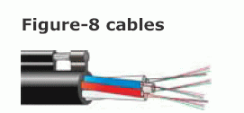
Images of self-supporting cable from ericsson.net and Arcelect.com (link Ch 4p & 4g)

OGW (Optical Ground Wire) cables carry both electricity and fiber optic signals
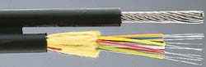

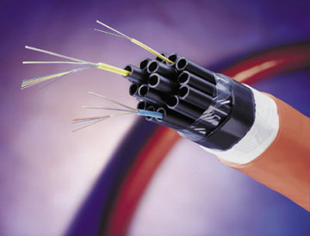
Blown-in Fiber

Fiber is blown through plastic tubes with air

Faster than pulling

Image from fpnmag.com (link Ch 4q)

Fire Code Ratings

NEC Rating | Description
OFN | Optical fiber non-conductive
OFC | Optical fiber conductive
OFNG or OFCG | General purpose
OFNR or OFCR | Riser rated cable for vertical runs
OFNP or OFCP | Plenum rated cables for use in air-handling plenums
OFN-LS | Low smoke density

See link Ch 4r for details

NEC Requirements

OFC cables have noncurrent-carrying conductive elements

Must be grounded

Cannot share a raceway with electric power lines

Can share with communications lines

Abandoned cables must be removed

Last modified 4-15-06

