Cable Parameters and Typical Values

Installation v. Environmental Specifications

Installation Specifications

Ex: Installation Load (Pulling force)

Environmental Specifications

Determine the cable’s long-term performance

Ex: Temperature range of operation

Installation Specifications

Maximum recommended installation load

Force in lb. (or kg-force or N)

Pulling with more than this force will permanently change the attenuation of the fiber

Typical values:

67-125 lb. for 1-fiber cables

250-500 lb. for cables with 6-12 fibers

600 lb. for self-supporting aerial cables

Minimum recommended installation bend radius

Don’t bend the cable under tension through a corner sharper than this

If you violate the bend radius, you may damage some part of the cable structure

Typical value: 20 times cable diameter

Diameter

Important when fitting the cable into a crowded conduit

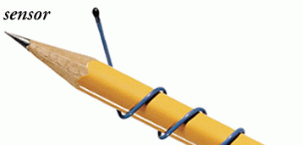
Temperature range for installation and storage

Environmental Specifications

Temperature range

Outside this range, the plastic may crack, or

Expansion cycles will create microbends in the fiber, increasing attenuation

Indoor, typically -10 to 50 Centigrade

Outdoor, typically -20 to 60 Centigrade

Military: -55 to 85 Centigrade

Image: a Teflon-coated fiber optic thermometer that operates down to 5 degrees Kelvin (link Ch 5i)

Minimum long-term bend radius

With the cable not under tension

Typically 10 diameters

There is a new Japanese fiber with bend radius under 1 cm (link Ch 5h)

NEC (National Electrical Code)

Three cable fire ratings:

No letter or G: General use—least stringent fire test

R: Riser—can be used in vertical shafts

P: Plenum—most strict test

Long-term use load

Important for long vertical installations

Aerial installation

Vertical rise distance

Must put in strain-relief loops

Flame resistance

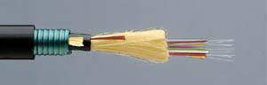
Non-building applications

UV stability

Resistance to Rodent Damage

Inner ducts are an alternative to armor

Steel armor

Copper tape armor

Braided armor

Dielectric armor

Image from arcelect.com

Armor makes the cable much less flexible

Resistance to water damage

Filled and Blocked

Each loose buffer tube is filled (with gel or tape)

A blocking material fills the space between the tubes

Crush load

Short-term v. long-term

Abrasion resistance

Resistance to chemicals

Resistance to conduction under high voltage

Toxicity

“Halogen-free” cables produce less harmful smoke

Required in Japanese and European buildings

High flexibility

If constantly bending, like an elevator

Hermetically sealed fiber

Protect it from water pressure, etc.

Radiation resistance

Nuclear reactors or satellites

Impact Resistance

Dropping heavy objects on the cable

Gas permeability

Preventing gas from escaping through the cable

Stability of filling compounds

Temperature cycles can pump filling compounds out the end of the cable

Vibration

Design Shortcuts

Future-Proofing a System

Include extra fibers in cables

It costs very little more to get a cable with more fibers in it

Include singlemode fibers in multimode cables

Allows enormous bandwidth increases later

Use dual-wavelength multimode fiber

Or even laser-optimized fiber

Multimode Fibers

Early multimode systems used 62.5/125 micron fiber

LED light sources at 850 or 1300 nm

10 Mbps or 100 Mbps

Huge installed base

50/125 micron fiber

Faster with VCSEL sources at 850 nm

Laser-optimized 50/125 micron fiber

Fastest, using VCSEL sources

Singlemode Fibers

Usually 1300 nm singlemode fiber is good enough

Cheaper than 1550 nm or two-wavelength systems

Cable Types

Indoor

Short distance – Break-out cable

Longer distance – Distribution cable

Rugged environment – Break-out cable

Use all-dielectric cable

Plenum-rated PVC is recommended

Outdoor

Cable should be water-blocked and gel-filled

Many fibers (>36) – consider ribbon cable

For midspan access, use stranded loose-tube cable

Use all-dielectric cable

Stranded Loose-Tube

Same as loose-tube table

Image from Corning (Link Ch 5f)
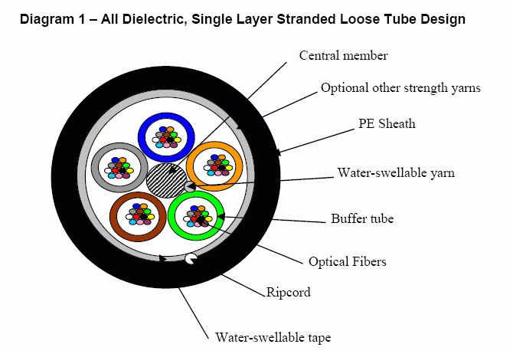

Indoor/Outdoor Cable

You could splice indoor to outdoor at the building entrance

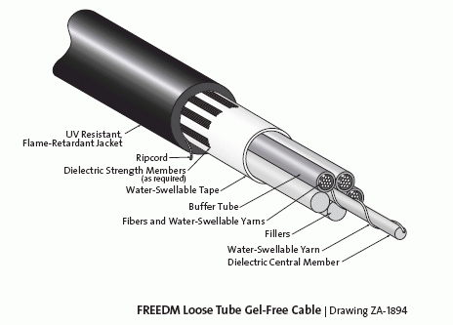
Or use indoor-outdoor cable like Corning’s FREEDM

Image from Corning (Link Ch 5g)

Cable and Source Prices (Not in textbook)

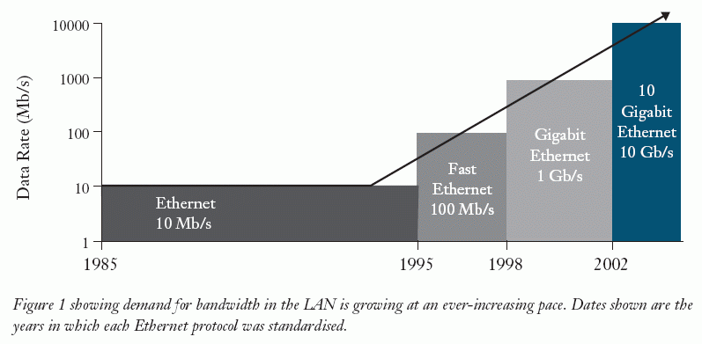
History of Ethernet

From Corning (link Ch 5b)

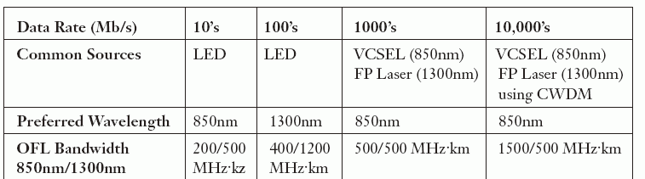

Sources

From Corning (link Ch 5b)

Cable Prices

For 500 feet of riser-rated indoor bulk cable, 12-fiber

62.5/125 micron MM $889

50/125 micron MM $889

50/125 micron
laser-optimized MM $1143

8.5/125 micron SM $584

From blackbox.com (link Ch 5c)

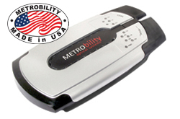
Media Converter Prices

100 Mbps Multimode: $ 229

1 Gbps Multimode: $ 760

1 Gbps Singlemode: $1,180

Prices from L-Com.com (Links Ch 5d & 5e)

Last modified 2-24-06

