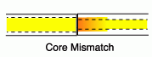
Fiber Joints

Fibers must be joined when

You need more length than you can get on a single roll

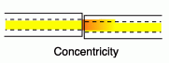
Connecting distribution cable to backbone

Connecting to electronic source and transmitter

Repairing a broken cable

Splices v. Connectors

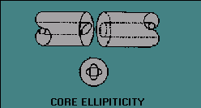
A permanent join is a splice

Connectors are used at patch panels, and can be disconnected

Optical Loss

Intrinsic Loss

Problems the splicer cannot fix

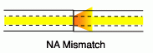
Core diameter mismatch

Concentricity of fiber core or connector ferrules

Core ellipticity

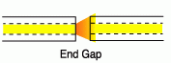
Numerical Aperture mismatch

Images from LANshack and tpub.com (links Ch 6a & 6c)

Optical Loss

Extrinsic Loss

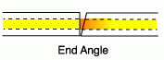
Problems the person doing the splicing can avoid

Misalignment

Bad cleaves

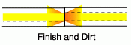
Air gaps

Contamination: Dirt, dust, oil, etc.

Reflectance

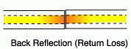
Measuring Reflectance

The reflected light is a fraction of the incoming light

If 10% of the light is reflected, that is a reflectance of 10 dB

If 1% of the light is reflected, 20 dB

Acceptable Losses
Fiber & Joint | Loss (max) | Reflectance (min)
SM splice | 0.15 dB | 50 dB
SM connector pair | 1 dB | 30 dB
MM splice | 0.25 dB | 50 dB
MM connector pair | 0.75 dB | 25 dB

Reflectance is not usually a problem for data networks, but causes ghosting in analog cable TV transmission

Angled connectors reduce reflectance

Connectors

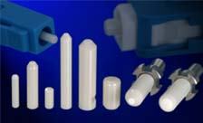
There are four types

Rigid Ferrule (most common)

Resilient ferrule

Grooved plate hybrids

Expanded beam

Image shows ferrules from swiss-jewel.com (link Ch 6e)

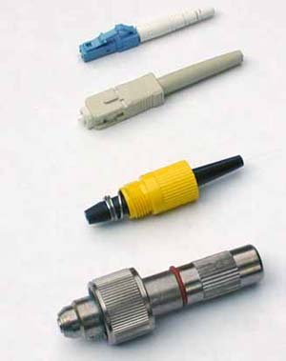
Image to the right shows LC, SC, Biconic, and the obsolete Deutsch 1000

From thefoa.org (link Ch 6d)

Rigid Ferrule Connectors

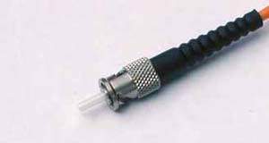
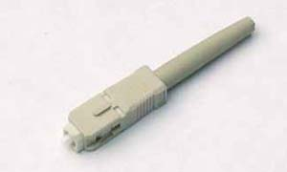
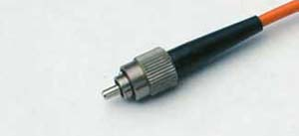
2.5 mm ferrule

ST

SC

Obsolete Connectors

Simplex (1-fiber)

SMA 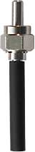

D4

Biconic

FC

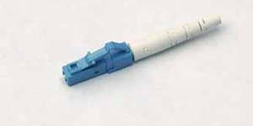
1.25 mm ferrule

Small Form Factor

LC
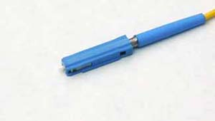

MU
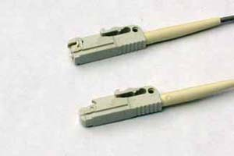

LX-5
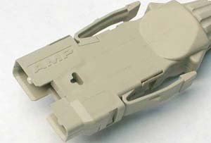

Duplex Connectors

Old, bulky

FDDI

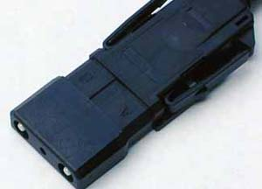

ESCON

Images from thefoa.org (link Ch 6d) except SMA pic from www.i-fiberoptics.com/conn/IFOconn.htm

Duplex Connectors

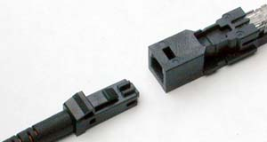
Newer, smaller

Small Form Factor

MT-RJ
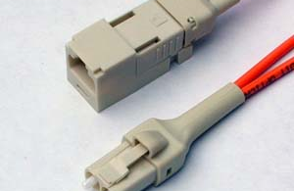

Opti-Jack

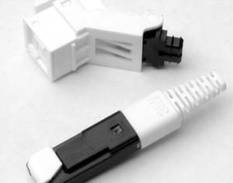

Volition

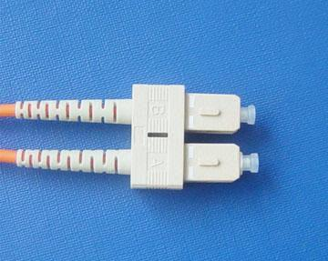
Popular

Duplex LC

Images from thefoa.org (link Ch 6d)

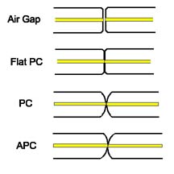
Duplex LC Image from globalsources.com (link Ch 6f)

Ferrule Polish

To avoid an air gap

Ferrule is polished flat, or

Rounded (PC—Physical Contact), or

Angled (APC)

Reduces reflectance

Cannot be mated with the other polish types

Image from LANshack (link Ch 6a)

FOCIS

Fiber Optic Connector Intermateability Standard

A document produced by a connector manufacturer so others can mate to their connector

Connectors with the same ferrule size can be mated with adaptors

But 2.5 mm ferrules can not be mated with 1.25 mm ferrules

Telecommunications

In telecommunications, SC and FC are being replaced by

LC in the USA

MU in other countries

Data

In data communications, SC and ST are being replaced by LC

Connectorizing a Cable

Epoxy-polish process (Proj. 4)

Strip cable, strip and clean fiber

Inject adhesive, put primer on fiber, insert fiber

Crimp connector, cleave protruding fiber

Air polish, final polish

Clean and inspect by microscope

Test connector loss with power meter

Cable Type and Connectors

Epoxy-polish process requires a cable jacket and strength member to make the connector durable

It works for simplex, zip, or breakout cables

But loose-tube cables and ribbon cables contain bare fiber, and cannot be connectorized this way

Distribution cables contain 900 micron buffered fiber – can be connectorized, but the connectors are not very strong and must be protected by hardware such as a junction box

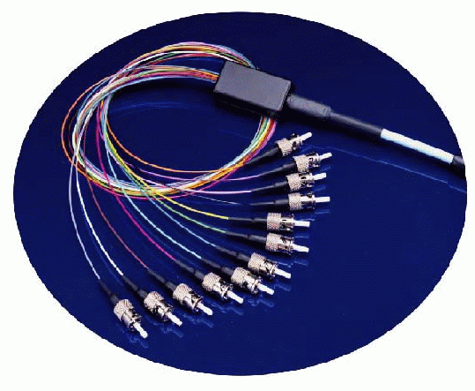
Breakout Kit

Provides tubing that protects the bare fiber so it can be terminated

Picture from fonetworks.com (link Ch 4d)

Mounting Methods for Connectors

Adhesives

Epoxy (room temperature-cure or oven-cure)

Quick-curing anaerobic adhesives (we used this method in Proj 4)

Hot-Melt adhesive

Crimping to hold the fiber

Like the Unicam – see link Ch 6h

Splicing to preconnectorized pigtails

Image of pigtail from fiberdyne.com (link Ch 6g)

Mounting Methods Comparison

Epoxy-Polish

Takes longer, but costs less and has lowest loss and reflectance

Anaerobic adhesive

Faster than epoxy-polish but higher loss because polishing is difficult

Crimping

Easier, but more expensive and more loss

Splicing to preconnectorized pigtail

Very easy, but expensive and higher loss

Strip, Clean and Cleave

Strip – remove 900 micron buffer (if present) and 250 micron coating

Clean with alcohol and lint-free wipe

Cleave – scribe and snap; goal is a 90 degree flat break

End-Face Polish

Polish on a flat glass plate for a flat finish

Polish on a rubber mat for a domed PC finish (Physical Contact)

Angled PC finish is tilted at 8 degrees to avoid reflectance (difficult to field-terminate)

Cleaning Connectors

Keep dust caps on

Use lint-free wipes and reagent-grade isopropyl alcohol to avoid attacking epoxy

“Canned air” has propellant, so does compressed air from a hose
Splices

Splices are a permanent join of two fibers

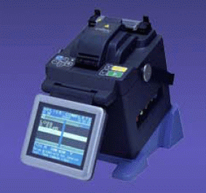
Lower attenuation and reflectance than connectors

Stronger and cheaper than connectors

Easier to perform than connectorization

Mass splicing does 12 fibers at a time, for ribbon cables

Mass Fusion Splicing

Video from fitel.fiberoptic.com (link Ch 6i)

Fusion Splicing

Melts the fibers together to form a continuous fiber

Expensive machine

Strongest and best join for singlemode fiber

May lower bandwidth of multimode fiber

Corning videos 1-7 & 12

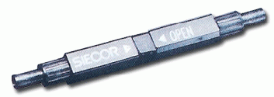

Mechanical Splicing

Mechanically aligns fibers

Contains index-matching gel to transmit light

Equipment cost is low

Per-splice cost is high

Quality of splice varies, but better than connectors

Fiber alignment can be tuned using a Visual Fault Locator

Tools

We covered them in Project 2

Last modified 4-15-06

