Chapter 7: Fiber Optic Hardware

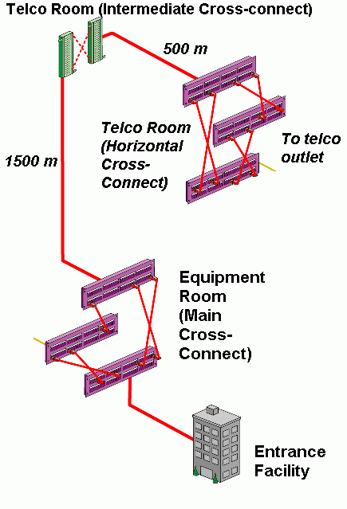
Hardware

Hardware protects and organizes cable, splices, and termination points

Premises Hardware – indoor

Outside plant Hardware – outdoor

Premises Cabling

TIA Standards

2000 m max. backbone wiring

Based on telco wiring standards

Image adapted from siemon.com (link Ch 7a)

Main Cross-Connect (MC)

Should be near the data center (for LANs) or the PBX (for telephones)

PBX: Private Branch Exchange; i.e., the campus switchboard

MC equipment should:

Handle enough fibers for all transmission needs

Accept:

Direct termination

Pigtail splices

Preterminated assemblies (see next slide)

Provide jumper storage and reconfiguration

Allow for growth

Preterminated Assemblies (Plug & Play)

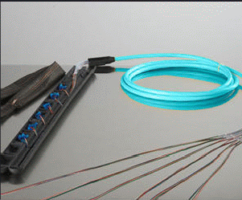
Preterminated cable

With SC or other connectors in a special sock for pulling, or

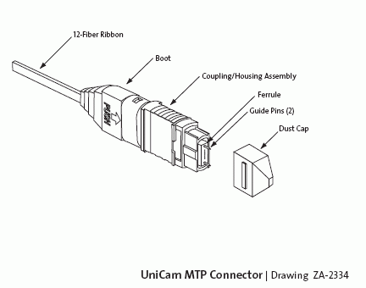
MTP ribbon cable connectors (12 fibers in a single SC-size plug) that plugs into a preconnectorized patch panel

Pictures from Corning (link Ch 7b & 7c)
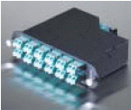

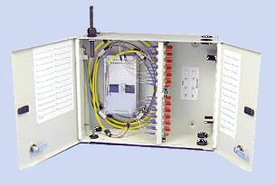
Intermediate Cross-Connect

Connects interbuilding cable plant to intrabuilding cable plant

May be wall-mounted

Image from apacn.com (link Ch 7e)

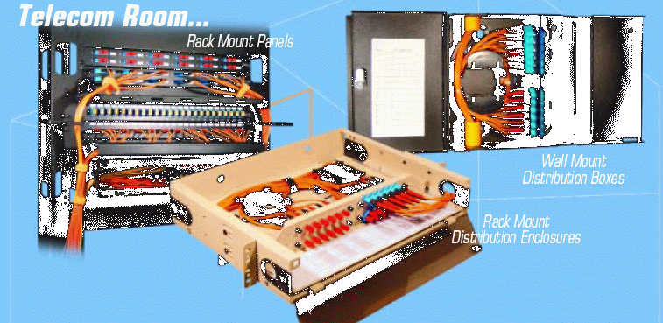

Telecom Closet

Transition from backbone to horizontal cable plant

Image icc.com (links Ch 7j)

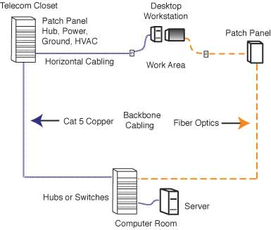

Homerun Cabling

This simpler, centralized network design is cheaper and popular

It works because fiber carries data over a long distance with passive links

Hardware for Distribution Points

Splice panel

Patch panel

Wall outlet

Conduit and innerduct

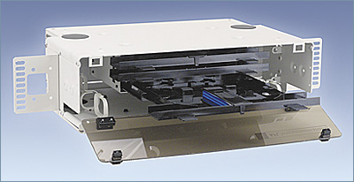
Splice Panel

Holds and protects splices in one or more splice trays

Images from aflfiber.com, siemon.com, and Corning (links Ch 7f, 7g, 7h)
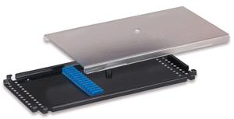

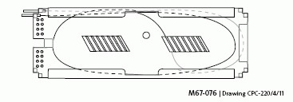

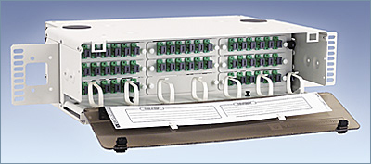

Patch Panel

Provides a centralized location for connecting fibers, testing, monitoring, and restoring riser or trunk cables

Requires short patch cords

Image from aflfiber.com (link Ch 7f)

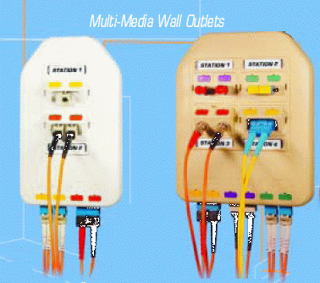

Wall Outlets

Terminates permanent wiring

Provides a connection for a jumper cable to equipment

Image from icc.com (links Ch 7j)

Outside Plant Hardware

Splice Closures

Conduit or innerduct

No connectors are usually used outdoors – only splices

Dome-type Splice Closure

Inline Splice Closure
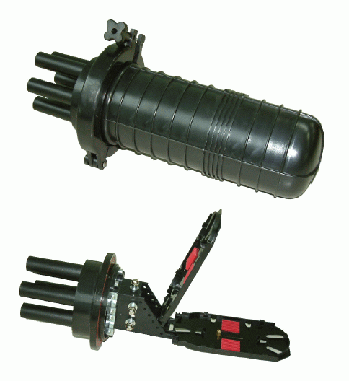

Splice Closures

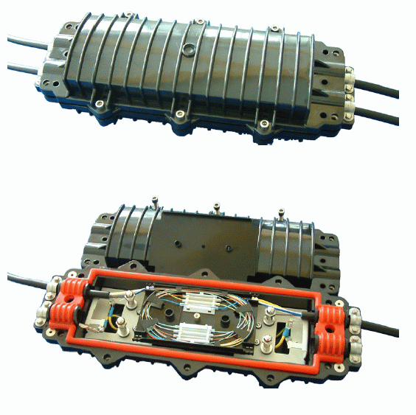
Protect splices from water and the elements

Image from pacificinterco.com (link Ch 7k)

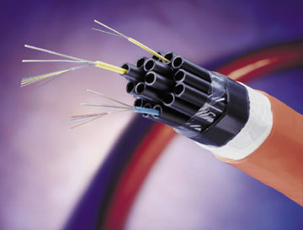
Conduit and Innerduct

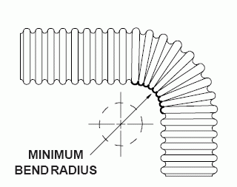
Cable is installed in conduit

Large conduits may have several innerducts inside them

Images from glenair.com and fpnmag.com links Ch 7l and 4q)

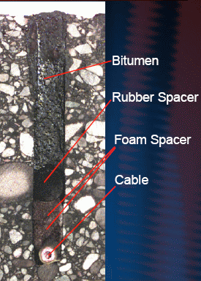

Cable Installed into Pavement

MCS Road Cable is designed to be inserted directly into a slit cut into pavement

This makes installation convenient – you don’t have to block traffic much

Image from Corning & CENIC, from link Ch 7m

Ch 8: Getting Started in Fiber Optics

Outside Plant

All singlemode fiber

High fiber counts, up to 288 or more

Cable reels are fusion spliced together for long distances

Preconnectorized pigtails are spliced onto the ends of the cables

Every fiber is tested with an OTDR (Optical Time Domain Reflectometer)

Very expensive equipment needed

Premises Cabling

Short lengths, fewer fibers per cable

Multimode fiber

Splicing is rare

Connectors and patch cords are used for flexibility

Installer often also installs power and copper LAN cables

Equipment is much cheaper

The Installers

Outside Plant installers work for telephone companies or other large corporations

Inside Plant installers are often independent contractors

Training

Go to an FOA-approved school

Get the FOA certification

CFOT or Certified Fiber Optic Technician (basic)

CFOS or Certified Fiber Optic Specialist (advanced)

CFxT (Certified FTTx Technician) (new, see link Ch 8c)

Tools and Test Equipment

You will need the basic tools, as found in our tool kits, including a microscope

And a power meter

If you do outside plant work, you will need a fusion splicer and OTDR

Keeping Up To Date

Like all other high-tech, fiber optics changes rapidly

You will have to constantly learn new things

LAN administrators typically spend 10 hours per week studying new technology

Entering the Market

Start slowly

Get a small job and do it carefully

Promote your services and grow

Promoting and Selling Fiber Optic Services

Make a brochure and Web site

Take photographs of your work

Give references of previous customers

Ask your suppliers to recommend you to customers

Overseeing Fiber Installations

Supervisors must know how to install fiber correctly

Make sure cables are pulled and terminated correctly

Workmanship should meet standards

NECA/FOA 301-2004, Standard for Installing and Testing Fiber Optic Cables (ANSI) (see link Ch 6d)

Test every fiber in every cable for loss

Document every fiber

Plan for Inspection

Before bidding on a job, make sure you know who the inspector will be and what will be required

Usually the person who hired you will be inspecting, or someone at their company

Local interpretations of fire codes and other regulations vary!

Pricing Fiber Installations

Request for Proposal

Gives you general description of a project

You must desicn, schedule, and price the job

Calculate real cost, add overhead and some extra for contingencies

Last modified 3-10-06

