Ch 9: Guidelines for Fiber Optic Design and Installation

General Guidelines

List Specifications

Know just what you want

Find Out how Performance Numbers were Measured

If a vendor says you can terminate each fiber in 3 minutes, make sure that’s really true

4 Vendors for Each Component

See table

Talk With Vendors Who Know More Than You Do

Avoid “the blind leading the blind”

Expect and Resolve Contradictions

Use Vendors With 5 Years in Business

Use “High Serial Numbers”

Tried and True

Design Decisions Impact Cost

Wavelength, connectors, cable

Buy Only Performance you Need

Ask Vendors About Competitors

Cable Guidelines

Check for Bargain Products Close to Your Needs

Leftovers, or with unimportant defects

Look for Best Price Possible

Often there are great deals

Be cautious about paying for premium fiber

Calculate the bandwidth limits to make sure you really need it

Other Considerations

Most manufacturers of cable provide about the same level of reliability

Connector Guidelines

No connector type is “the best”

Some are cheaper

Some are easier to install

Some require special tools

etc.

Ceramic Ferrules

They are all manufactured by the same few companies

Price and performance should not vary much

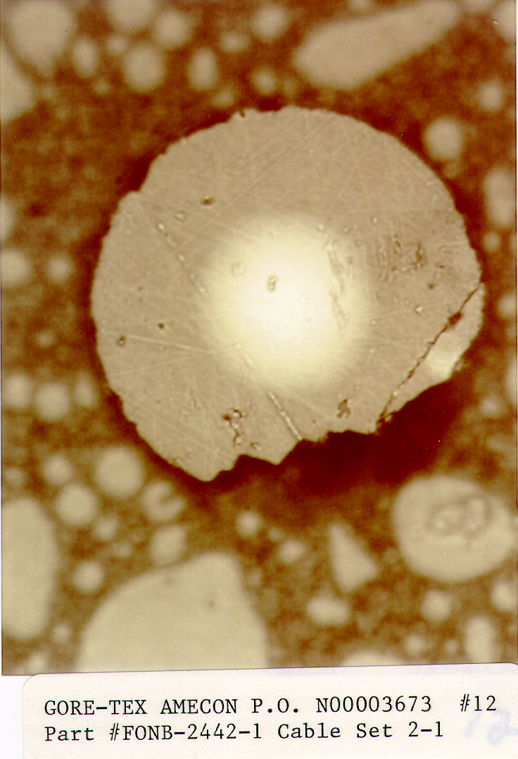
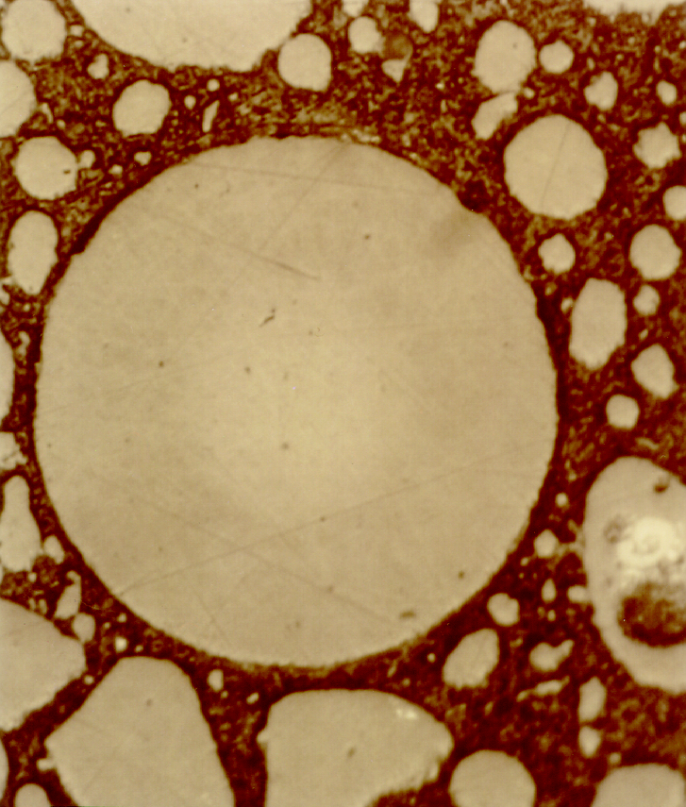
Ease of Installation May Lead to Poor Performance

Unicam-type connectors (no adhesive) use clamps to hold the fiber

They are subject to “pistoning”

Fiber moving in and out under thermal stress

Pistoning Damage

Pistoning causes cracking on optical fiber endface

Image from nasa.gov (link Ch 9a)

Connector Guidelines

There is no Substitute for Experience

Connectorization is a skill that requires constant practice

Ch 10: Cable Plant Link Loss Budget Analysis

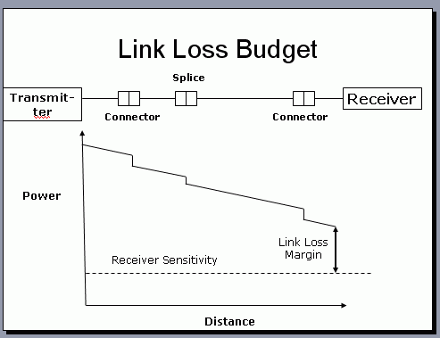
Losses

Light is lost by

Distance along fiber (attenuation)

Connector pairs

Splices

Splitters (if any)

Loss and Bandwidth

Loss is an important measure of a network’s quality

But for high data rates the bandwidth of the fiber can also be important

Attenuation-Limited Networks

Some networks are attenuation-limited

The max. length is determined by power loss

Adding another connector pair means the network must be shortened

Low Data Rate

This is an Attenuation-Limited Network
# Conn. Prs. | 2 | 3 | 4 | 5 | 6
Max Length (m) | 300 | 280 | 240 | 190 | 130

Standard 62.5/125 micron multimode

0.75 dB loss per connector pair

3.5 dB loss per km

1 Gb/s

Dispersion-Limited Networks

Some networks are dispersion-limited

The max. length is determined by spreading of the light pulses

Adding another connector pair does not affect max. length, until the loss becomes very severe

High Data Rate

This is a Dispersion-Limited Network

Standard 62.5/125 micron multimode
# Conn. Prs. | 2 | 3 | 4 | 5 | 6
Max Length (m) | 33 | 33 | 33 | 30 | 25

0.75 dB loss per connector pair

3.5 dB loss per km

10 Gb/s

Link Margin

Just take the difference between transmitter power and receiver sensitivity

Example: T=-20 dBm R = -30 dBm Link Margin = 10 dB

The loss of the total cable system must not exceed the Link Margin

Example: Media Converters

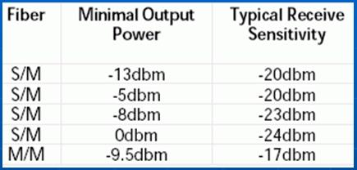
Top line: device with a link margin of 7 dB

4th line: device with a link margin of 24 dB

Last line: link margin of 7.5 dB

From link Ch 3h (arcelect.com)

Attenuation

Typical Attenuation for Multimode fiber:

3 dB/km @ 850 nm

1 dB/km @ 1300 nm

Typical Attenuation for Singlemode fiber:

0.4 dB/km @ 1310 nm

0.25 dB/km @ 1550 nm

Connector Loss

Typically 0.2 – 0.5 dB per mated pair of connectors

Industry standard max. 0.75 dB

A single connector has “no loss” – the light comes out of it

The measurable unit is a connector pair

Splice Loss

Mechanical splices – 0.3 dB max., 0.2 typical

Fusion splices – 0.05 dB max.

Stress Loss

Poor installation practices can stress the fiber, causing loss

Pulling with too much tension

Bending past the allowable bend radius

Tight cable ties

Calculated Loss Budget

Using standard values, calculate the expected loss of the link

Actual measured loss should be less

If it is higher, something is wrong
Transmit-ter
Receiver
Connector
Splice
Connector

Cable Plant Passive Component Loss Calculation

MM @1300 nm; typical values

2 km length x 1dB/km = 2.0 dB

4 connector pairs x 0.5 dB = 2.0 dB

1 splice (mechanical) x 0.2 dB = 0.2 dB

Total = 4.2 dB

Equipment Link Loss Budget Calc.

Last line: dynamic range of 7.5 dB

Recommended excess margin: 3 dB

Maximum cable plant loss: 4.5 dB

So our cable plant with 4.2 dB has a link loss margin of 0.3 dB

To Prepare for the Next Quiz

Study the questions on p. 137-138

I plan to give you a problem like that

Cable Plant Passive Component Loss Calculation

MM @850 nm; typical values

2 km length x 3dB/km = 6.0 dB

4 connector pairs x 0.5 dB = 2.0 dB

1 splice (mechanical) x 0.2 dB = 0.2 dB

Total = 8.2 dB

7-9-08

