Top half of case
Top Row:

Jacket Stripper (red handle, holes from .40 to 1.3 mm)

Miller Fiber Strippers (yellow handle, labeled Clauss Fiberoptic Stripper)

Round Cable Cutter (yellow handle, safety lock holds it shut)

Buffer Tube Stripper (looks like a gray clothespin, shown in lab manual on page 31 labeled Small Cable Stripper)

Tweezers

Screwdriver

Needle Nose Pliers

Kevlar Scissors
Bottom Row:

Black pocket containing:

4 packages Fiber Optic Connector Epoxy (blue dye)

5 packages D'GEL Solvent Wipes

Round Cable Slitter (shown in lab manual on page 31 labeled Large Jacket Slitter and Stripper

Utility Knife

Black Marker

Ruler

1/2" Nut Driver
Bottom half of case
Top Row:

(50) Foam Swabs in top long small compartment

P50 TUBE KIT containing:

4 colors heat shrink tubing

(5) Fusion Splice Sleeves (only 4 were in BASIC KIT 1)

P50 LABEL KIT containing:

Cable ties

Yellow plastic labels that say CAUTION FIBER OPTIC CABLE

Fiber Disposal Unit

4oz. Alcohol Bottle

Top right slot is empty (no cleaver)

Fabric Tape Measure

Piano Wire

PVC electrical tape
Bottom Row:

Kim Wipes

Connector Cleaner (white tape in blue plastic dispenser)

Safety Glasses

Matching Gel

Wire Marker Dispenser

Canned Air

Universal Continuity Tester
Behind Top Panel:

Black Work Mat

1Mtr 3mm Furcation Tube

1Mtr 900um Furcation Tube
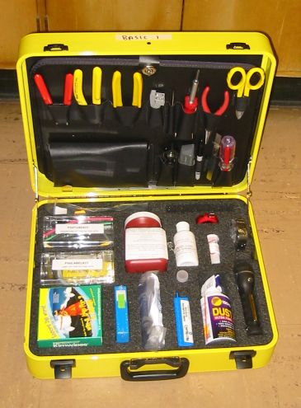
Top half of case
Top Row:

Jacket Stripper (red handle, holes from .40 to 1.3 mm)

Miller Fiber Strippers (yellow handle, may be labeled Clauss Fiberoptic Stripper)

Round Cable Cutter (yellow handle, safety lock holds it shut)

Buffer Tube Stripper (looks like a gray clothespin, shown in lab manual on page 31 labeled Small Cable Stripper)

Tweezers

Screwdriver

Needle Nose Pliers

Kevlar Scissors
Bottom Row:

Black pocket containing:

5 Fibrlok Splices

5 packages D'GEL Solvent Wipes

Two 5-packs of swabs

Round Cable Slitter (shown in lab manual on page 31 labeled Large Jacket Slitter and Stripper

Utility Knife

Black Marker

Ruler (missing in Fibrlok Kit 1)

1/2" Nut Driver
Bottom half of case
Top Row:

(50) Foam Swabs in top long small compartment

P50 TUBE KIT containing:

4 colors heat shrink tubing

(5) Fusion Splice Sleeves (only 4 were in BASIC KIT 1)

P50 LABEL KIT containing:

Cable ties

Yellow plastic labels that say CAUTION FIBER OPTIC CABLE

Fiber Disposal Unit

4oz. Alcohol Bottle

Cleaver in top right slot

Fabric Tape Measure

Piano Wire

PVC electrical tape
Bottom Row:

Kim Wipes

Connector Cleaner (white tape in blue plastic dispenser)

Safety Glasses

Matching Gel

Wire Marker Dispenser

Canned Air

Universal Continuity Tester
Behind Top Panel:

Black Work Mat

1Mtr 3mm Furcation Tube

1Mtr 900um Furcation Tube

Fibrlok Assembly Tool (black plastic with red labels)

5 packs TRA-BOND epoxy
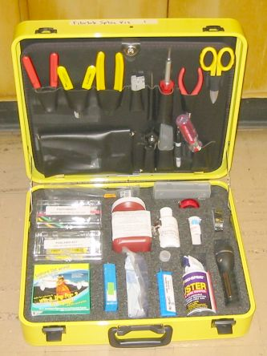
Top half of case
Top Row:

Jacket Stripper (red handle, holes from .40 to 1.3 mm)

Miller Fiber Strippers (yellow handle, may be labeled Clauss Fiberoptic Stripper)

Round Cable Cutter (yellow handle, safety lock holds it shut)

Buffer Tube Stripper (looks like a gray clothespin, shown in lab manual on page 31 labeled Small Cable Stripper)

Tweezers

Screwdriver

Needle Nose Pliers

Kevlar Scissors
Bottom Row:

Black pocket containing:

5 Syringes

5 packages D'GEL Solvent Wipes

FIS Universal 2.5 mm Polish Disc

Round Cable Slitter (shown in lab manual on page 31 labeled Large Jacket Slitter and Stripper

Utility Knife

Carbide Scribe (looks like a pen with a green cap)

Black Marker

Ruler (missing in Fibrlok Kit 1)

1/2" Nut Driver
Bottom half of case
Top Row:

Universal Crimp Tool in top left slot (looks like large double-jointed pliers, red handles)

P50 TUBE KIT containing:

4 colors heat shrink tubing

(5) Fusion Splice Sleeves (only 4 were in BASIC KIT 1)

P50 LABEL KIT containing:

Cable ties

Yellow plastic labels that say CAUTION FIBER OPTIC CABLE

Fiber Disposal Unit

4oz. Alcohol Bottle

Microscope in top right slot with instructions sheet

Fabric Tape Measure

Piano Wire

PVC electrical tape
Bottom Row:

Kim Wipes

Connector Cleaner (white tape in blue plastic dispenser)

Safety Glasses

Matching Gel

Wire Marker Dispenser

Canned Air

Universal Continuity Tester
Behind Top Panel:

Black Work Mat

Glass polish plate (in padded brown envelope)

Rubber Polish Pad (about 6 inches square, thick black rubber)

(50) Foam Swabs

A pack of polish film containing:

(5) 1um polish film

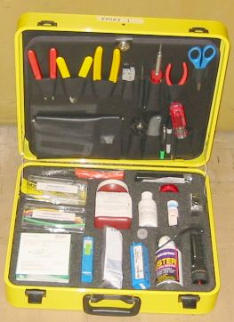
(5) 5um polish film

(5) 0.3um polish film

1Mtr 3mm Furcation Tube

1Mtr 900um Furcation Tube

5 packs epoxy

