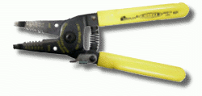
Required Equipment

Jacket Stripper (red handle, holes from .40 to 1.3 mm) used to remove the jacket from the outside of the cable

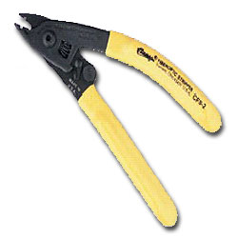

Miller Fiber Stripper (also called buffer stripping tool) (yellow handle, labeled Clauss Fiberoptic Stripper) used to remove the coating from the bare fiber, leaving only the core and cladding
Safety Rules
Wear glasses or safety glasses
Make sure there is sticky tape on the table to hold fiber shards. DISPOSE OF ALL SHARDS PROPERLY. Don't lose them or drop them on your clothes, the floor, etc.

Strain relief boot

Crimp sleeve

Aramid yarn scissors

Cleaning equipment:

Kimwipes

Alcohol bottle

Cable to terminate
Preparing the Cable & Stripping the Fiber
You will need to perform two separate operations to prepare the cable for termination. The jacket strip tool will expose the buffered fiber and strength members, then you must carefully remove the buffer with the fiber stripper in a series of small strips as explained below.
If the cable you are using is unterminated at both ends, then the cable jacket is unstable - it will slide. Before you begin to strip it, tie a firm knot in the other end. This will keep the jacket, aramid yarns, and buffer all in the same relative position.
Allow at least 3 inches (75mm) from the cut end of the fiber for termination. If the fiber has been cut for some time, the fiber may be brittle at the end, so cutting off 6 inches (150 mm) may make working with the fiber easier.

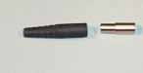
Preparing The Cable
Put these on first!
Slide the strain relief boot (pictured in black above) onto the cable first - narrow end first.
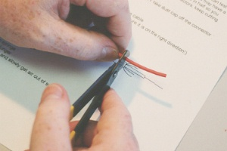
Then slide the crimp sleeve (pictured in silver above) onto the cable - narrow end first.
Slide them back along the cable, out of the way, as you prepare to strip the cable.
Use the jacket strip tool (don't confuse it with the buffer stripper) to cut through the protective jacket.
Bite down on the fiber at the desired location, and hold the tool closed.
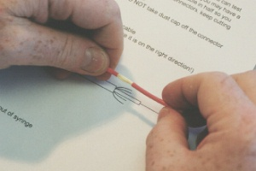
Release the tool, and grab the jacket with your fingers. Twist it and pull. It will slide off easily.

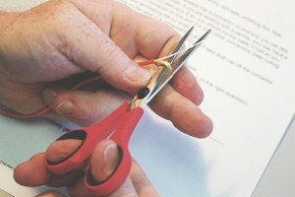
Now you should shake the Aramid yarns loose (blowing on them often helps loosen them), gather them together, make a loop, and cut the yarns with the special scissors designed to cut this material so that 1/4 - 3/8 inch of yarn is left, as required by the connector you are using. The strength members (usually aramid fibers, often called Kevlar, the DuPont trade name) will be crimped to the connector to give additional strength to the connection.

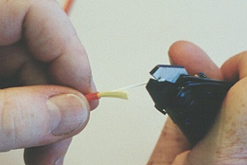
Removal of the buffer from the glass:
It is very important that care be taken here so that the glass fiber does not break. Attempt to strip no more than 1/8 in of buffer at a time until you get a "feel" for the fiber, then you may be able to strip longer lengths without breaking the fiber!
There are several types of stripping tools, but the "Miller Stripper" shown here is one of the most popular, since it is very reliable. Another type is the "No-Nik" which works well if kept clean.
Hold the Miller Stripper at a 45 degree angle to the fiber so that it does not bend the fiber when you clamp down on the fiber.
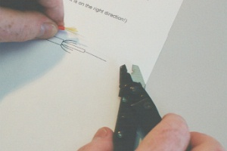
Squeeze the stripper firmly on the fiber to cut the buffer fully. Pull slowly and steadily, keeping the fiber straight as you strip the buffer off. It will NOT slide off easily like the jacket. Continue to take 1/8 to 1/4 inch bites of buffer (3-6 mm). You must leave enough exposed buffer for the connector body to adhere to, so there must be at least 5/8 to 1 inch of fiber exposed (15-25 mm) or whatever length is required by the connector you are terminating.
It helps to have a drawing of the stripping dimensions in the exact size you must strip to to compare directly to the fiber itself. This is much easier than measuring!

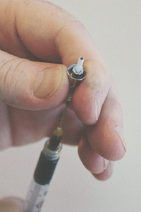
Attaching the Fiber to the Ferrule With Anaerobic Adhesive:
Remove the dust cover from the ferrule of a connector and set it aside - we'll put it back on after we're through.
Insert the needle into the connector body as far as it will go. Lightly squeeze the bottle until a tiny bead of adhesive appears at the tip of the ferrule.
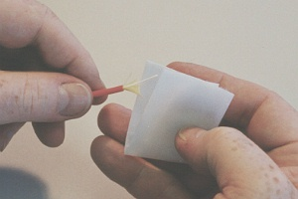
Remove the syringe from the connector. Lay the connector down for a moment while you deal with the syringe and clean the fiber with an Alco wipe. Wipe the tip of the needle with a clean wipe and set it aside with the wipe wrapped around the needle to prevent getting epoxy on anything.
Place an Alco pad between your thumb and forefinger, and wipe the fiber between them.
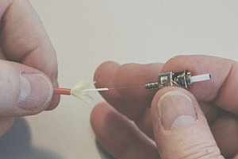
Slide the connector onto the fiber. As you feed the fiber into the connector, rotate the connector back and forth so the fiber will find its way through the ferrule.
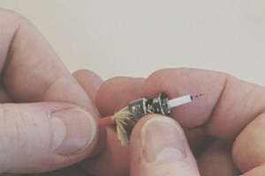

Slide the connector all the way back to the jacket. Some epoxy will leak out the back onto the yarn and jacket. This will help secure the connection.
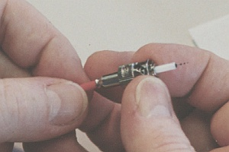
While you hold the connector against the jacket, slide the crimping sleeve onto the connector body. You will have to make two crimps on this sleeve.

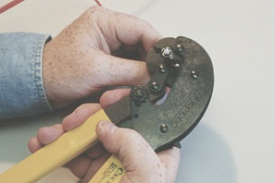
Crimp the wider part of the sleeve first. Sqeeze the tool to maximum compression to complete the crimp. Then crimp the narrow part of the sleeve over the jacket.

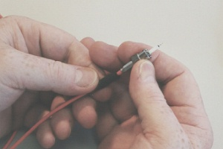
Slide the strain relief boot over the crimp sleeve. Be careful not to break the glass fiber protruding from the ferrule. This will be removed in the polishing step after the epoxy cures.
If you break the fiber at this point, cut the connector off and start over. The fiber always breaks below the end of the ferrule and cannot be polished properly.
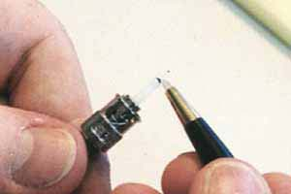
Cleaving
The next step is to "cleave" the stub of glass protruding from the ferrule. Take the connector in one hand and the scribe in the other. Holding the scribe very lightly, delicately give the glass 3 scratches at the point where it protrudes from the epoxy bead on the ferrule.
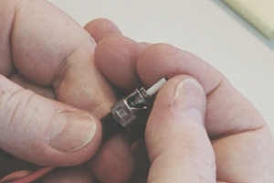
Lay the scribe aside, and grasp the glass. Carefully pull up and away from the scribe. The glass should break cleanly at the scribe point, but there will be a little bit left at the tip and it may be sharp! Discard the glass fiber fragment in the fiber disposal bin!

Polishing
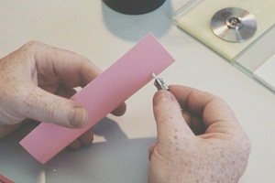
A preliminary step is to apply sheets of 3 and 0.3 micron lapping film to the polishing glass. If you are polishing PC (physical contact - or convex) ferrules, use a rubber pad between the polishing film and the glass plate.
"AIr Polish" the fiber stub first with 12 micron film, holding it as shown. Polish the tip lightly for 10 to 20 seconds. Notice the change in sound (quieter) as the burr gets filed down and the epoxy bead is removed. Remember to brush the tip lightly and do not overpolish.
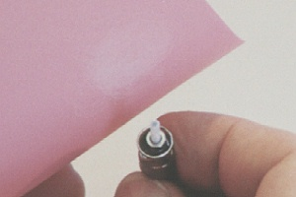
Visually inspect the tip. There should be some epoxy left, and the glass itself will be not be smooth.

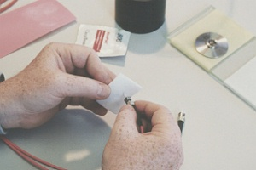
Clean the tip with an Alco pad to remove any loose grit or epoxy.

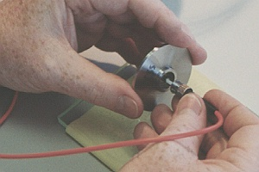
Now prepare to use the polishing puck with the polishing plate. Always hold the puck up in your hand and then insert the connector. Never insert the connector into the puck while it is lying on the glass because you may chip the glass at the ferrule tip.

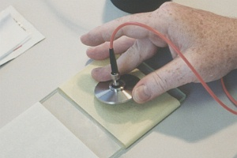
Gently place the puck with the connector in it on the yellow film which is on the polishing glass. Remember the tip is a ragged glass end which can be easily damaged.

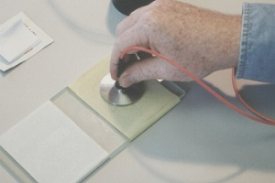
Very lightly make 4 or 5 figure eights as you polish the tip. You'll actually feel a smoothing of the surface as the epoxy scrapes off and the ceramic surface of the ferrule meets the surface of the abrasive. Do not overpolish the tip. Remember, the glass is softer than the polishing abrasives. Overpolishing can cause the glass to be undercut, and this will cause excess light loss at the connection.
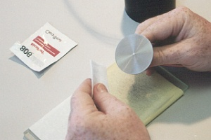
Stop as soon as the connector feels "slick"! The polishing film and the ferrule are made of similar materials. As soon as all the epoxy and protruding fiber is removed, the ferrule will be rubbing against the film and it will feel like the puck is floating on air.
Clean the tip with an Alco pad and inspect it to see that all the epoxy is gone. If not, give it 1 or 2 more figure eights on the yellow 3 micron film to remove it. Remember -do not overpolish!
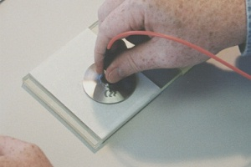
Very gently lay the puck on the 0.3 micron film. With almost no pressure, make about six figure eight strokes.

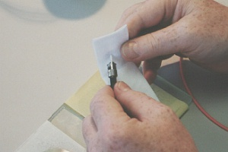
Remove the tip from the puck, and clean it with an Alco pad.

The connection is now complete, ready for visual inspection of the tip.

Visual Inspection With a Microscope
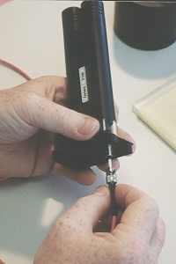
At this point, inspect the polished end of the ferrule with the microscope to see that the epoxy is completely removed and that the tip is smooth and free of scratches.
Focus the microscope. You can hold the other end of the fiber towards a light to couple light into the core as part of the inspection process. From head on at 100 times magnification, it should look like this:
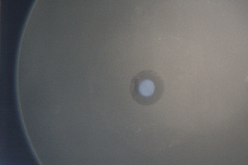
The bright dot in the center is the core of the fiber and the darker annular ring is the claddding. On this connector, notice the dark area to the left of the core, in the cladding. This appears to be a small crack in the fiber that only affects the cladding, not the core, so it is not a problem. If the crack had been in the core, we would not have seen a round dot for the illuminated core.
Grading
When your cable is done, label it with your name and show it to your instructor so your grade can be recorded.
Taken from Lennie Lightwave www.vdvworks.com/VHO
Last modified 9-8-06

